Economics Bridging Unit - Part 3 – Preparing for September
Answer all questions. Your hand-written responses must be handed in to me in the first week back in September. The number of marks in brackets indicates how long your answer should be. The total is 110 marks.
Biases in decision-making - Rules of thumb
Have you ever made a decision based on intuition or ‘gut feeling’?
Terry Christian, a TV celebrity who’s made a good living over the years as a professional Mancunian, once said:
“People ask me why I take an instant dislike to southerners…it just saves time.”
Mr Christian’s statement demonstrates what is known as a cognitive bias: he apparently believed everyone from south of England dislikeable. Consequently, getting to know them would have been a waste of time. Acting on this bias is unlikely to have improved Mr Christian’s life; it wasn’t based on evidence and, as most of us can testify, is plain wrong. Who knows how many potential good friends he lost because of his bias.
A cognitive bias is a systematic error in thinking; it happens repeatedly and leads to sub-optimal decision making.
A rule of thumb is a means of estimation made according to a rough and ready practical rule, not based on science or exact measurement. In behavioural economics rules of thumb are known as heuristics. Heuristics deliberately ignore some of the available information to enable quicker decision-making. Heuristics mean that individuals could repeatedly make the same mistakes leading to bias.
Heuristics are commonly associated with the work of two economists, Amos Tversky and Daniel Kahneman. Kahneman’s 2011 book “Thinking Fast and Slow” introduced dual- system theory to a wider audience and attempted to explain the specific ways of thinking that people rely on to simplify the decision-making process.

In “System 1 (thinking fast)” people rely on the impulsive, intuitive part of their brain to make decisions. This thinking leads to them making snap decisions based on heuristics which saves both time and effort. The resulting loss of accuracy leads to what is known as the accuracy–effort trade-off.

In “System 2 (thinking slow)” people taking the time to perform slow but reliable calculations, using data, theory and research to inform their decision-making.

Most of the time System 1 runs automatically and System 2 is in a comfortable low-effort mode in the background. When the two agree, impressions get turned into beliefs. When System 1 runs into trouble, it asks for processing help from System 2. This is a very good system that works very well most of the time, however System 2 is a lazy controller and doesn’t like to expend much effort. One of its main functions is to monitor and control thoughts and actions suggested by System 1, but the fact that it often doesn’t do that leads to poor decision making.

Brexit

In a 2016 ‘Telegraph’ article Kahneman warned that British voters were succumbing to impulsive gut feelings and irrational reflexes in the Brexit campaign. Kahneman appeared to suggest that voters in the referendum relied on System 1 thinking rather than System 2.

A survey conducted by the Online Privacy Foundation gave voters the same data sets, but with two very different contexts. In the first voters were asked to interpret data on whether a skin cream reduced or increased the chances of developing a rash. Irrespective of a voter’s viewpoint (Leave or Remain) they got the answer correct 57% of the time. When the same numbers were presented in the context of whether immigration increased crime rates something very interesting happened: Remain voters interpreted the statistics correctly 70% of the time, whereas Leave voter’s ability to do so dropped by over half.

This survey produced similar results to a study conducted by Dan Kahan. In Kahan’s experiment, respondents were asked to interpret a table of numbers about whether a skin cream reduced rashes, and some people were asked to interpret a different table — containing the same numbers — about whether a law banning private citizens from carrying concealed handguns reduced crime. Kahan found that when the numbers in the table conflicted with people’s positions on gun control, they couldn’t do the calculations right, though they could when the subject was skin cream. The bleakest finding was that the more advanced that people’s math skills were, the more likely it was that their political views, whether liberal or conservative, made them less able to solve the calculation.

These examples seem to show that political bias interferes with a person’s ability to assess the facts of an issue objectively. Research by Brendan Nyhan takes this one depressing step further: when people are presented with facts that challenge their political views they cling to those views more tenaciously.

In the survey people who believed that weapons of mass destruction (WMDs) had been found in Iraq believed this misinformation even more strongly after being presented with evidence that it was false. More recently Donald Trump denied that he had insulted the Duchess of Sussex, despite the existence of a recording. Perhaps the Dunning-Kruger effect could help explain this: not only are people mis-informed they are unaware that they have been mis-informed. In other words: some people are too stupid to realise they are stupid.

Anchoring bias

You own a restaurant in which the profit margin on drinks is much higher than on the food; ideally you want customers to buy a nice bottle of wine in the £40 - £50 price range with each meal. You know that customers on a night out are unlikely to want to read your wine list from start to finish before discussing the relative merits of each product, seeking advice from a qualified sommelier, and browsing online reviews. Customers will satisfice, (or put another way, they will rely on System 1).

Anchoring is a way to present (frame) your wine list to make it more likely that customers will buy in the price range desired. Placing Champagne and other luxury products at the top of the wine list anchors the customer to the first price they see: a £300 bottle of Krug makes a £50 bottle of red seem cheap by comparison.

A double-glazing salesman employs the same strategy. He knows that customers suffer a lack of information: they don’t know how much windows cost to make and fit, and probably won’t do the research to find out. The salesman wants as high a price as possible, whereas the customer wants as low a price as possible. The salesman uses anchoring to maximise revenue. After measuring up and discussing the exact requirements he introduces the price: £10,000 for the whole house. This is the anchor. When the customer hesitates, the salesman will offer a “special” discount, available today only, of 30%. The new price of £7,000 is still incredibly expensive, (and well above what the salesman would have been willing to accept), but now seems like a much better deal compared to the first price quoted.

In 2010 “Serendipity 3”, a NYC eatery popular with visitors, introduced a $69 hot dog. The hot dog came with medallions of foie gras, black truffles and caramelized Vidalia onions. The accompanying ketchup was made from heirloom tomatoes, and the Dijon mustard was spiked with truffle shavings. The new dish was introduced on National Hot Dog Day with a representative of the Guinness Book of World Records on hand to "certify" it as the world's most expensive hot dog. Whilst very few diners at the restaurant ordered the hot dog, the price made the alternative $17.95 hamburger seem reasonable in comparison even though $17.95 for a hamburger is still relatively expensive. The hot dog was the anchor.

Anchoring also works for special offers in supermarkets where a limit is placed on the number of products a customer can buy. An example would be Lidl offering 50% reduction on 6 packs of Coca-Cola. Limiting the number each customer can buy to 4 packs acts as a suggestion (an anchor) as to the quantity each customer should buy. Other promotions that kick in once a certain amount has been spent work in a similar way:

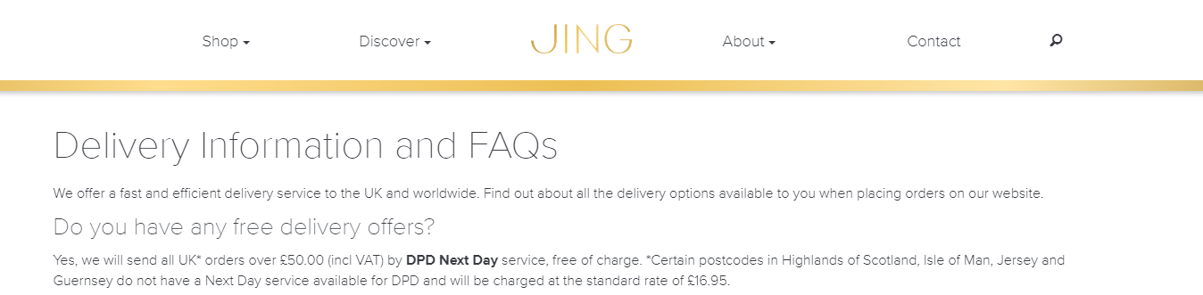
Here Jing Tea offers free delivery to customers spending £50 or more: what an excellent way of anchoring this amount as a minimum spend. Who doesn’t want free delivery?

Have a look at the advert below:
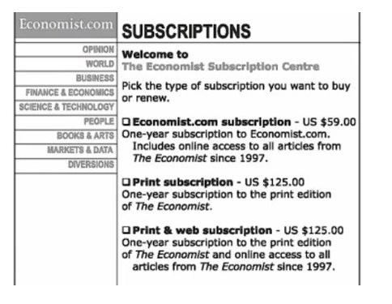

- Why is the advert slightly surprising? (5 marks)
- A type of anchoring is called “decoy pricing”. Research this concept and then apply what you have learnt to the advert. (10 marks)
- A famous example of anchoring relates to black pearls and the famous jeweller Harry Winston. Explain what happened. (10 marks)

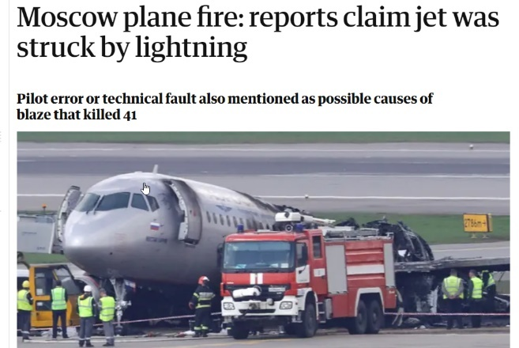
The availability bias

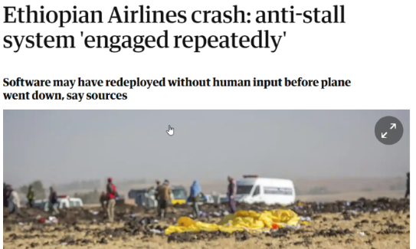

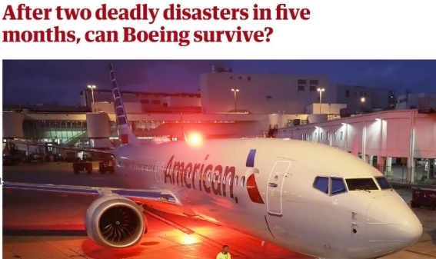

Someone reading the articles, above, might start to believe that flying a lot less safe than it really is. This individual might decide to drive to their destination rather than fly. Is this optimal behaviour? According to a 2017 Harvard University Study the chances of a plane crashing are one in 1.2 million and the odds of dying in a plane crash are one in 11 million, (plane crashes don’t always result in fatalities). The chances of dying in a motor vehicle accident? One in 5,000.
The availability bias describes judgments people make about the likelihood of an event based on how easily an example, instance, or case comes to mind.
- How widespread is knife crime in the UK? How has it changed over recent years? Research official government statistics. (5 marks)
- How could the availability bias lead to more young people carrying knives? (10 marks)
Social norms
Social norms signal appropriate behaviour and are classed as behavioural expectations or rules
within a group of people. In other words, norms are shared expectations of how most of a group would behave in a given situation. Human beings’ susceptibility to feedback about social norms is closely related to our desire to maintain a positive view of who we are as a person. We are heavily influenced by what those around us do and say.

Example

In a test the Behavioural Insights team worked with Co-op Legal Services to measure the power of social norms. When customers phoned to have a will written they were either:

- Not asked if they would like to donate money to charity in their wills (this is the control condition)
- Asked the simple question ‘Would you like to leave any money to charity in your will?’ (the ‘Just Ask’ condition)
- Told that ‘Many of our customers like to leave money to charity in their will’. They were then asked, ‘are there any causes you’re passionate about?’ (the ‘Social Passion Ask’ condition).

The results of the test were interesting and supported the idea that social norms can be used as a powerful policy tool. In the control group only 5% of customers left money to a charity. This rose to 10% in the ‘Just Ask’ group. In the ‘Social Passion Ask’ group 15% of customers left money to a charity. Furthermore, the average donation among people in the ‘Social Passion Ask’ group was twice as large (£6,661) than those in the control (£3,300) or ‘Just Ask’ group (£3,110). The more we think other people behave norm-compliantly, the more we are willing to comply ourselves.

- Explain how social norms could be used to reduce the number of patients missing hospital appointments. (5 marks)
- Using the ideas of feedback and social norms, explain why ‘Smart Meters’ for the home could reduce greenhouse gas emissions. (5 marks)

Policy makers must exercise some degree of caution though as using norms can sometimes backfire. Campaigns that highlight the prevalence of a behaviour can accidentally convey the message that it is it is widespread. Take the litter situation in the JT block: telling students that the quantity of litter is growing suggests that dropping litter is normal behaviour. Littering could increase, not decrease, because of the message.

- Explain how this relates to knife crime. (10 marks)

Behaving according to norms is widely considered ‘System 1’ thinking and the more people rely on the intuitive system to make decisions, the more they tend to comply with what they believe to be the social norm. Norm-compliance can be increased by a large degree if the possibility to punish those who continue to be non-compliant through "peer punishment" exists.

It should also be remembered that when people feel they have been treated unfairly, they are much more likely to show non-norm-compliant behaviour.

Altruism and fairness
According to neoclassical economics, rational beings do whatever they need to maximize their own wellbeing. However, when people make sacrifices to benefit others without expecting a personal reward, they are said to behave altruistically. Common applications of this pro-social behaviour include volunteering, philanthropy, and helping others in emergencies.
In classical economics people are altruistic because the act of generosity makes them feel better about themselves (the warm glow effect) or that they behave altruistically because there will be some form of reciprocity in the future; altruism therefore makes sense in a utility maximising model. Others suggest that altruism taps into people’s inequity-aversion, (i.e. people generally like fairness and dislike unfairness) or that altruism is normal in some cultures. Whatever the reason these models struggle to explain pure altruism, where the giver expects (and receives) no benefit for their generosity.
Tipping (service gratuities)
“Economists do not have a good theory of tipping. Normally, we assume that consumers pay as little as they have to when buying the products they want. Yet, when buying meals, haircuts and taxi services, most consumers voluntarily pay more than they are legally required. Why does this happen? Why is it more true for some services than for others? Why do tipping customs vary from country to country? I have no idea.” -- Greg Mankiw (2007)
- Suggest reasons why people leave tips. (5 marks)
Organ donation
On average three people in the UK die each day due to a lack of organ donors. Opinion polls suggest that 90% of the UK population is in favour of organ donation, but only 33% are on the donor list. As the UK uses an opt-in system of registration getting people to opt in is potentially lifesaving. Making opt-in the default choice (so people have spend time and energy to opt out) would be the best way to change the system, but this is controversial. What other strategies could work?
In a recent study in the UK a message was included whenever someone renewed their road tax online: given that every car on the UK’s road must be taxed by law, this seemed an effective way to reach potential registrants. Eight messages were designed and randomly generated at the end of the road tax transaction. These messages ranged from a simple “please register to be an organ donor” to “Every day thousands of people who see this message decide to register” to “You could transform the lives of up to 9 people as an organ donor”. The most successful message was: “If you needed an organ transplant would you have one? If so, please help others”, which would have led to 96,000 more people registering.
- Why do you think this message worked? (5 marks)
- Why is it normal for hotel and airlines to increase the price of tickets for the Champion’s League final? (5 marks)
- Why do fans consider the decision unfair? (5 marks)
- How could the companies have dealt with these accusations? (5 marks)

Research the following and write a paragraph on:
- Choice Architecture and Framing (5 marks)
- Default choices (5 marks)
- Restricted choices (5 marks)
- Mandated choices (5 marks)
- Nudges (5 marks)

