Media Studies Bridging Unit

Welcome to AQA A-Level Media Studies! Put simply, Media Studies is the study of the world of the Media, from analyzing camera shots in a TV or music video sequence, to evaluating how media moguls -like News Corporation- are owned and regulated. Our exam is worth 70% and involves the analytical study of advertising, newspapers, music videos, video games and television dramas. Our course work is worth 30% and so we are looking for a practical and creative person who can apply the knowledge they’ve learnt in lessons. Please complete our transition task by your first lesson back in September.
Should you require any help or if you have any questions then please contact the Head of Media: cclewer@blue-coat.org

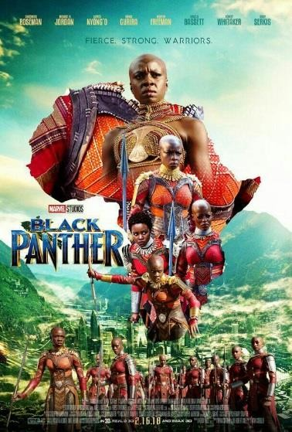
SUMMER TASK
Written-based 1
Write a 500 word essay entitled: How is ethnicity and gender constructed in the ‘Black Panther’ film poster? [30 marks]

Success criteria:
- Aim to write 4-5 PEE paragraphs: point-evidence-explain
- In your point, explicitly explain what you learn about ethnicity
- Refer to specific evidence from the poster (see the list below for ideas)
- Develop and explain your views by exploring the connotations and meaning of the evidence you have chosen
- Make links to the context of the poster- what is it implying about ethnicity/ gender and our views towards ethnicity/gender in society today? How have these changed?

Some ideas you could explore:
- The visual codes in the poster e.g. outline of Africa, tribal dress code, use of props, colour scheme, location
- The language used e.g. in the tagline, name of the film
- The camera angles used- look up what a low angle is
Want to challenge yourself? Use the following theory by bell hooks to add depth to your response: hooks is a feminist and argues that race, sex and class determine the extent to which one is discriminated against and oppressed in and by society. Are these characters oppressed? Or does this poster challenge this theory?

Practical-based task 2

In your course work you will be asked to design a product that clearly represents a group (e.g. ethnicity or gender) in an insightful and complex way. Choose one of tasks below and be ready to share it your first lesson back.

- Create a lifestyle magazine front cover- take your own image and write your own cover lines- that represents a group is a specific way. You could use word or publisher.
- Write the script for a radio show in which you interview the director and a cast member about an upcoming film (that you have made up) in which representation of a group is complex (like Black Panther).
- Choose a song that does not currently have a music video, create a 15 frame storyboard using your own photographic images to go with the song. Represent a group in a complex way.

