The Blue Coat School French A Level Year 11 Bridging Material – part 2: An introduction to the A Level Course

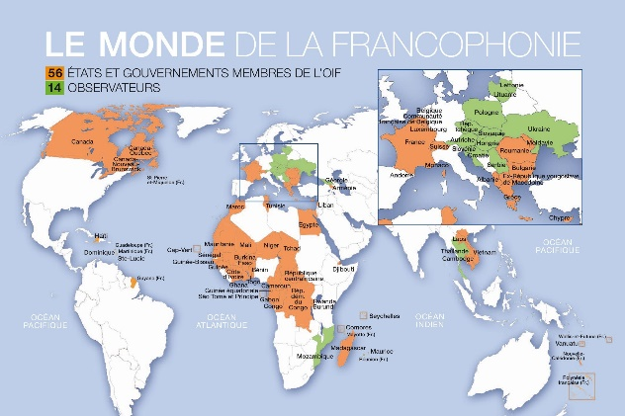

Bonjour! Welcome to your first taste of French A level! In the second section of material, we want to give you a taste of what you will be studying in the first few weeks of the A Level course in September. Make sure you bring this work with you in September!
Bridging Work Part 2 tasks:
- La famille- in the first weeks of the A Level course, you will be looking at French and francophone societies and how families and marriage has changed. On the next page there is a worksheet, in the middle of which is a link to a video with some questions. Watch the video (feel free to re-watch it, pause the recording and add subtitles if you need them) and answer all the worksheet questions.

- La famille research- Do some research on ‘le mariage pour tous’ in other French speaking countries and make some notes in English or French. What is the stance in other francophone countries ?

- La musique- Alongside looking at the change of family structures you will be looking at French and Francophone music. On the second task page there’s a gap-fill of a song by a really famous Belgian artist called Stromae. Have a go at filling in the gaps and see if you can work out the general meaning of the song!

- La musique research- Pick 3 French speaking countries and research what’s currently in the charts. Have a listen to some of the French-speaking songs- are there any you like? Or any you really dislike? What kind of genres do French speaking people listen to? Are there geographical links E.G. Do European French speakers listen to similar music? How about West African French speakers?

- La grammaire- Brush up on your passé compose and present tenses looking at regular ER,IR and RE verbs as well as irregulars stem-changing verbs via https://www.laits.utexas.edu/fi/vp/

- Le film- Find a French film to watch (Netflix has lots!) and write a short review (no more than 200 words in French) about what you thought of it and why. Be prepared to discuss it when we meet for lessons

4. Choisis la réponse correcte
a. En France, les avis sur le mariage pour tous sont
1. unanimes | 2. divisés | 3. controversés

b. Dorénavant, en France … peuvent se marier
1. tous les couples | 2. certains couples | 3. seulement les couples homosexuels

c. Chez certains français, le mariage pour tous crée de
1. de l’ambition | 2. la tension | 3. la gêne

d. Un des droits du mariage est celui
1. de fonder une famille | 2. de vivre sous le même toit | 3. de faire un enfant

e. Le modèle de famille répandu dont il est question dans la vidéo est proche du modèle
1. « nucléaire » | 2. « familles monoparentales » | 3. « familles tribus »

Le mariage pour tous
https://education.francetv.fr/matiere/education-civique/ce1/video/pourquoi-certaines-personnes-sont-contre-le-mariage-pour-tous-1-jour-1-question
- Complète les phrases
Pourquoi certaines personnes sont ………………………. le mariage pour tous ?
C’est le nom d’une loi qui a été ………………………. le 17 mai 2013
Parce que désormais tous les ………………………. ont le droit de se marier
Certains sont gênés à l’idée que deux personnes du même ………………………. Puissent former un couple
Cela bouscule l’idée de la ………………………. Car le mariage donne des droits comme celui d’………………………. un enfant
Et comme à chaque fois que les règles de la société changent, cela peut faire ……………………….
Le mariage c’est le ………………………. de l’amour de deux personnes
Les députés ont ……………………….

3. Les questions

En France, tout le monde est contre le mariage pour tous
Vrai | Faux

La loi autorise tous les hétérosexuels à se marier
Vrai | Faux

Certaines personnes n’apprécient pas l’idée que deux personnes homosexuelles puissent être ensemble
Vrai | Faux

Des personnes ne souhaitent pas que les couples homosexuels adoptent des enfants
Vrai | Faux

Le changement, en France, provoque souvent des craintes
Vrai | Faux

Le mariage est la concrétisation de l’union de deux personnes
Vrai | Faux

Les députés ont tranché et ont aboli la loi sur le mariage pour tous
Vrai | Faux

Plus de 7000 couples homosexuels se sont mariés depuis cette loi. (vidéo publiée en 2014)
Vrai | Faux

- Cherche les synonymes

Permettre à | Avoir le pouvoir de
Se marier | Angoisser
Avoir le droit de | Accueillir
Être gêné | Les opinions
Adopter | Ont décidé
Répandu | Autoriser
Faire peur | L’image
Le symbole | Être embarrassé
Les avis | S’unir
Ont tranché | Propagé

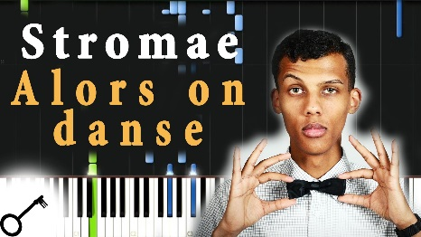
Alors on danse- Youtube the song and see if you can fill in the gaps (it’s tough!)
Qui dit étude dit___________,
Qui dit taf te dit les thunes,
Qui dit _________dit dépenses,
Qui dit crédit dit créance,
Qui dit _________ te dit huissier,
Oui dit assis dans la merde.
Qui dit les gosses,
Dit toujours et dit_________.
Qui dit ___________ te dis deuils car les problèmes ne viennent pas seuls.
Qui dit ___________ te dis monde dit famine dit tiers- monde.
Qui dit fatigue dit réveil encore sourd de la veille,
Alors on sort pour oublier tous les__________.
Alors on danse… (x9)
Et la tu dis que c’est __________car pire que ça ce serait la mort.
Qu’en tu ___________ enfin que tu t’en sors quand y en a plus et bien y en a encore!
Ecstasy, dis problème les problèmes ou bien la____________.
Ca t’prends les trips ca te prends la tête et puis tu prie pour que ça s’arrête.
Mais c’est ton ___________ c’est pas le ciel alors tu t’bouches plus les oreilles.
Et là tu cries encore plus fort et ça persiste…
Alors on _________
Lalalalalala, Lalalalalala,
Et puis seulement quand c’est fini, alors on______

