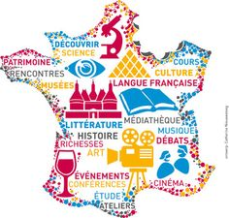
The Blue Coat School French A Level Year 11 Bridging Material – part 1: GCSE review

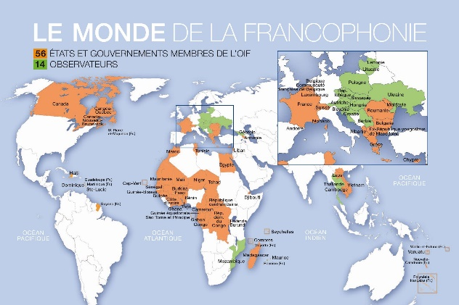

Bonjour! Welcome to your first taste of French A level! The A-level specification builds on the knowledge, understanding and skills gained at GCSE. There is of course a continued focus on language, but increasingly you will learn about French-speaking culture and society.
Bridging Work Part 1 tasks (work to record and bring in September is underlined):
- Grammar
You will need to be confident with both regular and irregular verbs in the present, perfect, imperfect, simple future and conditional tenses. A fantastic way to go over the rules for these tenses and practise them is on the University of Texas interactive grammar platform.
Go on to:
https://www.laits.utexas.edu/tex/gr/index.html#v
Any of the activities on the Verbs section are useful, and on the Tense/Aspect/Mood/Voice section the activities on passé composé with avoir and être, imparfait: formation, simple future (regular and irregular) and conditional are probably the most important at this stage. Each activity has an explanation first (in English!) and then a self-marking activity, and they all centre around the activities of Texan creatures Tex and Tammy and their friends.
- Culture and society
- Revise GCSE family vocab (members of the family, relationships, etc) then watch this video:
https://www.youtube.com/watch?v=T16pVP1IbIY
and take notes about types of family in current French society. Make a list of all the types of family mentioned in both French and English and save it ready to show us in September.
- Revise the GCSE region vocab first (type of area, location vocab, weather, geographical features, etc). Then follow this link:
https://www.podcastfrancaisfacile.com/videos-apprendre-francais
- choose the option: dictée and scroll right until you find ‘Félix et sa région’. Play the video and it will ask you to listen, write what you hear and then check what you’ve written against the transcript. Useful revision (and extension) of region vocab but also really good practice for matching up what you hear with the written word, a skill that can be really tough.
- C’est quoi, les symboles de la République ? (1jour1actu.com)
This is a lovely website which is designed for French children. Each video on there deals with one question asked by a French child (this one is about the origins of French national symbols). Each question has a video illustrating the answer and also the transcript below. Watch this video (the French is very fast but the illustrations should help) and read the transcript - see how much you can understand. Make a list of some of the ‘République’ vocab you come across in both French and English and save it ready to show us in September. Doing this kind of activity regularly is really beneficial for your vocabulary and listening skills – try to look at another few videos of your choice between now and September and write down what you thought, we can discuss them when we get together.

