A-level Biology
at The Blue Coat Sixth Form
Part of the Science Department
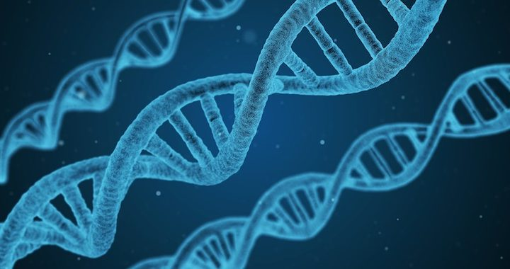
Throughout your A-level course you will be taught by two different teachers. Initially one teacher will begin to work with you on the topic ‘Biological Molecules’ whilst the other teacher begins work on the topic ‘Cells’. The final part of the bridging material contains two tasks, one for each teacher, which you should complete in preparation for the start of your course. It is essential that this work is completed before your first lesson.
Biological Molecules Task:
Food tests is a subject that is covered by both the GCSE and A-level specifications. Despite this we have found that many students miss out on easy marks by not knowing how to test for protein, reducing and non-reducing sugars, lipid and starch. We would really like you to revise this GCSE topic very carefully to consolidate this knowledge.
What to do-
Either print the set of flashcards provided or make your own. On the back of each card write prompt questions. Learn the contents of the flashcards so that your recall is faultless.
Answer the practice exam questions provided, there are both GCSE and A-level questions so that you can see how the style differs. A range of simple recall and some more difficult A-level application of knowledge are provided, notice how the more difficult questions require you to link knowledge together.
Mark and MIB your practice questions.
Arrive at school for your first lesson prepared to complete an assessment of this knowledge which will consist of similar questions.
Cells Task:
We will be studying the structure of eukaryotic and prokaryotic cells and this work will revise your existing knowledge and help you to prepare for this.
Please do not bring this work to the first lesson, you will be using it in one of your early lessons. Your teacher will tell you when they want you to bring it into school.
What to do-
- Make a model (not a diagram) of a plant OR an animal cell – this should include all the parts (organelles) that can be seen using an electron microscope. Label your model with the name of each of the organelles.

- Produce a set of flashcards which describe the function of the following parts of a cell:
Nucleus
Mitochondrion
Ribosome
Endoplasmic Reticulum (rough and smooth)
Golgi Body (or Golgi Apparatus)
Lysosome
Cell membrane
Cell wall
Vacuole
Chloroplast
Useful information to know
Course leader: Dr Lawson, Head of Biology (ELAWSON@blue-coat.org)
Director of Science: Mrs C Oles (COLES@blue-coat.org)

What specification is it?

AQA A level Biology 7402
https://www.aqa.org.uk/subjects/science/as-and-a-level/biology-7401-7402
You can download the specification for free. Have a look through to see what sort of topics you will be covering.
If you want to get organised you can set up your folder using the unit headings in section 3.

What textbook will I use?
You will receive textbooks from the library when you start in September. If you want to purchase a copy in advance you can find it here:
https://qrgo.page.link/gxVH7

You may find it useful to purchase a revision and practice book – we recommend this one:
https://qrgo.page.link/ZmNm3

