A Level History
Bridging Material
Congratulations on picking A Level History.
It is a fantastic subject [we think so!] and we are so passionate about our A Level. Our students work hard and achieve amazing results alongside the development of those all-important skills that are crucial to life after A Levels.
The bridging tasks in this pack are designed to bridge the gap between GCSE History and A Level History and will hopefully confirm that History is the right subject for you!
The tasks involve reading and summarising texts alongside research skills, and then using the materials to complete tasks which will be assessed by your class teacher in September. This work gives you an opportunity to set a really good first impression. We expect you to work hard and produce the best work as possible, ensuring any work completed isn’t done to simply tick a box; but you actually take the time to complete it properly and display high level thinking skills.
We hope you have a safe and relaxing summer, and we look forward to meeting you in September!
The History department.

Please keep all the completed work safe and bring it to your first A Level History lesson in September. You will hand in each unit of work separately; one to each of you teachers.

OCR A Level History, 2021-2023
Topics studied | Unit 1  Y108 – The early Stuarts and the origins of the Civil War, 1603-1660 | Unit 2  Y216 – The USA in the 19th Century, 1803-1890 | Unit 3  Y319 – Civil rights in the USA, 1865-1992 | Unit 4  Y100 – Independent study - Topic based essay [coursework] of 3000-4000 words
When is this taught? | Year 12  Revised in Y13 | Year 12  Revised in Y13 | Year 13 | Begin in Year 12  Finish Feb in Y13
% towards the total A Level? | 25% | 15% | 40% | 20%

Please purchase the following textbooks and bring to your first lesson in September
Topics studied | Unit 1  Y108 – The early Stuarts and the origins of the Civil War, 1603-1660 | Unit 2  Y216 – The USA in the 19th Century, 1803-1890
Textbook to purchase  [can be purchased off Amazon] | Access to History: The Early Stuarts and the English Revolution, 1603–60, Second Edition Paperback – 25 Jun. 2021 by Katherine Brice (Author), Michael Lynch (Author) | OCR A Level History: The American Revolution 1740-1796 and The USA in the 19th Century 1803–1890 Paperback – 27 July 2018 by Mike Wells (Author), Nicholas Fellows (Author)

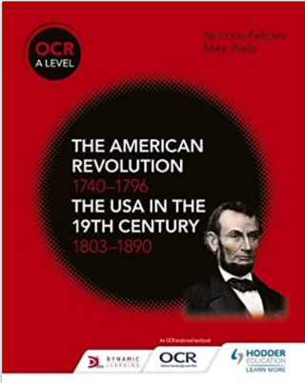
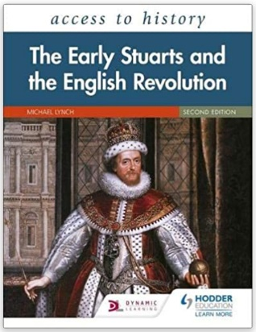

It is also worthwhile ensuring that you have a pack of highlighters for summarising and selecting key information across the texts that you will read.
To prepare for your Stuarts area of study, you will research what preceded it. This is so that you can easily make comparisons with how well the Stuart kings dealt with their problems in comparison to earlier monarchs around the Early Modern Period. This task will also enable you to develop your research skills to apply them to the unit of work.
Unit 1:
The Early Stuarts and the origins of the Civil War 1603-1660

Task: Produce a research report which answers the following questions in detail:
- What was life like in Elizabethan England?
- What was religion like in Elizabethan England?
- How successfully did Elizabeth I deal with threats to her reign?
It is completely up to you how you construct this report. Some ideas could be:
- A short essay on each
- A museum board/display
- A PowerPoint presentation answering each question
- A podcast (with an accompanying transcript)
You must also include a bibliography, which is a list of any books/clips/podcasts/articles you use too research your work.
Bring this work [printed off] to your first day at Blue Coat in September.

Where to begin your research
https://www.historyhit.com/what-did-elizabeth-i-achieve/
https://www.bbc.co.uk/bitesize/guides/zcnqsg8/revision/1
https://www.hoddereducation.co.uk/media/Documents/Magazines/Sample%20Articles/JanFeb%202018/HS28_2_Jan2018.pdf
https://www.historyextra.com/period/elizabethan/catholics-in-elizabethan-england/
https://www.youtube.com/watch?v=87kZSY9On7k
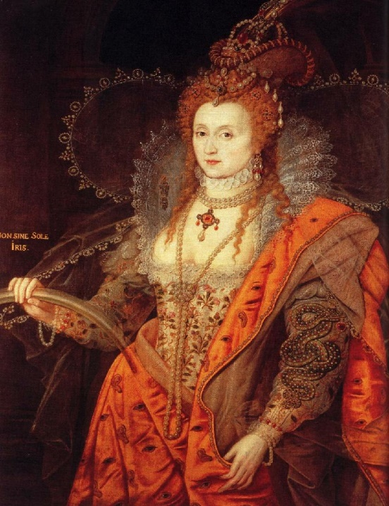

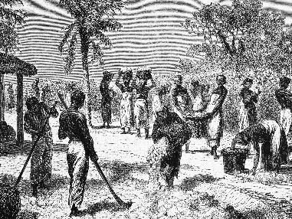
Optional extras
The articles below link slavery to modern day issues surrounding the USA.
https://www.nytimes.com/interactive/2019/08/14/magazine/slavery-capitalism.html
https://www.brookings.edu/articles/an-american-tragedy-the-legacy-of-slavery-lingers-in-our-cities-ghettos/
Extra research
For task three you may find it useful to carry out further research. You can of course do this for yourself, but here are some examples below that you may find useful.
https://www.history.com/news/slavery-profitable-southern-economy
https://www.youtube.com/watch?v=Ajn9g5Gsv98
https://www.forbes.com/sites/hbsworkingknowledge/2017/05/03/the-clear-connection-between-slavery-and-american-capitalism/#5f8b5f487bd3
You have been given an article about slavery in the USA. There are a number of tasks that you need to complete using this information and this will be assessed by your class teacher in September.
- Take detailed notes on the nature of slavery, the importance of it, and the different views towards slavery during this period. This can be paragraph summaries or bullet points.
- Create a glossary of 15 key words [including definitions] that you think are non-negotiable when discussing slavery in the USA [Ideally these should be ones you have included in task 1!]
- “Slavery was vital to the economy of the USA.” Do you agree? Write an answer to this question. This should be two developed sides to the argument with multiple lines of argument analysed as well as a clear, well developed conclusion. Aim for 2-3 sides of A4 lined paper.
Bring this work [printed off] to your first day at Blue Coat in September.
Across the 19th century there was tension growing between North and South America [known as sectional tension]. One of the main causes of this sectional tension was the question of whether slavery should be expanded into the new territories; should the new states be “free states” or “slave states”. Slavery and the tension it created contributed in a significant way to the outbreak of the Civil War in 1861. A large part of our unit involves looking at the causes of sectional tension, therefore you need to have a good understanding of the role that slavery played in the USA.
Unit 2:
Westward expansion and the American Civil War, 1803-1890

