

AQA Applied Science Level 3

Bridging work Part 2

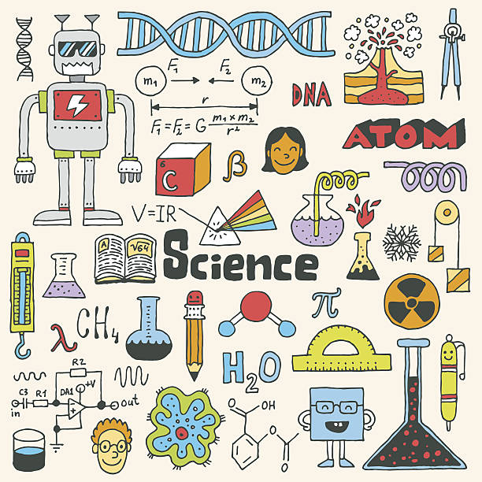

Table of Contents

Introduction 5

Biology 6

Task 1 6

Task 2 6

Task 3 6

Task 4 6

Task 5 6

Chemistry - Key definitions 7

Ionic bonding 8

Practice questions 8

Answers 10

Covalent bonding 11

Practice questions 11

Answers 13

Physics - Electrical circuits 14

The Magnificent 7 Equations 14

Practice questions 14

Answers 17

Circuit Rules (This is **optional**) 18

Practice questions 18

Circuit Rules Question Pack 1 (LD) 18

Circuit Rules Question Pack 2 (SD) 18

Circuit Rules Question Pack 3(HD) 18

# Introduction

Welcome back to part 2 of the bridging work for Applied Science!

In part 2, you’ll be focussing on reviewing aspects of GCSE which you need to have a strong understanding of to succeed on the course. An important reminder - store all the completed work from part 1 in a safe location. You will be expected to bring evidence of this work in to class when we start in September!

How should I use this booklet?

Part 2 of the bridging work has been split into the 3 sciences. Read the instructions in each section as the approach is different for each one. Set a target to complete 20-30 mins each day, and you’ll have this done in no time.

Good luck!

Mr Bhula

# Biology

Hello! Welcome to the Applied Science – Biology course. Our coursework in Year 12 requires an understanding of enzyme structure and how they work. This bridging work will help you get up to speed so that you can tackle the coursework with confidence.

Good luck; enjoy your learning. I look forward to meeting you in September.

Miss Elliott

## Task 1

Review your GCSE Biology knowledge of enzymes using the following BBC Bitesize links:

www.bbc.co.uk/bitesize/guides/z9jrng8/revision/2

www.bbc.co.uk/bitesize/guides/z9jrng8/revision/3

## Task 2

Answer the two GCSE exam questions on enzymes below.

Q1. The graph shows the effect of pH on the activities of three enzymes, X, Y and Z.

These enzymes help to digest food in the human digestive system.

Each enzyme is produced by a different part of the digestive system.

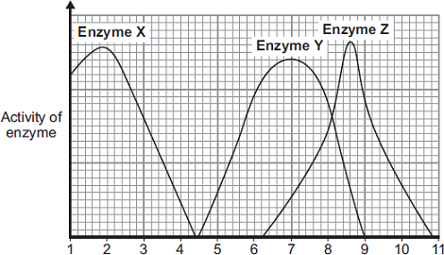

pH

(a) What is the optimum (best) pH for the action of enzyme Z? ____________

(1)

(b) The stomach makes a substance that gives the correct pH for enzyme action in the human stomach. Name this substance. __________________________________________

(1)

(c) Which enzyme, X, Y or Z, will work best in the human stomach? _______________

(1)

Q2. There are enzymes in biological washing powders. Biological washing powder has to be used at temperatures below 45 °C.

(a) The enzymes in biological washing powders do not work on the stains on clothes at temperatures above 45 °C.

Explain why.

___________________________________________________________________________

___________________________________________________________________________

___________________________________________________________________________

___________________________________________________________________________

(2)

(b) Some bacteria, called thermophilic bacteria live in hot springs at temperatures of 80 °C.

Scientists have extracted enzymes from these thermophilic bacteria. These enzymes are being trialled in industrial laundries. The laundries expect to increase the amount of clothes they can clean by using enzymes from thermophilic bacteria instead of using the biological washing powders the laundries use now.

The laundries expect to be able to increase the amount of clothes that they can clean each day.Suggest why.

___________________________________________________________________________

___________________________________________________________________________

___________________________________________________________________________

___________________________________________________________________________

(2)

## Task 3

YouTube has some helpful videos. Watch this one: [www.youtube.com/watch?v=A1xWfd0fcjo](http://www.youtube.com/watch?v=A1xWfd0fcjo)

## Task 4

Make a set of notes using these links:

https://alevelnotes.com/notes/biology/biological-molecules/enzymes/enzymes

https://alevelnotes.com/notes/biology/biological-molecules/enzymes/factors-affecting-enzyme-activity

You need to make notes on **two** specific areas ONLY:

* How enzymes work
* How temperature affects the rate of an enzyme-controlled reaction

Keep these **notes safe**, **bring them to your first lesson with me** and we will be **using** them when we are completing our **coursework**.

# Chemistry - Key definitions

**Memorise** the answers to the questions below. These are definitions you are expected to know completely. Then cover the answers column with a piece of paper and write as many answers as you can. **Check and repeat**.

|  |  |
| --- | --- |
| What does an atom consist of? | a nucleus containing protons and neutrons, surrounded by electrons |
| What are the relative masses of a proton, neutron, and electron? | 1, 1, and $\frac{1}{1836}$ respectively |
| What are the relative charges of a proton, neutron, and electron? | +1, 0, and -1 respectively |
| How do the number of protons and electrons differ in an atom? | they are the same because atoms have neutral charge |
| How does the number of protons differ between atoms of the same element? | it does not differ – all atoms of the same element have the same number of protons |
| What is the proton number / atomic number of an element? | the number of protons in the atom’s nucleus of an element |
| What is the mass number of an element? | number of protons + number of neutrons |
| What is an isotope? | an atom with the same number of protons but different number of neutrons |
| What is the equation for relative isotopic mass? | The mass of an atom of an isotope compared to one-twelfth the mass of an atom of carbon-12. |
| What is the equation for relative atomic mass (*Ar*)? | The weighted mean mass of an atom of an element compared to one-twelfth the mass of an atom of carbon-12. |
| What is the equation for relative molecular mass (*Mr*)? | The weighted mean mass of a molecule of a compound compared to one-twelfth the mass of an atom of carbon-12. |
| What is an ion? | an atom or group of atoms with a charge (a different number of electrons to protons) |
| Define the term cation | a positive ion (atom with fewer electrons than protons) |
| Define the term anion | a negative ion (atom with more electrons than protons) |
| What is a binary compound? | a compound which contains only two elements |

# Ionic bonding

## Watch the following video which summarises the [properties of ionic compounds](https://www.youtube.com/watch?v=leVxy7cjZMU)

## Ionic bonding involves the transfer of electrons. The electrons are transferred from metal atoms to non-metal atoms. The metal atoms become positively charged ions and the non-metal atoms become negatively charged ions. Upon transfer, both sets of ions have a full outer shell of electrons. Ionic bonding is therefore the electrostatic attraction between the oppositely charged ions. This is shown in Figure 1 below.

## 

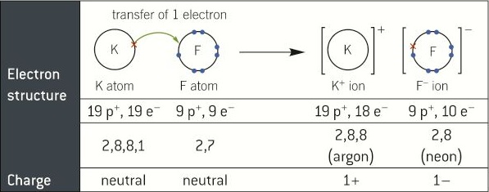

## ***Figure 1 Dot and cross diagram for potassium fluoride***

## 

## In an **ionic compound** the ions are arranged in a **giant ionic lattice**. This is where ions are surrounded by **oppositely charged ions**. Ions attract each other in **all directions**. There are **strong electrostatic forces of attraction** between these oppositely charged ions.

## Practice questions

1. Complete the dot and cross diagram to show the sodium ions and chloride ions in sodium chloride.

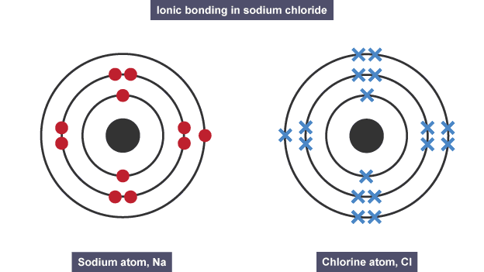

(4 marks)

## A **3d** diagram representing the structure of **NaC*l*** is shown below. What information can you add to each of the circles? Add this. *(1 mark)*

## 

## http://www.bbc.co.uk/bitesize/higher/chemistry/images/bonding_fig15.gif

1. Explain why sodium chloride has a **high melting point**.  *(3 marks)*
2. Explain why **solid** sodium chloride **does not conduct** electricity. *(1 mark)*
3. Explain why **molten** sodium chloride **does conduct** electricity.  *(1 mark)*

## Answers

1. *Award a maximum of four marks from the following:*

*• electrons drawn correctly on sodium (1 mark)*

*• ‘plus’ sign indicating positive charge on sodium (1 mark)*

*• electrons drawn correctly on chlorine (1 mark)*

*• ‘minus’ sign indicating negative charge on chloride (1 mark)*

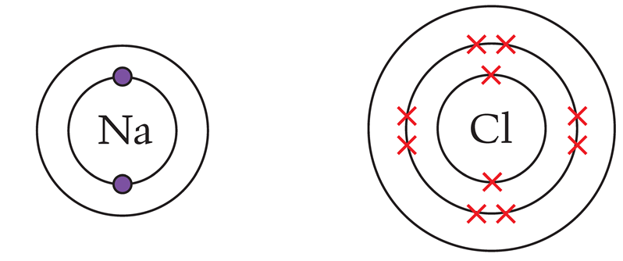



## *Negatives (-) in the green spheres and positives (+) in pink spheres.*

1. *The sodium and chloride ions are held together by strong electrostatic forces. (1 mark)*

*A large amount of energy is required to break these forces of attraction so sodium chloride will only melt at a high temperature. (1 mark)*

1. *Solid sodium chloride does not conduct electricity because the ions are held in a lattice and cannot move. (1 mark)*
2. *In molten sodium chloride, the ions can move. (1 mark)*

# Covalent bonding

Covalent bonding involves the sharing of pairs of electrons. The electrons are shared between non-metal atoms. Covalent bonding can be separated into 2 groups: simple molecular and macromolecules. In this section, you will only be considering simple molecules. Watch the following videos on [Covalent bonding](https://www.youtube.com/watch?v=lenvZEcMc60) , [simple molecules](https://www.youtube.com/watch?v=DECGNyC-x_s) and answer the practice questions below:

## Practice questions

1. Complete the dot and cross diagrams for the following simple molecules.

**Hydrogen Chloride, HC*l***

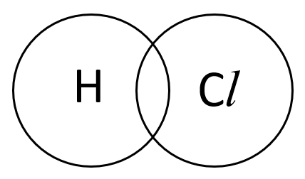

**Methane, CH4**

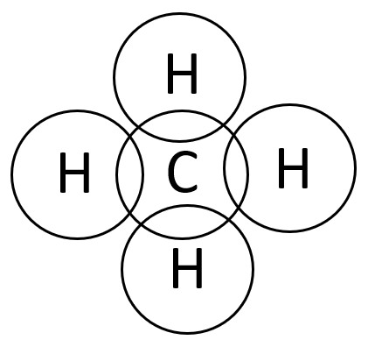

**Water, H2O**

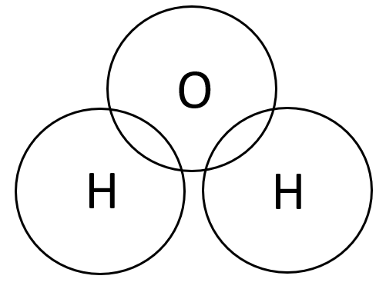

2. Explain why methane **does not conduct** electricity. *(1 mark)*

3. Compare the bonding in **ionic compounds** and in **simple molecular substances**.

*(4 marks)*

## Answers

1. **Hydrogen Chloride, HC*l***





**Methane, CH4**





**Water, H2O**





1. *Methane does not conduct electricity because it has no overall electrical charge. (1 mark)*
2. *In ionic compounds, electrons are transferred from metal atoms to non-metal atoms to form positively and negatively charge ions. (1 mark)*

*These ions are then held together by strong electrostatic charges. In simple molecular substances, non-metal atoms are held together by shared pairs of electrons. (1 mark)*

*There are strong covalent bonds between the atoms within a simple molecule but only very weak forces of attraction between the molecules. (1 mark)*

*Little energy is required to break the forces of attraction between the molecules so methane melts and boils at low temperatures and is a gas at room temperature. (1 mark)*

# Physics - Electrical circuits

In the physics section of Applied Science, you will learn more about electrical circuits. Therefore, it is essential that you have a solid foundation to build upon. The following activities will ensure you have all the prerequisite knowledge from GCSE at the depth required to take your learning further.

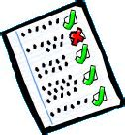Watch the following videos, make flash cards and get yourself tested on your recall of each of the equations. Then try to recall all the equations in one group. Test yourself until you can always recall them correctly.

[Electricity Equations | GCSE Physics - YouTube](https://www.youtube.com/watch?v=ydE6T78VX1k)

[GCSE Science Revision Physics "Power of Components" - YouTube](https://www.youtube.com/watch?v=LOyJdI41aCU)

[GCSE Science Revision Physics "Potential Difference from Batteries" - YouTube](https://www.youtube.com/watch?v=4ZjzbqtP-tY)

[GCSE Science Revision Physics "Charge in Circuits" - YouTube](https://www.youtube.com/watch?v=ts7WumFAaSg)

[GCSE Science Revision Physics "Calculating Energy Transferred by Appliances" - YouTube](https://www.youtube.com/watch?v=WLaUmNr4lho)

[GCSE Science Revision Physics "Resistance" - YouTube](https://www.youtube.com/watch?v=cx9xLwa7Gco)

[GCSE Science Revision Physics "Resistors" - YouTube](https://www.youtube.com/watch?v=2CA1mcYw3IQ)

Follow this up by answering the past paper questions, and MIB (self-assess in a different colour using the answer section.)

## Practice questions

**Q1.** (a)     An appliance is connected to the mains electrical supply. The mains potential

difference is 230 V.

Calculate the energy transferred when 13 C of charge flows through the appliance.

___________________________________________________________________

___________________________________________________________________

___________________________________________________________________

___________________________________________________________________

Energy transferred = _______________________ J

**(2)**

The diagram below shows the structure of a fuse.

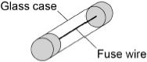

(b) The fuse wire melts when 1.52 coulombs of charge flows through the fuse in 0.40 seconds. Calculate the current at which the fuse wire melts.

___________________________________________________________________

___________________________________________________________________

___________________________________________________________________

___________________________________________________________________

Current = _______________________ A

**(3)**

Energy = _______________________ J

**(2)**

**Q2.** (a)     **Figure 2** shows how the amount of energy transferred by a kettle varies with time.

**Figure 2**

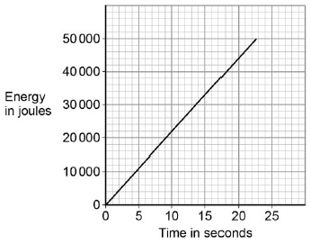

Calculate the power output of the kettle.

___________________________________________________________________

___________________________________________________________________

Power output = ____________________ W

**(2)**

(b)    Calculate the current through the kettle when 2400 coulombs of charge flows in 250 seconds.

___________________________________________________________________

___________________________________________________________________

___________________________________________________________________

___________________________________________________________________

Current = ____________________ A

**(3)**

**Q3.** The diagram shows an electrical circuit.

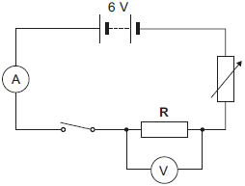

(a)     The switch in the diagram is shown in the open position. Closing the switch completes the circuit.

Charge flows through the completed circuit and a reading is shown on both the ammeter and the voltmeter.

(i)      In 10 seconds, 20 coulombs of charge flows through the circuit.

Calculate the current reading shown on the ammeter.

______________________________________________________________

______________________________________________________________

Current = ___________________ A

**(2)**

(ii)     For 20 coulombs of charge to flow through the resistor R, 100 joules of work must be done.

Calculate the potential difference reading given by the voltmeter.

______________________________________________________________

______________________________________________________________

Potential difference = _______________ V

**(2)**

## Answers

***Q1.*** *(a)     E = 2990 (J) scores* ***2*** *marks*

*(b)     I = 3.8 (A) scores 3 marks*

***Q2.*** *(a)     Power input = 2200 (W)*

*accept an answer that rounds to 2200 (W) for* ***2*** *marks*

***1***

*(b)     I = 9.6 (A) an answer of 9.6 (A) scores 3 marks*

***Q3.*** *(a) (i)      2*

*allow* ***1*** *mark for correct substitution ie*

**

*provided no subsequent step*

***2***

*(ii)     5*

*allow* ***1*** *mark for correct substitution ie*

**

*provided no subsequent step*

***2***

# Circuit Rules

Watch the following videos. Practise writing out the circuit rules so you can do this from memory.

[GCSE Science Revision Physics "Current in Series Circuits" - YouTube](https://www.youtube.com/watch?v=CEBfn4ndQWI)

[GCSE Science Revision Physics "Current in Parallel Circuits" - YouTube](https://www.youtube.com/watch?v=JhBrAmQYr2g)

Watch the next two videos to learn even more about how potential difference is shared in series circuits.

[GCSE Science Revision Physics "Potential Difference in Series Circuits" - YouTube](https://www.youtube.com/watch?v=YAzyHRusOS0)

[GCSE Science Revision Physics "Potential Difference in Parallel Circuits" - YouTube](https://www.youtube.com/watch?v=UM1jyQVdGD8)

Watch the next video to learn how resistance acts in a series circuits and parallel circuit.

[GCSE Science Revision Physics "Resistors in Series and Parallel - YouTube](https://www.youtube.com/watch?v=vJRXozSVTI8)

## Practice questions

Click on the links to Exampro Questions, these are past paper question. Follow this up by answering these and MIB (self-assess in a different colour using the answer section) with the mark schemes and examiners reports.

## [Circuit Rules Question Pack 1 (LD)](https://ooxaryh.exampro.net/)

## [Circuit Rules Question Pack 2 (SD)](https://xogyzeo.exampro.net/)

## [Circuit Rules Question Pack 3(HD)](https://fojoyou.exampro.net/)