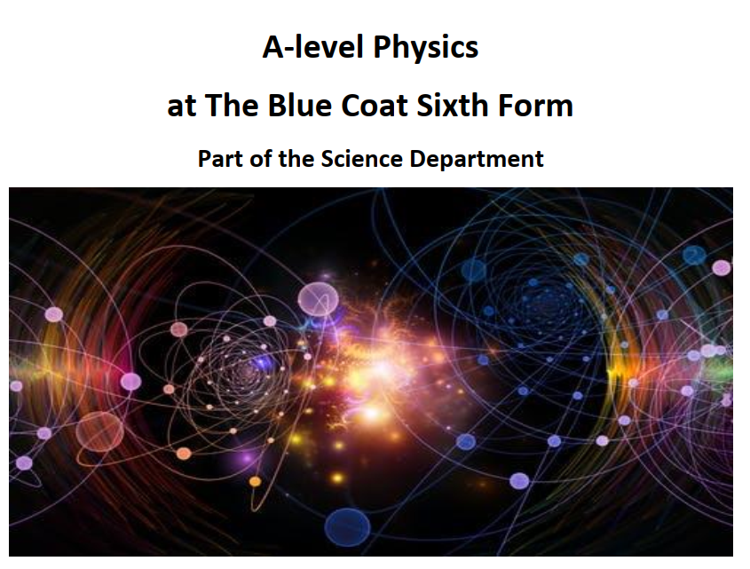
Welcome Back to the Physics Bridging Material. For part 3 we will be revising some vital skills from GCSE that you will be expected to demonstrate and improve on at the start of the A level course.
A lot of people have misconceptions about how to make progress at A-level, thinking that their notes have to be perfect first time, or that it is better to not write anything down until you know it is right. If you have found yourself falling into this habit in the past, please try and overcome that during this task. Whether you get questions right first time is not what matters – it is the work you do after getting things wrong.
As you are completing this assignment, please take your time. This is designed as a Summer Task, so you have six weeks over which to spread the work. If you struggle with any of the topics, leave it for a couple of days and then go back and do it again.
Self-mark honestly and make sure you correct anything you got wrong. Your work toward this part of the bridging material will be assessed in September. Please put your best into this and make a strong start to the A-level. We look forward to seeing you!

Part 1 Formula use
In GCSE Physics you need to learn all your equations. At A level you are given a data sheet you need to be able to use, that will include all GCSE equations and more that you will be introduced to over the next two years. For the first questions in this pack please select the correct equation before answering the questions. There are 4 marks per question: Formula, working, answer and unit, and should be clear in each box.
Equations for GCSE Physics
Word equation | Symbol equation
$$\text{Density = }\frac{\text{Mass}}{\text{Volume}}$$ | $$ρ = \frac{m}{V}$$
$$\text{Speed = }\frac{\text{Distance}}{\text{Time}}$$ | $$s = \frac{d}{t}$$
$$\text{Acceleration = }\frac{\text{Change in speed}}{\text{Time}}$$ | $$a = \frac{v-u}{t}$$
$$\text{Kinetic energy = }\frac{\text{1}}{\text{2}}\text{ × mass × }{\text{velocity}}^{\text{2}}$$ | $$E = \frac{1}{2}mv^{2}$$
$$\text{Force = mass × acceleration}$$ | $$F = ma$$
$$\text{Momentum = mass × velocity}$$ | $$p = mv$$
$$\text{Work done = force × distance (in direction of the force)}$$ | $$W = Fd$$
$$\text{Power = }\frac{\text{Work done}}{\text{Time}}$$ | $$P = \frac{W}{t}$$
$$\text{Force exerted by a spring = spring constant × extension}$$ | $$F = k∆l$$
$$\text{Weight = mass × gravitational field strength}$$ | $$W = mg$$
$$\text{GPE = mass × gravitational field strength × height}$$ | $$E = mgh$$
$$\text{Pressure = }\frac{\text{Force ⊥ to surface}}{\text{Area of surface}}$$ | $$P = \frac{F_{⊥}}{A}$$
$$\text{Moment = force × ⊥ distance between force and pivot }$$ | $$moment = Fd$$
$$\text{Current = }\frac{\text{Charge}}{\text{Time}}$$ | $$I = \frac{Q}{t}$$
$$\text{Potential difference = }\frac{\text{Energy transferred}}{\text{Charge}}$$ | $$V = \frac{E}{Q}$$
$$\text{Resistance = }\frac{\text{Potential difference}}{\text{Current}}$$ | $$R = \frac{V}{I}$$
$$\text{Power = Current × Voltage}$$ | $$P = IV$$
$$\text{Power = }{\text{Current }}^{\text{2}}\text{× Resistance}$$ | $$P = I^{2}R$$
$$\text{Wave speed = Frequency × Wavelength}$$ | $$c = fλ$$
$$\text{Efficiency = }\frac{\text{Useful energy output}}{\text{Total energy input}}$$ | $$Efficiency= \frac{Useful}{Total}$$
$$\text{Energy to change the temperature of a material =}$$  $$\text{mass × specific heat capacity × temperature change}$$ | $$E = mc∆T$$
$$\text{Energy to change the state of a substance =}$$  $$\text{mass × specific latent heat}$$ | $$E = mL$$
$$\text{Energy transferred in stretching =}$$  $$\frac{1}{2}×\text{spring constant ×}{\text{extension}}^{\text{2}}$$ | $$E = \frac{1}{2}kx^{2}$$
$${\text{Final velocity}}^{\text{2}}\text{-}{\text{initial velocity}}^{\text{2}}\text{ =}$$  $$\text{2 ×acceleration ×distance}$$ | $$v^{2}-u^{2}=2as$$
$$\text{Force on a current carrying conductor =}$$  $$\text{magnetic field strength × current × length}$$ | $$F = BIL$$
$$\text{p.d. across primary coil × current in primary coil =}$$  $$\text{p.d. across secondary coil × current in secondary coil}$$ | $$V_{p}×I_{P}= V_{S}×I_{S}$$

- A car has a mass of 1,000 kg and a velocity of 15 m/s. What is its momentum?
Formula needed | Numbers in the formula (working) | Answer | Units

- A cyclist peddles a bicycle with a force of 1,000 N moving it 250 m. How much work is done?
Formula needed | Numbers in the formula (working) | Answer | Units

- A singer sings a note with a frequency of 256 Hz. Calculate the wavelength of this note. The speed of sound in air is 330 m/s.
Formula needed | Numbers in the formula (working) | Answer | Units

- A train takes 100 seconds to travel 1,500 m. What is the speed of the train?
Formula needed | Numbers in the formula (working) | Answer | Units

- A current of 0.15 A flows through a lamp with a resistance of 40 Ω. Calculate the potential difference across it.
Formula needed | Numbers in the formula (working) | Answer | Units

- Calculate the density of a block of material with a mass of 160 g and a volume of 200 cm³.
Formula needed | Numbers in the formula (working) | Answer | Units

- Calculate the acceleration of a car if the resultant force from the engine is 400 N and the mass of the car is 800 kg.
Formula needed | Numbers in the formula (working) | Answer | Units

- A motorcycle has a speed of 15 m/s. Ten seconds later it is travelling at 35 m/s in the same direction. What is the car’s acceleration?
Formula needed | Numbers in the formula (working) | Answer | Units

- A 1 kW microwave oven works on a potential difference of 230 V. Calculate the current through it.
Formula needed | Numbers in the formula (working) | Answer | Units

- Calculate the kinetic energy of a tennis ball which has a mass of 0.050 kg and is moving at speed of 36 m/s.
Formula needed | Numbers in the formula (working) | Answer | Units

- A car travels at 25 m/s for 3 minutes. How far does it travel?
Formula needed | Numbers in the formula (working) | Answer | Units

- Calculate the spring constant of a spring that stretches 2 cm when a force of 10 N is applied.
Formula needed | Numbers in the formula (working) | Answer | Units

- On the Moon an astronaut has a weight of 120 N. Calculate the mass of the astronaut. (g = 1.6 N/kg)
Formula needed | Numbers in the formula (working) | Answer | Units

- Alice runs up a hill in 5 seconds with a power of 300 W. Calculate the work done in running up the hill.
Formula needed | Numbers in the formula (working) | Answer | Units

- Calculate the current through the air in a lightning strike if a charge of 300 C flows in 0.01 seconds.
Formula needed | Numbers in the formula (working) | Answer | Units

- Calculate the resistance of a wire that has a current of 18 mA through it when the potential difference across is it is 230 V.
Formula needed | Numbers in the formula (working) | Answer | Units
- A hospital defibrillator uses a potential difference of 500 V. It transfers 125 J of energy to restart a patient’s heart. Calculate the charge that flows.
Formula needed | Numbers in the formula (working) | Answer | Units

- Calculate the charge flowing in 2 minutes for a toy electric car that needs a current of 14 mA.
Formula needed | Numbers in the formula (working) | Answer | Units

- Air has a density of 0.012 kg/m³. Calculate the mass of air in a room with a volume of 300 m³.
Formula needed | Numbers in the formula (working) | Answer | Units

- A lorry has a mass of 8000 kg. Calculate the resultant force needed to produce an acceleration of 2 m/s².
Formula needed | Numbers in the formula (working) | Answer | Units

- Calculate the current flowing if a charge of 450 C is transferred in 10 minutes.
Formula needed | Numbers in the formula (working) | Answer | Units

- Calculate the energy needed to melt an ice cube with a mass of 25 g. The specific latent heat of fusion is 334 000 J/kg.
Formula needed | Numbers in the formula (working) | Answer | Units

- Calculate the force on a 0.10 m piece of wire in a field of 0.75 T that carries a current of 3.0 A.
Formula needed | Numbers in the formula (working) | Answer | Units

- Calculate the energy needed to increase the temperature of 300 g oil by 20 °C. The specific heat capacity of oil is 1500 J/kg °C.
Formula needed | Numbers in the formula (working) | Answer | Units

- The Sun emits ultraviolet waves with a wavelength of 320 nm (320 × 10⁻⁹ m). The speed of the waves is 3.0 × 10⁸ m/s. Calculate the frequency of ultraviolet waves.
Formula needed | Numbers in the formula (working) | Answer | Units

- Calculate the force needed to stretch a spring with a spring constant of 100N/m so that it extends by 0.02 m.
Formula needed | Numbers in the formula (working) | Answer | Units

- A car comes to a stop over a distance of 50 m. The work done to shift energy from the kinetic store is 1.2 × 10⁸ J. Calculate the braking force used to stop the car.
Formula needed | Numbers in the formula (working) | Answer | Units

- Calculate the current in a wire of length 20 cm in a flux density of 0.30 T when there is a force of 0.32 N.
Formula needed | Numbers in the formula (working) | Answer | Units

- A small motor that turns in a DVD player has a resistance of 50 Ω and a power of 5 W. Calculate the current.
Formula needed | Numbers in the formula (working) | Answer | Units
- It takes 80 kJ to raise the temperature of 500 g of a liquid by 50 °C. Calculate the specific heat capacity of the liquid.
Formula needed | Numbers in the formula (working) | Answer | Units

Part 2 Standard form
You need to be familiar with standard form and use standard form in your exam answers.
Convert the following numbers into standard form:
1 | 4000
2 | 600
3 | 200
4 | 7
5 | 90000000
6 | 0.5
7 | 0.0008
8 | 440
9 | 0.0013
10 | 7770000

Convert the following numbers out of standard form
11 | 6 x 10³
12 | 2 x 10²
13 | 8 x 10¹
14 | 7 x 10⁰
15 | 9 x 10⁴
16 | 6 x 10⁻¹
17 | 7 x 10⁻⁴
18 | 5.4x 10²
19 | 6.3x 10⁻³
20 | 8.8x 10⁵

- What is 1x10² x 1x10⁴ ?
- What is 1x10⁵ x 1x10³ ?
- What is 1x10⁵ x 1x10⁻³ ?
- What is 1x10⁵ / 1x10³ ?
- What is 1x10² / 1x10⁴ ?

Part 3 Significant figures
A lot of A level marks and lost and gained through the proper use of significant figures, we will practise this throughout the course but If you have a good understanding to begin with it will really help you throughout the 2 years.
 | Number | Number to 3 significant figures | Put the number into standard form
1 | 7317873998
2 | 24005
3 | 0.0000035567
4 | 2/6
5 | 542/3.4

What is the number of significant figures for the following numbers?
 | Number | Number of significant figures
1 | 32
2 | 4
3 | 5.55
4 | 667.5
5 | 4203
6 | 101
7 | 50.998408
8 | 0.345
9 | 0.033
10 | 0.000404
11 | 200
12 | 200.0
13 | 200.00
14 | 200.02
15 | 202.0

Part 4 Changing the subject
Change the subject to b in each of these made up equations:
- a=bc
- e=b/f
- g=h/b
- i=jkb
- m=bn/p
- q=rs/b
- u=vb²

Change the subject in these real equations:
- F=ma, find a
- I=V/R, find V
- a=Δv/t, find t
- E=mcΔT, find c
- E=½mv², find m
- E=½mv², find v

Part 5 units
We will use many different units, it is important to convert between different units, do these questions with familiar units to help you progress with more difficult ones in the future:
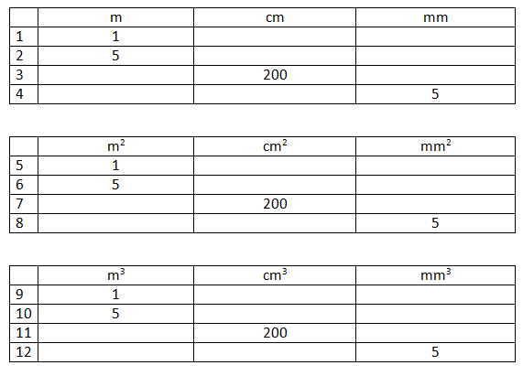
Convert between meters centimetres and millimetres:
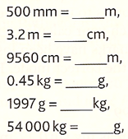

Combination questions:
Write the following values in standard form to 2 significant figures:
- 151 million km in meters

- 365 days in seconds

- The acceleration of a cart if the force is 5555N and the mass is 13.7kg

- 13.7cm² in mm²

- 150m in millimetres

Viewing List:
To get a head start on the new particle physics and quantum phenomena topics while revising Key GCSE content watch this documentary:
Atom: Clash of Titans (Jim Al-Khalili) | Science Documentary | Reel Truth Science - YouTube

Part 1 Answers
- An car has a mass of 1,000 kg and a velocity of 15 m/s. What is its momentum?
Formula needed  $$p=m×v$$ | Numbers in the formula (working)  $$p=1000×15$$ | Answer  $$15 000$$ | Units  $$kg m/s$$

- A cyclist peddles a bicycle with a force of 1,000 N moving it 250 m. How much work is done?
Formula needed  $$W=F×d$$ | Numbers in the formula (working)  $$W=1000×250$$ | Answer  $$250 000$$ | Units  $$J$$

- A singer sings a note with a frequency of 256 Hz. Calculate the wavelength of this note. The speed of sound in air is 330 m/s.
Formula needed  $$λ=\frac{v}{f}$$ | Numbers in the formula (working)  $$λ=\frac{330}{256}$$ | Answer  $$1.29$$ | Units  $$m$$

- A train takes 100 seconds to travel 1,500 m. What is the speed of the train?
Formula needed  $$s=\frac{d}{t}$$ | Numbers in the formula (working)  $$s=\frac{1500}{100}$$ | Answer  $$15$$ | Units  $$m/s$$

- A current of 0.15 A flows through a lamp with a resistance of 40 Ω. Calculate the potential difference across it.
Formula needed  $$V=I×R$$ | Numbers in the formula (working)  $$V=0.15×40$$ | Answer  $$6.0$$ | Units  $$V$$

- Calculate the density of a block of material with a mass of 160 g and a volume of 200 cm³.
Formula needed  $$ρ=\frac{m}{V}$$ | Numbers in the formula (working)  $$ρ=\frac{160}{200}$$ | Answer  $$0.8$$ | Units  $$g/{cm}^{3}$$

- Calculate the acceleration of a car if the resultant force from the engine is 400 N and the mass of the car is 800 kg.
Formula needed  $$a=\frac{F}{m}$$ | Numbers in the formula (working)  $$a=\frac{400}{800}$$ | Answer  $$0.5$$ | Units  $$m/s^{2}$$

- A motorcycle has a speed of 15 m/s. Ten seconds later it is travelling at 35 m/s in the same direction. What is the car’s acceleration?
Formula needed  $$a=\frac{v-u}{t}$$ | Numbers in the formula (working)  $$a=\frac{35-15}{10}$$ | Answer  $$2.0$$ | Units  $$m/s^{2}$$

- A 1 kW microwave oven works on a potential difference of 230 V. Calculate the current through it.
Formula needed  $$I=\frac{P}{V}$$ | Numbers in the formula (working)  $$I=\frac{1000}{230}$$ | Answer  $$4.3$$ | Units  $$A$$

- Calculate the kinetic energy of a tennis ball which has a mass of 0.050 kg and is moving at speed of 36 m/s.
Formula needed  $$E=\frac{1}{2}mv^{2}$$ | Numbers in the formula (working)  $$E=0.5×0.05 ×{36}^{2}$$ | Answer  $$32$$ | Units  $$J$$

- A car travels at 25 m/s for 3 minutes. How far does it travel?
Formula needed  $$d=s×t$$ | Numbers in the formula (working)  $$d=25×180$$ | Answer  $$4500$$ | Units  $$m$$

- Calculate the spring constant of a spring that stretches 2 cm when a force of 10 N is applied.
Formula needed  $$k=\frac{F}{x}$$ | Numbers in the formula (working)  $$k=\frac{10}{2}$$ | Answer  $$5$$ | Units  $$N/cm$$

- On the Moon an astronaut has a weight of 120 N. Calculate the mass of the astronaut. (g = 1.6 N/kg)
Formula needed  $$m=\frac{W}{g}$$ | Numbers in the formula (working)  $$W=\frac{120}{1.6}$$ | Answer  $$75$$ | Units  $$kg$$

- Alice runs up a hill in 5 seconds with a power of 300 W. Calculate the work done in running up the hill.
Formula needed  $$W=P×t$$ | Numbers in the formula (working)  $$W=300×5$$ | Answer  $$1500$$ | Units  $$J$$

- Calculate the current through the air in a lightning strike if a charge of 300 C flows in 0.01 seconds.
Formula needed  $$I=\frac{Q}{t}$$ | Numbers in the formula (working)  $$I=\frac{300}{0.01}$$ | Answer  $$30 000$$ | Units  $$A$$

- Calculate the resistance of a wire that has a current of 18 mA through it when the potential difference across is it is 230 V.
Formula needed  $$R=\frac{V}{I}$$ | Numbers in the formula (working)  $$R=\frac{230}{0.018}$$ | Answer  $$13 000$$ | Units  $$Ω$$
- A hospital defibrillator uses a potential difference of 500 V. It transfers 125 J of energy to restart a patient’s heart. Calculate the charge that flows.
Formula needed  $$Q=\frac{E}{V}$$ | Numbers in the formula (working)  $$R=\frac{125}{500}$$ | Answer  $$0.25$$ | Units  $$C$$

- Calculate the charge flowing in 2 minutes for a toy electric car that needs a current of 14 mA.
Formula needed  $$Q=I×t$$ | Numbers in the formula (working)  $$Q=0.014×120$$ | Answer  $$1.68$$ | Units  $$C$$

- Air has a density of 0.012 kg/m³. Calculate the mass of air in a room with a volume of 300 m³.
Formula needed  $$m=ρ×V$$ | Numbers in the formula (working)  $$m=0.012×300$$ | Answer  $$3.6$$ | Units  $$kg$$

- A lorry has a mass of 8000 kg. Calculate the resultant force needed to produce an acceleration of 2 m/s².
Formula needed  $$F=m×a$$ | Numbers in the formula (working)  $$F=8000×2$$ | Answer  $$16 000$$ | Units  $$N$$

- Calculate the current flowing if a charge of 450 C is transferred in 10 minutes.
Formula needed  $$I=\frac{Q}{t}$$ | Numbers in the formula (working)  $$R=\frac{450}{600}$$ | Answer  $$0.75$$ | Units  $$A$$

- Calculate the energy needed to melt an ice cube with a mass of 25 g. The specific latent heat of fusion is 334 000 J/kg.
Formula needed  $$E=m×L$$ | Numbers in the formula (working)  $$E=0.025×334 000$$ | Answer  $$8400$$ | Units  $$J$$

- Calculate the force on a 0.10 m piece of wire in a field of 0.75 T that carries a current of 3.0 A.
Formula needed  $$F=B×I×L$$ | Numbers in the formula (working)  $$F=0.75×3×0.1$$ | Answer  $$0.23$$ | Units  $$N$$

- Calculate the energy needed to increase the temperature of 300 g oil by 20 °C. The specific heat capacity of oil is 1500 J/kg °C.
Formula needed  $$E=m×c×∆T$$ | Numbers in the formula (working)  $$E=0.3×1500×20$$ | Answer  $$9000$$ | Units  $$J$$

- The Sun emits ultraviolet waves with a wavelength of 320 nm (320 × 10⁻⁹ m). The speed of the waves is 3.0 × 10⁸ m/s. Calculate the frequency of ultraviolet waves.
Formula needed  $$f=\frac{v}{λ}$$ | Numbers in the formula (working)  $$λ=\frac{3.0×{10}^{8}}{320×{10}^{-9}}$$ | Answer  $$9.4×{10}^{14}$$ | Units  $$Hz$$

- Calculate the force needed to stretch a spring with a spring constant of 100 N/m so that it extends by 0.02 m.
Formula needed  $$F=k×x$$ | Numbers in the formula (working)  $$F=100×0.02$$ | Answer  $$2$$ | Units  $$N$$

- A car comes to a stop over a distance of 50 m. The work done to shift energy from the kinetic store is 1.2 × 10⁶ J. Calculate the braking force used to stop the car.
Formula needed  $$F=\frac{W}{d}$$ | Numbers in the formula (working)  $$F=\frac{1200000}{50}$$ | Answer  $$24 000$$ | Units  $$N$$

- Calculate the current in a wire of length 20 cm in a flux density of 0.30 T when there is a force of 0.32 N.
Formula needed  $$I=\frac{F}{B×L}$$ | Numbers in the formula (working)  $$I=\frac{0.32}{0.30×0.2}$$ | Answer  $$5.3$$ | Units  $$A$$

- A small motor that turns in a DVD player has a resistance of 50 Ω and a power of 5 W. Calculate the current.
Formula needed  $$I=\sqrt{\frac{P}{R}}$$ | Numbers in the formula (working)  $$I=\sqrt{\frac{5}{50}}$$ | Answer  $$0.32$$ | Units  $$A$$

- It takes 80 kJ to raise the temperature of 500 g of a liquid by 50 °C. Calculate the specific heat capacity of the liquid.
Formula needed  $$c=\frac{E}{m×∆T}$$ | Numbers in the formula (working)  $$λ=\frac{80 000}{0.5×50}$$ | Answer  $$3200$$ | Units  $$J/kg℃$$

Part 2 Standard form Answers
1 | 4000 | 4 x 10³
2 | 600 | 6 x 10²
3 | 200 | 2 x 10²
4 | 7 | 2 x 10⁰
5 | 90000000 | 9 x 10⁷
6 | 0.5 | 5 x 10⁻¹
7 | 0.0008 | 8 x 10⁻⁴
8 | 440 | 4.4x 10²
9 | 0.0013 | 1.3x 10⁻³
10 | 7770000 | 7.77x 10⁶

Convert the following numbers out of standard form
11 | 6 x 10³ | 6000
12 | 2 x 10² | 200
13 | 8 x 10¹ | 80
14 | 7 x 10⁰ | 7
15 | 9 x 10⁴ | 90000
16 | 6 x 10⁻¹ | 0.6
17 | 7 x 10⁻⁴ | 0.0007
18 | 5.4x 10² | 540
19 | 6.3x 10⁻³ | 0.0063
20 | 8.8x 10⁵ | 880000

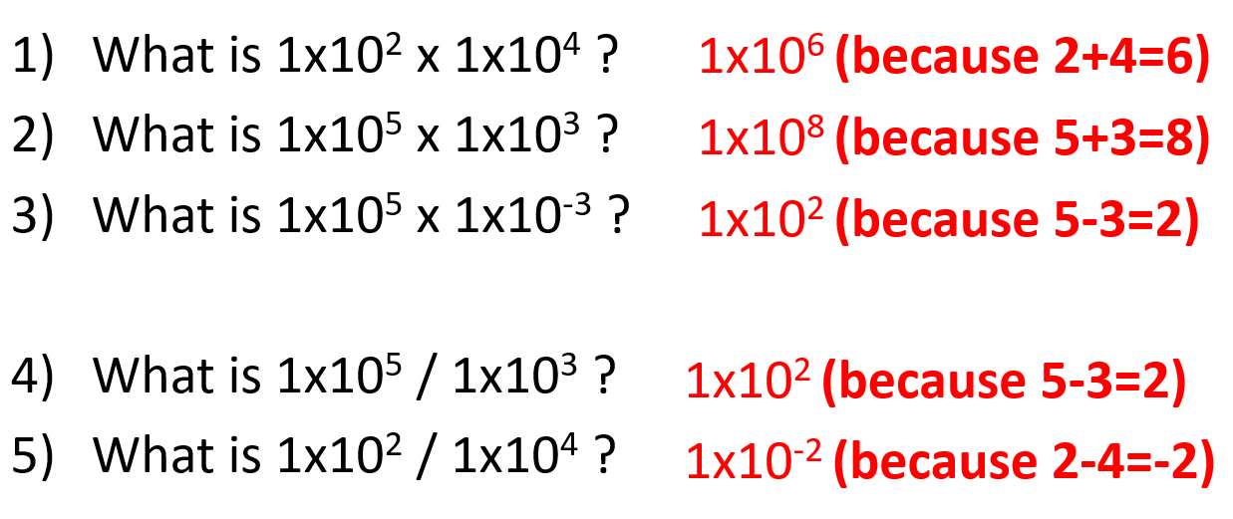

Part 3 Significant figures Answers

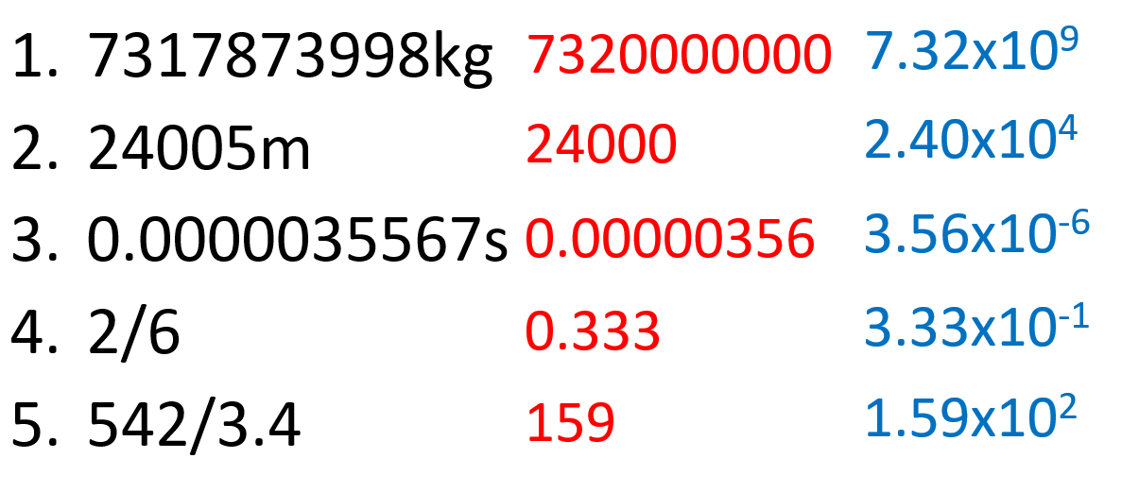
 | Number | Number of significant figures
1 | 32 | 2
2 | 4 | 1
3 | 5.55 | 3
4 | 667.5 | 4
5 | 4203 | 4
6 | 101 | 3
7 | 50.998408 | 8
8 | 0.345 | 3
9 | 0.033 | 2
10 | 0.000404 | 3
11 | 200 | 1
12 | 200.0 | 3
13 | 200.00 | 3
14 | 200.02 | 5
15 | 202.0 | 3

Part 4 Changing the subject Answers

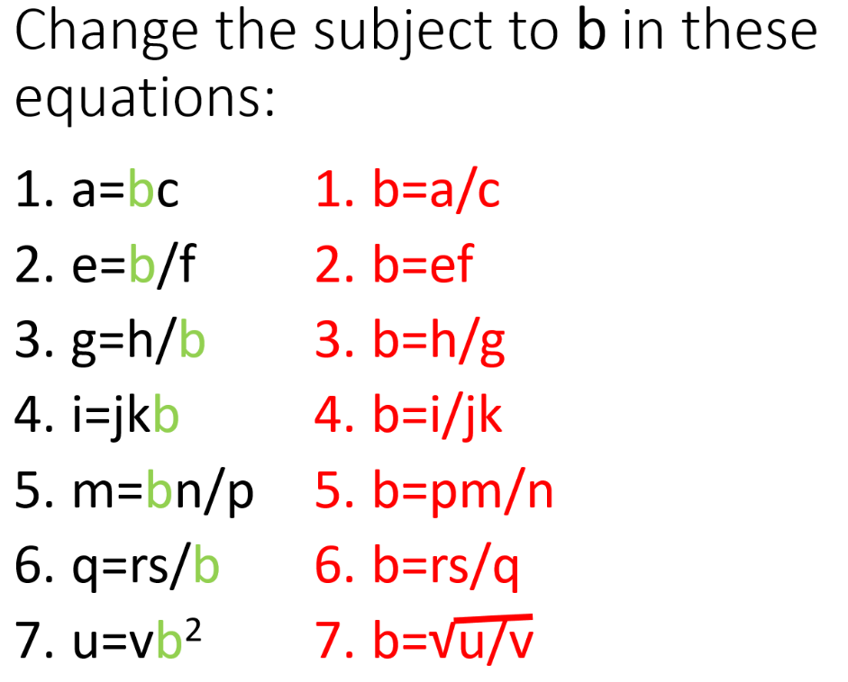

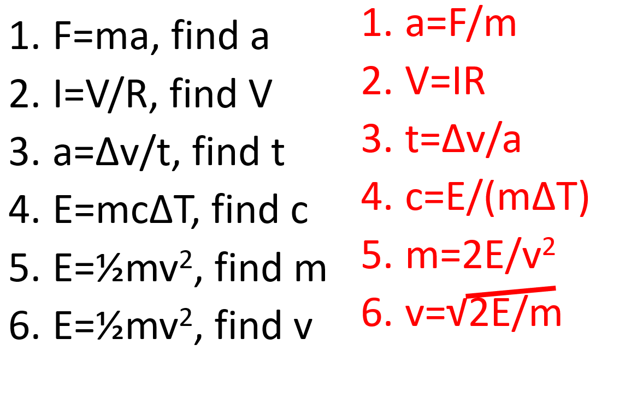

Part 5 Units Answers

 | m | cm | mm
1 | 1 | 100 | 1000
2 | 5 | 500 | 5000
3 | 2 | 200 | 2000
4 | 5x10⁻³ | 0.5 | 5
 | m² | cm² | mm²
5 | 1 | 1x10⁴ | 1x10⁶
6 | 5 | 5x10⁴ | 5x10⁶
7 | 2x10⁻² | 200 | 2x10⁴
8 | 5x10⁻⁶ | 5x10⁻² | 5
 | m³ | cm³ | mm³
9 | 1 | 1x10⁶ | 1x10⁹
10 | 5 | 5x10⁶ | 5x10⁹
11 | 2x10⁻⁴ | 200 | 2x10⁵
12 | 5x10⁻⁹ | 5x10⁻³ | 5

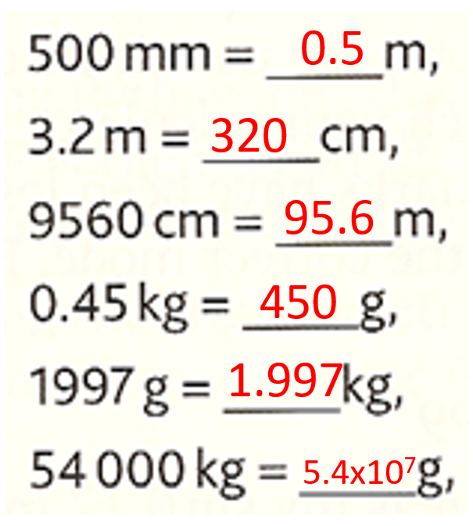
Combination questions Answers:
Write the following values in standard form to 2 significant figures:
1. 151 million km in meters
1.5x10¹¹m
2. 365 days in seconds
3.2x10⁷s
3. The acceleration of a cart if the force is 5555N and the mass is 13.7kg
4.1 x10² m/s²
4. 13.7cm² in mm²
1.4x10³ mm²
5. 150m in millimetres
1.5x10⁵mm

