A-level Sociology
at The Blue Coat Sixth Form
Part of the Social Sciences Department

Part 3
Welcome Sociologists! This is Part 3 of the Bridging course aimed to assess your readiness for your level Sociology course in September.
Last time, we looked at the sociology of the family and of education; two of the key areas studied on your course. In part 3, we are going to focus on some of the key social groups in society and look at how those variables can impact a person’s life chances.

Section A- Social Variables

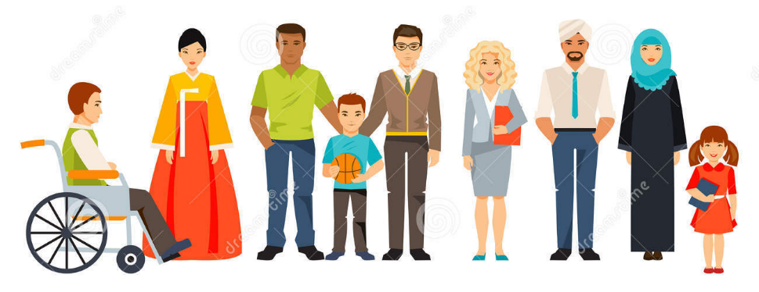
In sociology, students need to understand the following two core themes:
- socialisation, culture and identity
- social differentiation, power and stratification.

The themes apply to all areas of Sociology, like family and education which you were introduced to in part 2. To understand society and the way individuals behave within it, it is important to understand the threads that run through many areas of social life.

Task 1: Social variables can be remembered using the acronym DR CAGES. Find the definitions for each of the categories.

- Disability

- Region

- Class (Socio-economic)

- Age

- Gender

- Ethnicity

- Sexuality
Task 2: How might your life be different if you belonged to different social groups? Think about the power/ wealth/ status/ opportunities that may be affected by being in a different social group.

Class: Think about the class you are currently in. If you were brought up in a different category (rich/poor, educated/uneducated, high-paying employment/low-skilled job), how might your life be different now?
_____________________________________________________________________________________________________________________________________________________________________________________________________________________________________________________________________________________________________________________________________________________________________________________________________________________________________________________________________________________________________________________________________________________________________________________________________________________________________________________________________________________________________________________

Age: You are currently 15 or 16 years old. How might your status or life chances (opportunities) be different if you were in your 20s? What about in your 40s? What about in your 80s?
_____________________________________________________________________________________________________________________________________________________________________________________________________________________________________________________________________________________________________________________________________________________________________________________________________________________________________________________________________________________________________________________________________________________________________________________________________________________________________________________________________________________________________________________

Gender: Imagine you were born as a different gender to the one you currently identify with. How might your life have been different? What differences might you have experienced in terms of the opportunities open to you and the status you would have in society? Within your family?
_____________________________________________________________________________________________________________________________________________________________________________________________________________________________________________________________________________________________________________________________________________________________________________________________________________________________________________________________________________________________________________________________________________________________________________________________________________________________________________________________________________________________________________________

Ethnicity: Imagine you were born within a different ethnic group. Perhaps you are now part of an ethnic majority/minority. If that were different, might your experiences be different? Would your power/ status/ opportunities be different?
_____________________________________________________________________________________________________________________________________________________________________________________________________________________________________________________________________________________________________________________________________________________________________________________________________________________________________________________________________________________________________________________________________________________________________________________________________________________________________________________________________________________________________________________

Section B- Focus on ethnicity
Task 3: Research the ethnic profile of the UK. Using the government’s official statistics from the 2011 Census, note down 10 key facts about the national picture of ethnicity and the demographics of different ethnicities within the UK.
https://www.ethnicity-facts-figures.service.gov.uk/uk-population-by-ethnicity

Task 4: Racism and racial inequality in the UK
Racial inequality in Britain is "entrenched and far-reaching," according to a report published by the Equality and Human Rights Commission, which says that the life chances of young ethnic minority people in the UK have become much worse over the past five years.
The EHRC report, the biggest review of race equality in the UK, found black and ethnic minorities are: more likely to be unemployed; more likely to live in poverty; less likely to go to a good university and get a good degree; less likely to work in senior positions; and more likely to be a victim of hate crime.
What is meant by the term Institutional racism?

Use the links below, as well as your own research skills to investigate institutional racism in the UK.
https://www.theweek.co.uk/105815/what-is-institutional-racism
https://metro.co.uk/2020/03/05/institutional-racism-harmful-12176557/
https://www.theguardian.com/education/2020/jun/09/new-uk-teachers-union-chief-institutional-racism-in-schools-patrick-roach
https://www.theguardian.com/us-news/2020/jun/12/black-lives-matter-historic-moment-protesters-on-why-they-have-been-demonstrating
https://www.independent.co.uk/arts-entertainment/tv/news/george-the-poet-newsnight-emily-maitlis-black-lives-matter-george-floyd-a9544776.html
https://www.independent.co.uk/news/uk/home-news/protest-london-uk-black-lives-matter-demonstrations-uk-george-floyd-coronavirus-a9552211.html

Optional Tasks: Research the following issues.

Black Lives Matter movement
*Please be aware that some of the footage you may see when researching BLM is upsetting and disturbing.
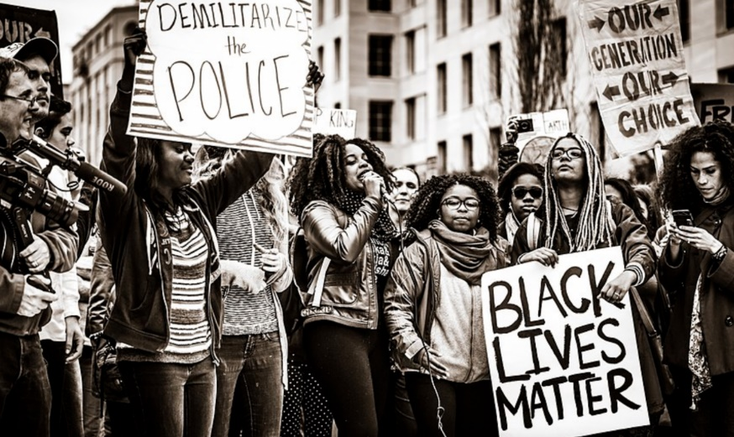
- What is the Black Lives matter movement?
- When did it start?
- What are it’s aims?
- What sparked the most recent protests by the movement in the US and the UK?
- What is meant by defund the police?
- Why was Edward Colston’s statue thrown into Bristol harbor?

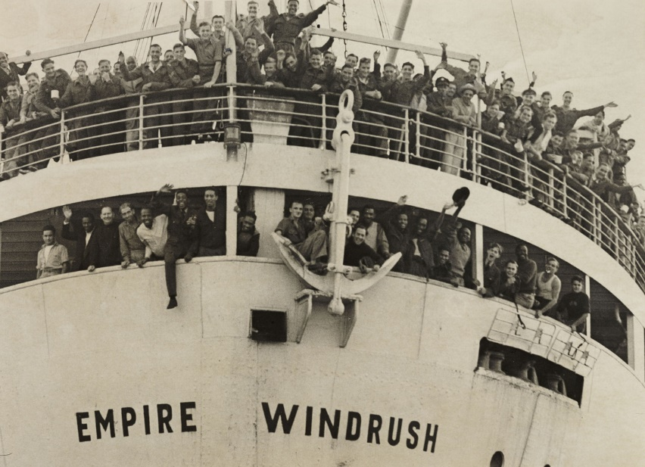
The Windrush scandal
- Who are the ‘Windrush generation’?
- What was the ‘scandal’ that happened in 2018?
- What problems and difficulties have the Windrush generation encountered whilst living in the UK?
- What does the treatment of the Windrush generation indicate about the UK’s attitude towards migration and ethnic minorities?

Section C- Assessment
Using some of the key themes and vocabulary that you have learned over part 1-3 of the pre-course material, answer the question below.
Success Criteria:
- Your essay should include and introduction, structured paragraphs and a conclusion.
- You should use some key vocabulary.
- You should aim to write a minimum of two sides of A4.
- Your essay will be marked as fail/pass/merit/distinction.

Evaluate the extent to which institutional racism is still a feature of life in Britain today.
________________________________________________________________________________________________________________________________________________________________________________________________________________________________________________________________________________________________________________________________________________________________________________________________________________________________________________________________________________________________________________________________________________________________________________________________________________________________________________________________________________________________________________________________________________________________________________________________________________________________________________________________________________________________________________________________________________________________________________________________________________________________________________________________________________________________________________________________________________________________________________________________________________________________________________________________________________________________________________________________________________________________________________________________________________________________________________________________________________________________________________________________________________________________________________________________________________________________________________________________________________________________________________________________________________________________________________________________________________________________________________________________________________________________________________________________________________________________________________________________________________________________________________________________________________________________________________________________________________________________________________________________________________________________________________________________________________________________________________________________________________________________________________________________________________________________________________________________________________________________________________________________________________________________________________________________________________________________________________________________________________________________________________________________________________________________________________________________________________________________________________________________________________________________________________________________________________________________________________________________________________________________________________________________________________________________________________________________________________________________________________________________________________________________________________________________________________________________________________________________________________________________________________________________________________________________________________________________________________________________________________________________________________________________________________________________________________________________________________________________________________________________________________________________________________________________________________________________________________________________________________________________________________________________________________________________________________________________________________________________________________________________________________________________________________________________________________________________________________________________________________________________________________________________________________________________________________________________________________________________________________________________________________________________________________________________________________________________________________________________________________________________________________________________________________________________________________________________________________________________________________________________________________________________________________________________________________________________________________________________________________________________________________________________________________________________________________________________________________________________________________________________________________________________________________________________________________________________________________________________________________________________________________________________________________________________________________________________________________________________________________________________________________________________________________________________________________________________________________________________________________________________________________________________________________________________________________________________________________________________________________________________________________________________________________________________________________________________________________________________________________________________________________________________________________________________________________________________________________________________________________________________________________________________________________________________________________________________________________________________________________________________________________________________________________________________________________________________________________________________________________________________________________________________________________________________________________________________________________________________________________________________

