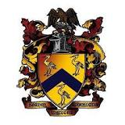

Religious Studies:
Christianity

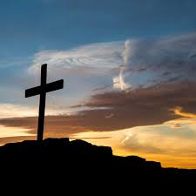

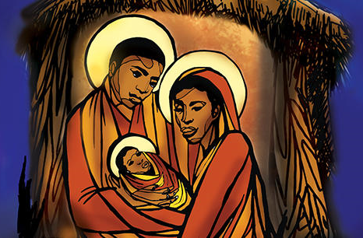
Year 12-13 2020
Summer work
Topics included:
- Baptism
- Easter
- Christmas

Read through this booklet and complete the sheets that can be found at the end of each section. You will need to highlight and annotate as you go through. There is a space at the end of the booklet for you to write down any questions that you have about the content. We will discuss this further in Y13. The final task is to write two part a) essays from the choice of three at the end of this booklet. Have a lovely summer.
BAPTISM
The case for infant baptism: Introduction
- Most Christian religions consider baptism to be one of their main customs. Augustine believed that it was necessary in order to take away the result of the original sin.
- In the Council of Carthage (418 CE) said, ‘even babies, who are yet unable to commit any sin personally, are truly baptised for the forgiveness of sins, for the purpose of cleansing by rebirth what they have received by birth.’

New Testament support
- Luke 18:15 says ‘People were bringing even infants to him that he might touch them;…Jesus called for them and said, “ let the little children come to me, and do not stop them; for it is to such as these that the kingdom of God belongs”.’ Nowadays this means bringing children to Jesus through baptism as baptism is the only way to bring people together with Jesus.
- We can see in Matthew 28:19, Jesus tells his disciples to, ‘and make disciples of all nations, baptising them in the name of the Father and of the Son and of the Holy Spirit’
- In Acts 2:38-39, Peter said to them, ‘Repent, and be baptised every one of you in the name of Jesus Christ so that your sins will be forgiven; and you will receive the gift of the Holy Spirit. For the promise is for you, for your children.’
- In Corinthians, Paul writes that a believing parent will make the children holy.
- It was practised by the early church consistently. It was promoted by all of the early church fathers; Irenaeus, Hippolytus, Origen, Cyprian, Gregory of Nazianzus, John Chrysostom and Augustine.

Augustine’s View
- Augustine wrote a lot about Baptism, he was a big fan. He believed that it was passed down by apostolic authority, which means it was passed down by the apostles and so it is an important rite for all Christians.
- Because the infants are not yet able to imitate Christ’s good acts, they need to be ‘ingrafted’ into his body. Augustine said that Jesus uses the holy spirit to guide hid followers, ‘which he secretly infuses even into infants’.
- The fact that infants cannot profess their will to be baptised or their faith does not matter to Augustine…
- ‘When children are presented to be given spiritual grace, it is not so much those holding them in their arms who present them… as the whole company of saints and faithful Christians… it is done by the whole of the Mother Church.’
- They do not believe on their own but ‘through the Church’s faith communicated to them.’
- Baptism is a sacrament. This means that it is a religious rite that imparts God’s spiritual grace.
- Augustine discussed the North Africans and the way that they viewed the sacraments. They called the sacrament of baptism, ‘salvation’ and the sacrament of the Eucharist, ‘life’. Without participating in the sacrament of ‘life’ and ‘salvation’ we cannot expect to make it to the kingdom of God (heaven).
- ‘the sacrament of baptism is most assuredly the sacrament of regeneration’.
- His ideas were constantly reaffirmed (agreed with) throughout the middle ages. There was no controversy about it.
Zwingli’s view
- Huldrych Zwingli (1484-1531) was the leader of the Protestant Reformation in Switzerland. The only way in which he differed to Augustine is that he did not believe that it was a way of achieving regeneration but actually the sign and seal of regeneration.
- Zwingli did not believe that baptism could remove someone’s sins. He believed instead that the sin is removed by the faith in Christ and the baptism is a way of demonstrating this faith and sealing their salvation. He makes it very clear that the baptism is the demonstration of salvation not the cause of it.
- In infant baptism, the divine promise is guaranteed to young children, on the basis that their parents pledge to bring them up in the Christian faith.
- The sacrament is one that comes from the divine and sent for humanity to use. It is an effective aid to spiritual belief. He believes that it is a sign of belonging to the new covenant, just as circumcision was a sign of belonging to the Old Covenant.
- Infant baptism is done by aspersion. This is the sprinkling of water over the infants head.
- ‘In this matter of baptism… I can conclude that all the doctors have been in error from the time of the apostles… All the doctors have ascribed to the water a power it does not have and the holy apostles did not teach.’ What he is saying here is that the water is not a magical water from God that takes sins away, it is a symbol of the faith that the believer or the infant’s parents have in God.

The Case for Believers Baptism
- Believers baptism is the immersion of the person in water, the water covers the candidate’s whole body.
- No Christian objections to the practice of infant baptism were ever voiced until the reformation. At this point a diverse group of radical reformers began baptising adults who had made a profession of their faith.
- The Catholics and protestants at the time both hated this practice and called those who did it Anabaptists which meant re-baptisers.
- The Anabaptists hated the name because they believed that they were not re-baptising, they believe that infant baptism is not real baptism and so it is not a second one. Infant baptism is null and void.

New Testament support:
- There is New Testament support for believers baptism. The NT does not have a record of infants baptised. The NT tells us that only people who are old enough to decide can actually get baptised.
- We can see this in Acts 8:12, the Samaritans are baptised after they believe the good news preached by Paul.
- The Ethiopian eunuch is baptised in 8:35-36.
- Acts 9:18 is where we see the Apostle St Paul getting baptised after he sees a vision on Jesus on the road to Damascus.
- In Acts 16:14-15 Lydia and her household are baptised after she believes.
- John the Baptists disciples were baptised after they accepted Paul’s teachings about Jesus. (Acts 19:5-6)
- Many of the early Christians would have taken this step of Baptism when they accepted the words and way of Jesus Christ. It was a step after accepting Jesus, not something done to an infant.
- The Anabaptist process involved people baptising those who had been baptised as infants. This second baptism was denounced by the Council of Trent in 1547.
- Hubmaier said, ‘I teach, and say that infant baptism is a robbery of the right baptism of Christ.’

Karl Barth
- He thought that belivers baptism was a good thing and gave many lectures saying this. He compiled all of his thoughts on this in his book, The teaching of the Church regarding Baptism (1948).
- He doesn’t believe that baptism brings salvation but instead he sees it as a symbolic representation of the renewal of Christ.
- Barth makes and argument that we can summarise in 6 parts:
1. Baptism with water is the first step in a way to life of Christ.
2. God’s grace coverts individuals, they respond to the HS
3. It is not a sacrament. It is a human action that acknowledges the one true sacrament, ‘the sacrament of the history of Jesus Christ’.
4. It seals (proves) God’s grace but does not make it a reality. Baptism does not make God’s grace, it just acknowledges it.
5. It must be a free act. An adult must make the decision.
6. Infant baptism is wrong because it is coercive (it is forced). Barth said, ‘it is not done in obedience, it is not administered according to proper order, and therefore it is necessarily clouded baptism.’
Controversy
- Barth knew that his theory was going to cause a controversy. He even wrote at the start of one of his books, ‘this book, which will be my last publication, will leave me in … theological and ecclesiastical isolation… I am thus to make a poor exit with it.’
- Some agreed with him such as Jurgen Moltmann but others did not agree such as T.P Forsyth. He said that both types of baptism are equally valid.
- Oscar Cullman (Baptism in the NT, 1950) said that baptism is not dependent on the persons faith. It is a symbol of the death of sin and a new life with the HS.
- Peter Bruner (Worship in the Name of Jesus, 1968) insisted that in baptism Christ unites people in his body. It can be either through infant or believers baptism.
- Others have said that in baptism we receive what Christ has already done for us, unconditioned by anything in us.
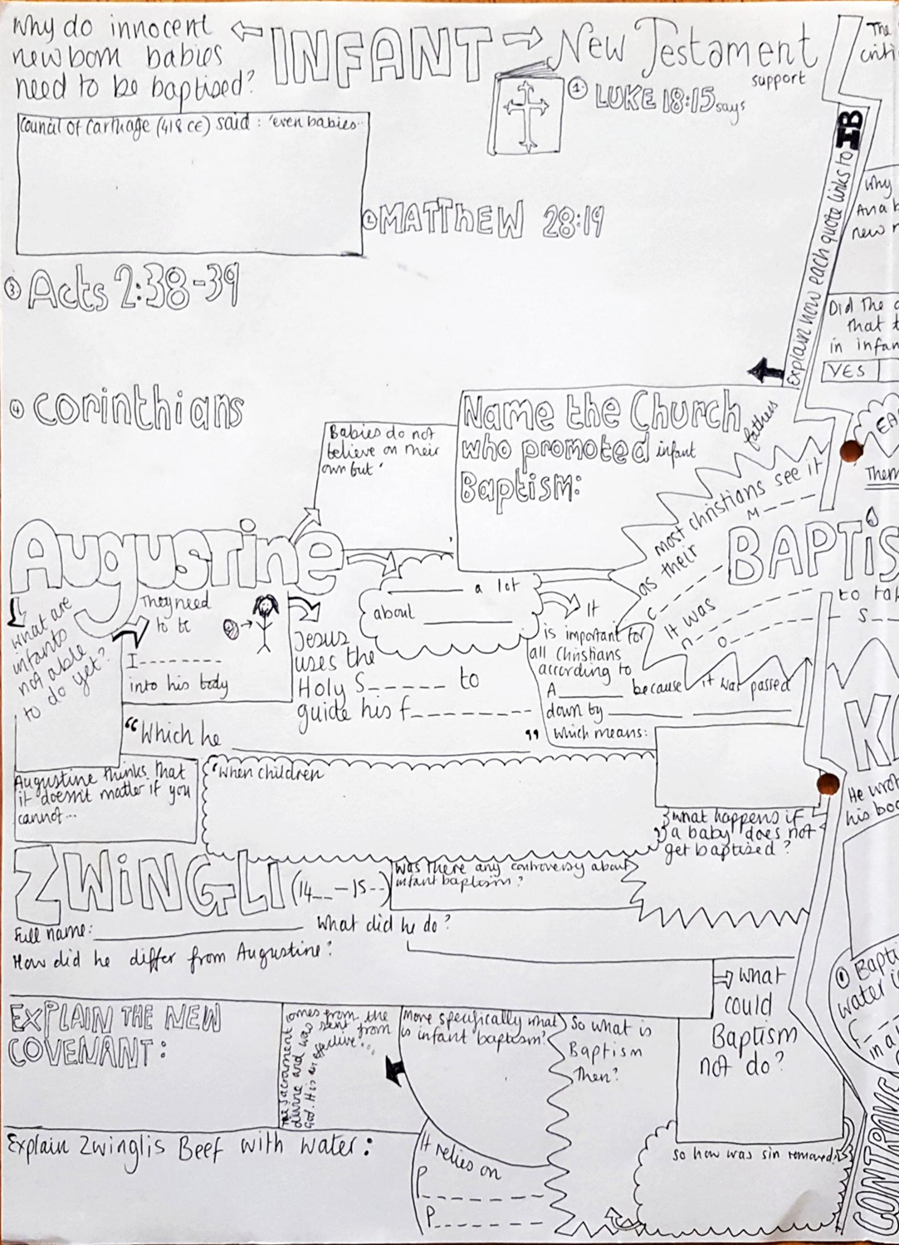
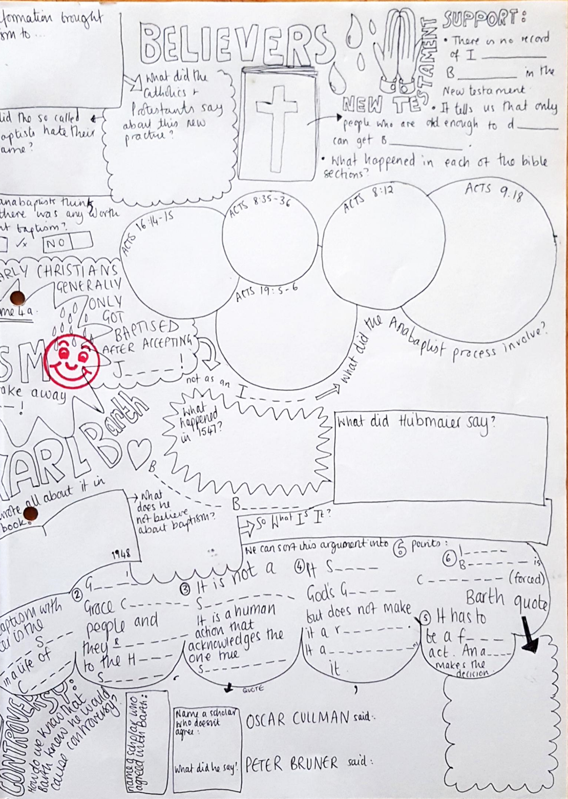
Christmas
- Comes from the words ‘Christ’s Mass’ and is a celebration of Jesus’ birth.
- No-one knows the exact date of Jesus’ birth. In the western church it is set as December 25th. Some say that this date was picked because it coincided with an existing pagan holiday. It was easy to slot this into a holiday (Saturnalia- Roman winter celebration) that was already celebrated.
- The pagan celebration was the winter solstice that ran from 17th-23rd of December.
- Some of the symbols that were celebrated by the Pagans are still used by Christianity today. Candle lighting represents the light to come and the cutting of pine trees for decoration is a triumph over death and darkness.
Advent in the Western Church
- Before Christmas Christians celebrate Advent. This is the four weeks prior to Christmas. It comes from the latin adventus which means coming.
- It is the beginning of the western churches year and celebrates Jesus coming in two ways. His birth and his return at the end of time (Parousia).
- During Advent the priest’s clothing and the wall hangings are purple. But now some are using blue (hope), on the third Sunday the colour may change to rose (rejoice) and this third Sunday celebration is called GAUDETE SUNDAY.
- Wreath: There is often a special wreath that has four external candles and one central one, kept at church. These four candles are purple and one rose, representing the four Sundays; Hope, Prophets, Gaudete Sunday & Joy, Angle candle- annunciation. The central one is Jesus and it lit at the Christmas eve service.
- Calendar: many celebrate with an Advent calendar. This may contain hidden prayers or poems or even chocolate gifts.
- Decorations: Decorations are often put up during advent, in people’s houses and outside.
- Fasting: There was an old tradition of fasting during this month but western churches do not do this anymore. It is a time of penitence (thinking about the sins you have done) for some though.
- Hymns: There are certain hymns that a sung at the end of each evening prayer called the great advent ‘O Antiphons’. They call upon the great attributes of Jesus.
Christmas in the Western Church
- The church holds carol services in the lead up top Christmas and they often have a nativity display up showing Jesus as a baby in the manger.
- Plygain is a Welsh impromptu service that happened early Christmas day before sunrise. Groups of men used to sing carols. Now modern Plygain services are held where women can sing too. This happens any weekday evening after 21st (the feast of st Thomas)
- Christingle services are popular too. Christingle is a Scandinavian work that means the ‘light of Christ’. It is represented by an orange that is the world. It has a red ribbon around to show the saving blood of Christ. There are four cocktail sticks that have fruit and sweets on. These represent the four seasons or the four corners of the world. There is a small candle on the top that represents the light of the world, Jesus.
- There are usually three Eucharists at Christmas. One on Eve, on at dawn and one during the day.
- Christians often spend the rest of the day with family, feasting and sharing gifts. There is a lot of consumerism today that some say is affecting the religious significance of the day.
Advent in the Eastern Church
- Many Orthodox Christians celebrate the birth of Jesus on the 7th of January. This is because that date relates to the old Julian calendar, one that predates our calendar. Armenian Orthodox celebrate on the 6th.
- Advent is observed. They call it the nativity fast. It lasts for 40 days. Up to the eve of the Nativity.
- During this time they will not eat red meat, poultry, egg or dairy products, fish, oil or wine.
- The last day of this nativity fast (paramony meaning preparation) is the most important and no solids are eaten until the first star in the sky is seen.
- In the west, Advent starts the new year. In the East this is not a focus.
- The colour in the Church is red or gold.
- During the fast there are celebrations of other prophets. There are two important ones; there is the Sunday of the forefathers and the Sunday of the Holy Fathers. The latter is all about commemorating the men and women who pleased god from the start of time to Mary and Joseph.
Christmas in the Eastern Church
- On Christmas eve there are services that intentionally mimic those held on Good Friday. This makes the point that the whole idea of Jesus birth was for him to eventually save humanity from sin.
- The hours: psalms, hymns and readings for each hour
- Vespers: 8 biblical readings to celebrate the incarnation
- The liturgy of St basil the Great: this is when some catechumens (peeps who want to be baptised) get baptised.
- The Vigil: a special service that begins with the Great Compline (google if you like).
- Matins: Now for the first time the words ‘Christ is born’ is sung while people venerate (pay respect to) the nativity icon.
- Christmas day is all about feasting and spending time with family and friends. Candles are lit to represent the light of Jesus.
- White linen at the table symbolises the cloth that Jesus was wrapped in. Sometimes straw is put on the table.
- Sometimes people walk to a body of water.
- There is little emphasis on the sharing of gifts and there is not much consumerism like that found in the West.
Easter
Intro
- It is considered to be the most important festival for Christians, all Christians. This is because it celebrates the resurrection of Jesus.
- The feast has no set date and in fact moves each year. It is celebrated on different dates in the east and the west because they cannot agree on a date. They disagree on how it should be calculated.
- The agree that it is the first Sunday after the full moon of the vernal equinox but this changes because they disagree on the dates of Christmas. They also use a different calendar, one Julian and one Gregorian.
- They disagree on the definition of the vernal equinox and the full moon. The eastern church base it in the astronomical full moon and the west use a fixed date of March 21st. It is also based on the ‘ecclesiastical moon’ a table created by the church. The benefit of this is that they know the date of Easter in advance.
- The orthodox church also make sure that Easter is after the Jewish Passover. This is because Passover took place after he entered Jerusalem to celebrate Passover (remember Jesus was a Jew). This doesn’t always happen in Western churches.
Lent in the Western Church
- Easter is always proceeded by a solemn season of religious observance known as Lent. It lasts for 40 days and it commemorates the 40 days that Jesus spent fasting before he started to spread the word as a missionary.
- In the Western Church it begins with Ash Wednesday. This is the day that ash made from palm leaves is placed on the foreheads of the participants (from the previous Palm Sunday) and this rids them of their sins.
- Many people give up certain foods or bad habits during lent. This helps them to remember God. Many churches remove flowers during this time and cover icons. The colour is purple at this time of year.
- There is often a re-enactment of the stations of the cross displayed in the church.
- There are 6 key dates that are important in the Western church:
- The fourth Sunday- Laetare Sunday – means rejoice (a pink kinda day for the Priest). This is also a celebration of the mother church but has come to be known as mothering Sunday and is a celebration of mothers.
- The fifth Sunday is known as Passion Sunday and is the beginning of passiontide. It marks Jesus’ passion.
- The sixth Sunday is known as Palm Sunday and it starts Holy Week. This is when jesus came into Jerusalem before his crucifixion.
- Thursday of this Holy Week is called Maundy Thursday or Holy Thursday and is the day that Jesus had his last supper. As part of this service the priest may wash the feet of 12 of the congregation like Jesus did to his disciples on this day.
- Good Friday is the day after and is the day that remembers Jesus’ crucifixion. It is a day of atonement (being at one with god). On this day there are differences in the way that each denomination celebrates.
- The Catholics see it as a fast day. Catholics do not celebrate this day with Eucharist, or the Saturday. The only people who would receive the sacrament are those who are at risk of death. The celebration of the passion usually happens at 3pm and the clothes of the priest are black and red. The stations are prayed to in church or outside.
- Anglican communion does not observe a particular rite on Good Friday but a popular service is a 3 hour meditation on the cross from 12pm.
- Lutheran Churches: the Good Friday liturgy is one part of the Holy Tridium (3 special days: MT, GF and Easter vigil). They often do a Tenebrae service which is held by candlelight and where the accounts of the passion by the gospels is read.

Easter in the Western Church
- A Vigil (being awake in the night to pray) is held after nightfall on Holy Saturday or before Dawn on the Sunday. The Paschal candle is lit (remembers res). Statues are unveiled.
- It is a day of celebration and the church is decorated in white and gold. There is happy music played and church bells.
Lent in the Eastern Church
- Before Easter in the Eastern Church there is a big fast before it. The great lent is preceeded by three weeks of preparation.
- The first week of the Great fast/lent starts on Clean Monday (not Ash Wednesday). This is the spiritual cleansing through strict fasting.
- The second week commemorates St Gregory palamas, a great saint of the Orthodox Church.
- Halfway through the great fast on a Sunday is the veneration (showing respect to) of the cross. During an all night vigil the priest brings out a cross for everyone to see.
- The fourth week is more venerating of the cross.
- The Saturday of the fifth week is dedicated to the mother of God. It is known as Akathist Saturday because a hymn to Mary is sung during matins (morning prayer).
- Great lent ends with Vespers on the Friday of the sixth week. It is followed by Lazarus Saturday, it is about celebrating the resuscitation of Lazarus as a sign of the resurrection of Jesus to come.
- Holy week comes next! It starts on palm Sunday where the blessing of the Palms happens.
- Each of the next 6 days has a theme:
1. Holy and Great Monday: Joseph as a type of Christ and the Cursing of the Fig tree
2. Holy and Great Tuesday: the parable of the 10 virgins
3. Holy and Great Wednesday: the anointing of Jesus at Bethany
4. Holy and Great Thursday: the mystical supper (quite a festive day)
5. Holy and Great Friday: A strict fast day celebrating the passion. There are solemn services. There is a cloth that is draped over a tomb representing Jesus’ tomb and the priest sprinkles rose petals and rose water on it.
6. Holy and Great Saturday: Jesu’ burial and descent to hell. Fasting. The church is decorated in black but half way through they change it to white and it gets more celebratory. Bay leaves are sprinkled around to symbolise victory over death.
- The good news will be proclaimed in the Paschal Vigil.
Easter in the Eastern Church
- The Midnight office is the first part of the Easter service. During this service the priest takes the cloth (epitaphist) to the alter. It stays there until the feast of ascension. There are many candles lit at the midnight office and at the end they blow all of the candles out and wait for the stroke of midnight signifying Easter Sunday.
- At midnight the priest lights a candle and this candle lights another until all the congregation are holding candles and chanting whilst processing.
- The procession will holt at the doors and then bells and percussion the next service will begin- Easter Matins and then the Easter Divine Liturgy.
- After the liturgy the priest may bless Paschal eggs and baskets of food that were forbidden in the fast.
- The congregation may celebrate an agape meal. They may crack open red dyed hard boiled eggs to remember the opening of Jesus’ tomb
- The Gospel of John may be read and sometimes in many languages to demonstrate universality.
- Easter week is bright week. There is no fasting. Christians greet each other with ‘Christ is risen’ and respond with ‘He is risen indeed’.

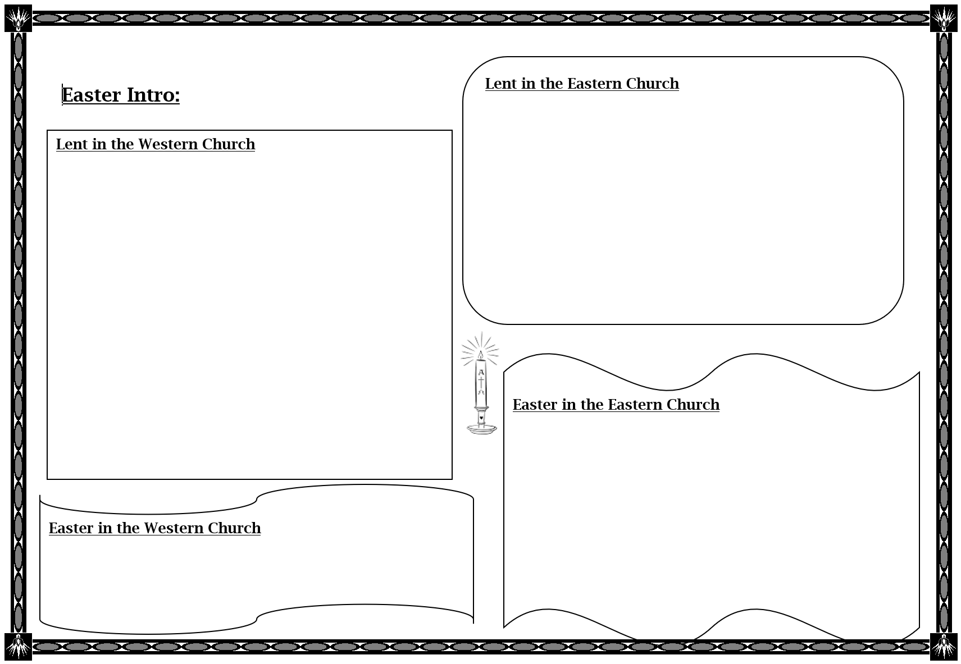
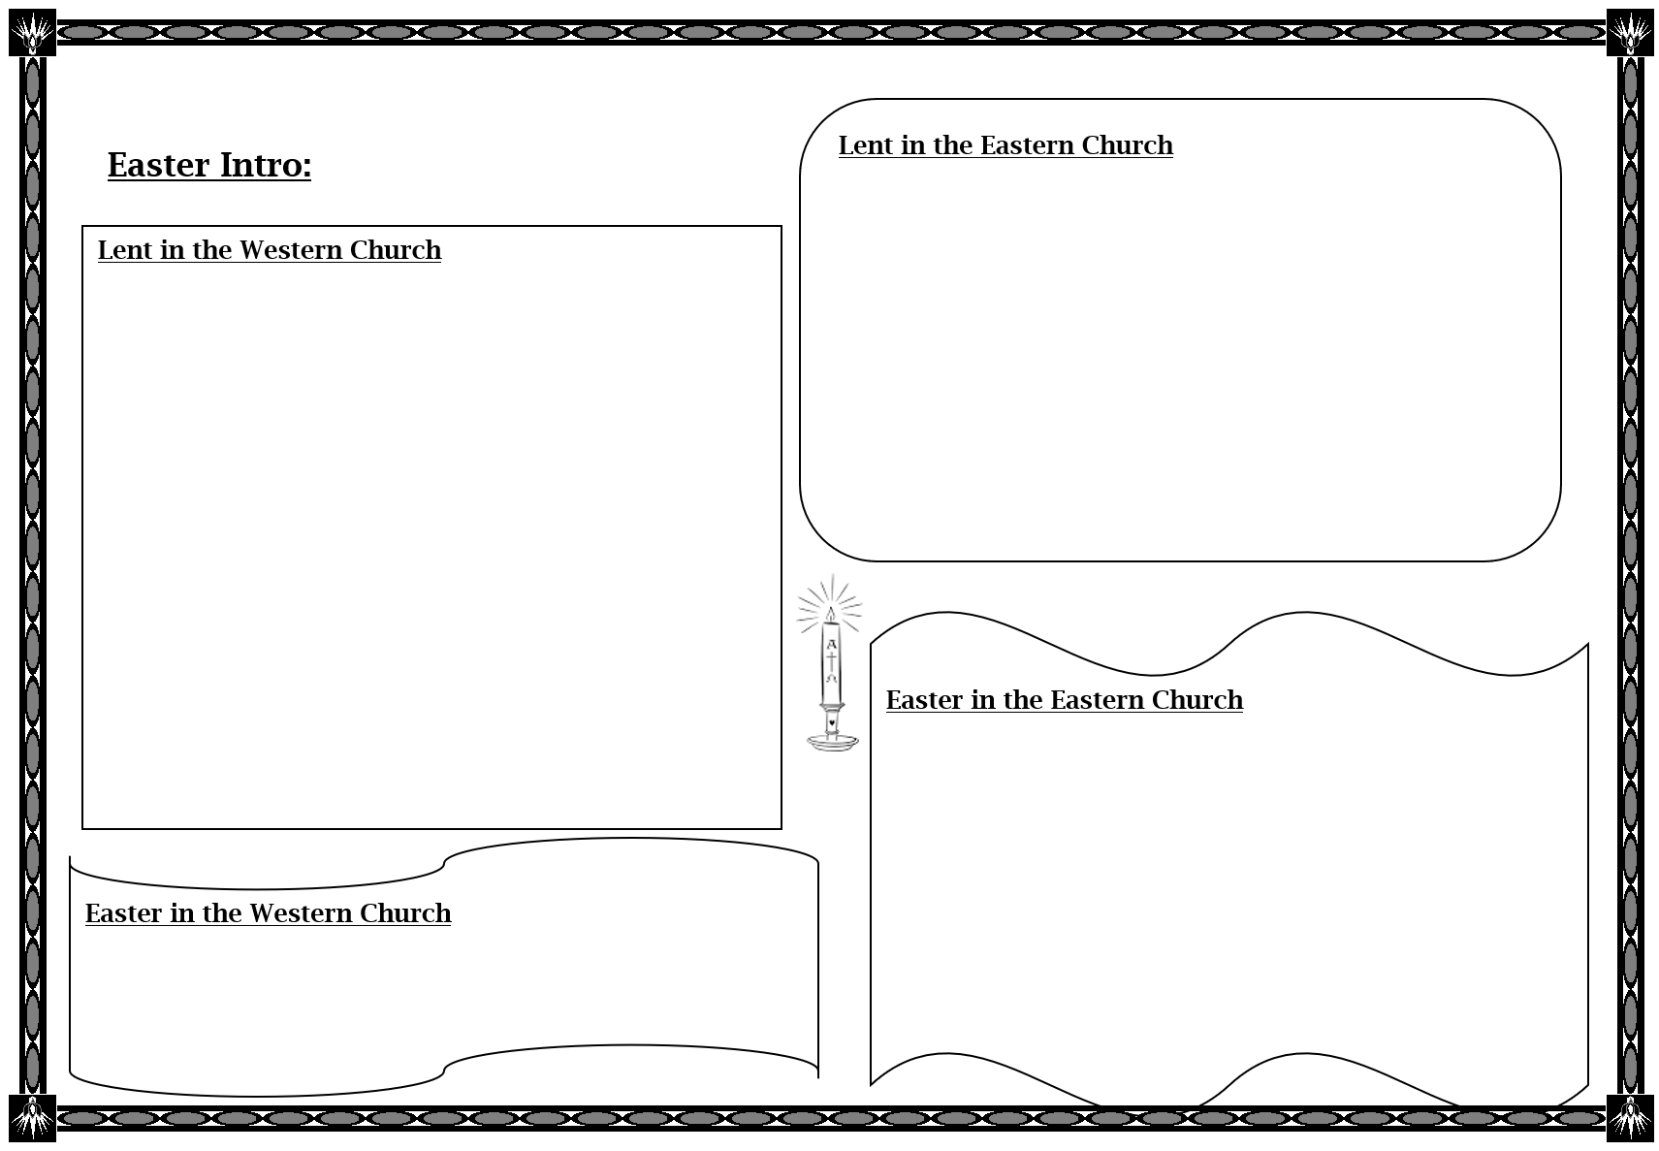
Questions
Are there any parts of this booklet that you have found hard? Are there any questions that you want to ask? Jot down anything!

QUESTIONS
Exam questions to choose from:
- Examine the differences between the Easter traditions of the Eastern and Western Churches (20)
- Explain the case for believers baptism (20)
- Examine advent and Christmas in the Eastern church (20)
Email to lalmond@blue-coat.org or ffrazer-davies@blue-coat.org when completed

