

**A-Level Religious Studies**

**Y11 Bridging Document**

**Part 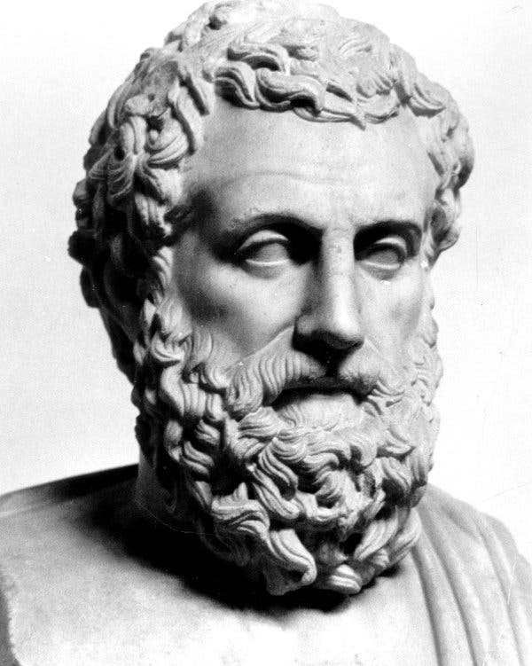3**

Welcome philosophers, ethicists and theologians. This is part 3 of the bridging course aimed to get you ready for you A-Level Religious Studies course.

This section of the bridging course aims to introduce you to some of the topics that we study in year 12. You have the opportunity to pre-read the content and do some research of your own. Now that you are familiar with the level of content taught in year 12, you can start to look at some of the revision techniques we use. Every theory that you have been shown so far, you could be asked to write an essay on in your final exam. We will cover the content in more detail, in class. The final task is an essay that will be graded in September.

Please read the list of stationary that you need to purchase before you start the course.

**Philosophy Summer Work in preparation for Year 12**

**Task 1:** Watch these 2 videos about the cosmological argument and make notes: [**https://www.youtube.com/watch?v=yyiNbJlqcJo**](https://www.youtube.com/watch?v=yyiNbJlqcJo)and

<https://www.youtube.com/watch?v=WLKwImYuEKU>

**Task 2:** Read through the 4 pages of information about the cosmological argument for God’s existence. Read the information on the two forms of the cosmological argument, highlight and annotate to help you to understand it. Answer the comprehension questions in the booklet.

**Theme 1. Inductive Arguments:   
The Cosmological Argument**

**Part ‘A’ Questions (Theory)**

**Section 2: Inductive arguments for the existence of God – Cosmological Arguments**

**Background: Cosmological Argument**

* The cosmological argument tries to show that God exists 100% - that definitely exists.
* Cosmological arguments start with observable idea that all ‘effects’ have a ‘CAUSE’ e.g. the football moved (effect) only because I kicked it (cause).
* The cosmological argument then works on the empirical belief that every cause must also have a cause e.g. I kicked the football (cause) but I also have a cause (my parents).
* However, the cosmological argument then states this chain of causes cannot go back an infinite number of times. Therefore, there must be a first causer that started the first cause. Cosmologists believe that the first causer is God.
* Your syllabus wants you to look at two Philosophers who have created Cosmological Arguments:
* An older version by St. Thomas Aquinas (1225–1274)
* A more modern version (called the Kalam Argument) by William Lane Craig (1949-………)

**Version 1: Aquinas’ Cosmological Arguments**

* Aquinas cosmological arguments (from his book ‘**Summa Theological’**) are influenced by the work of the great Ancient Greek philosopher **Aristotle.** Aristotle, as well as great Jewish thinker **Maimonides** and influential Muslim thinker **Avicenna.**
* Aquinas split his cosmological argument into 3 different ways. This was to reflect the slightly different arguments of his influences (Aristotle, Maimonides and Avicenna) .
* These 3 arguments are known as the first three of ‘five ways’ Aquinas attempted to prove God’s existence (you will come across ‘way 5’ when you look at the teleological argument)

# Way 1 – The Unmoved Mover – (a.k.a. The Unchanged Changer)

# Way 2 – The Uncaused Causer (a.k.a. The First Cause Argument)

# Way 3 – Contingency & Necessity

**Aquinas’ Way 1 – The Unmoved Mover (influenced by Aristotle)**

* Aquinas observed (empirical/a-posteriori) that somethings are in motion. He defines the word ‘motion’ as anything that is changing state e.g. water can change state from being solid (ice) to liquid.
* However, Aquinas reasoned that things that have the potentiality to change state (like ice has the potential to change state into a liquid) cannot change themselves. For this change of state to happen (to be actualised) it must be changed by something else (Note: Aristotle called this ‘something else’ – the ‘efficient cause’).
* For example, for ice to change state into liquid it must be changed by something else (an efficient cause) – like a hot fire. As Aquinas states **“Whatever is in motion must be put in motion by another.”**
* However, Aquinas argues, the ‘efficient cause’ must also have actualised (changed state) due to another efficient cause e.g. a pile of wood has the potential to be a fire but must be actualised by an efficient cause – a match.
* However, according to Aquinas, this set of changes of state cannot go back an infinite number of times (infinite regress); therefore, there must be a first changer. This is because as Aquinas states **“If there was no first changer there would be no subsequent changes.”**
* Aquinas observed (a-posteriori) that everything in the universe is in motion, therefore, we need to look outside the universe for the ‘first changer’. Moreover, the ‘first changer’ cannot be changed by anything else (does not have an efficient cause) and thus must be responsible for starting off all motion/change.
* This first changer, for Aquinas, could only be God. Therefore, God must exist (Note: Aristotle, who influenced this argument, called this first changer the ‘Prime Mover’)

**Aquinas’ Own Example for Way 1**

* Aquinas argued that a piece of wood has the potentiality to change state from being cold (not on fire) to being hot (on fire). However, this can only happen (be actualised) if something else (an efficient cause) that is hot touches it (such as another piece of wood that is on fire)
* However, this hot piece of wood must also have changed state (been made hot / set on fire) by another piece of wood that had changed state to hot etc.
* This chain of changes of state cannot go back an infinite number of times (infinite regress). Therefore, there must have been a first changer of state, changed by no other e.g. the first entity to make something hot.
* This is what we understand by God (and therefore God must exist).

**Aquinas’ Way 2 – The Uncaused Causer**

* This is often seen as the classic cosmological argument.
* Aquinas argued, from observation, that it is a universal law that every effect in the universe has a cause (Aquinas called this an ‘intermediate cause’). For example, the pen in your hand must have had an intermediate cause i.e. your pen did not cause itself.
* Aquinas argued this must a be a universal law because it is logically impossible for anything to cause itself. This is because it would mean, otherwise, that something would have to already exist; to create itself i.e. you cannot cause yourself - it would be like being your own parent!!!!
* However, Aquinas further argued that every intermediate cause (of an effect) must also have an intermediate cause e.g. one of the intermediate causes of your pen is plastic, however, the plastic in your pen did not cause itself. Therefore, it too must have an intermediate cause.
* However, Aquinas believed that this chain of intermediate causes and effects cannot logically go back an infinite number of times (**infinite regress**). Aquinas argued this must be the case because if there was no first cause, nothing would exist now. As Aquinas stated: **“out of nothing comes nothing”** or in Latin **“**[**ex nihilo**](http://en.wikipedia.org/wiki/Ex_nihilo) **nihil fit”.**
* Therefore, there must be a first causer, that started off all the intermediate causes but is itself uncaused (Aquinas called the ‘ultimate cause’). According, to Aquinas this first/ultimate cause is God, therefore God exists. As Aquinas states **“It is necessary to admit a first causer, to which everyone gives the name of God.”**

**Analogy to illustrate Way 2**

* A famous analogy to illustrate this is a series of dominoes falling down, one after another.
* Each domino cannot fall down of its own accord; it needs another domino to fall on to it (an intermediate cause).
* However, this series of falling dominoes cannot have started itself; it needs someone to push the first domino (an ultimate cause).
* In this analogy the pusher of the first domino (the ultimate cause) is God and the proceeding falling dominos represent all the intermediate causes and effects.

**Aquinas’ Way 3 – Contingency & Necessity**

* Aquinas observed (a-posteriori) the world consists of contingent beings. Existing as a contingent being means you were created and you will eventually cease to exist e.g. for humanity this means we are born and eventually we will die.
* Therefore, Aquinas argued, as a contingent being you exist now but there was a time in the past before you existed (before you were born). Moreover, there will be a time, in the future, when you do not exist (after you die).
* Aquinas argues that if everything in the universe is a contingent being (and can therefore either exist or not exist) then it was a logical necessity that there would have been a time when no contingent beings existed. As Aquinas states **“Therefore, if everything cannot be, then at one time there was nothing is existence.”**
* (Optional – this is called the ‘Principle of Plenitude’: which states that if something is a real possibility, then given an infinite amount of time, it will happen)
* Aquinas then argues that if there was a time when there were no contingent beings, then no contingent beings would exist today, this is because contingent beings cannot ‘come from nothing’. As Aquinas states **“If at one time nothing was in existence, it would be impossible for anything to have begun to exist.”**
* However, contingent beings do exist (including ourselves), therefore logically there must be a necessary being (a being that is not reliant on its creation by any other being) capable of bringing contingent beings into existence.
* Therefore, a Necessary Being must exist that is the source of all contingent beings. As Aquinas states: **“We cannot but postulate the existence of some being having of itself its own necessity”**
* Aquinas refers to this Necessary Being as God, therefore God exists.
* **Optional 1**: Aquinas does make a distinction between caused necessary beings (angels) and uncaused necessary beings (God). He argues that everything cannot depend upon caused necessary beings since this would mean an infinite regression of caused necessary beings, but no complete explanation. Therefore, there must be some uncaused necessary being upon which everything relies – something which is self-explanatory and eternal. This uncaused necessary being, Aquinas says, is God.
* **Optional 2**: Years later a theologian called Frederick Copleston simplified Aquinas’ Third Way in a famous radio debate (1947) with atheist philosopher Bertrand Russell. His argument goes like this: everything in the universe in contingent and the universe is the sum total of contingent things, and so the universe is itself must be contingent. If this is the case, there must be something upon which it depends – a necessary being, namely God. As Copleston stated: **“In order to explain existence, we must come to a being who contains within itself the reason for its own existence. That is to say a being which cannot not exist.”)**

**Version 2: William Lane Craig’s (Kalam) Cosmological Argument**

* William Lane Craig created a more modern version of the cosmological argument.
* Craig called it the ‘Kalam Argument’: the name ‘Kalam’ is taken from a group of Muslim philosophers (such as Al-Kindi) from the 9th century; who created a version of the cosmological argument.
* The original 9th century Kalam argument basically argued that everything having a cause was a simple law of the whole universe. Therefore, it was logical to assume the universe itself must also have a cause. Moreover, the cause of the universe must be outside of the universe itself (just as the cause of you tripping up would be something outside of yourself – like a banana skin). Therefore, as the cause of the universe must be something outside of itself it must be non-physical in nature. This non-physical nature is ‘God’.
* Craig updated the Kalam groups cosmological theory and out of respect for the Kalam philosophers named his book after them: ‘The Kalam Cosmological Argument (1979)’.
* Craig’s argument is best explained in two sections:

**Section 1 – Craig’s Kalam cosmological argument:**

* Craig’s Kalam cosmological argument is fairly straight forward. It consists of only four simple statements:

1. Everything that begins to exist must have a cause for its existence.
2. The universe began to exist.
3. Therefore, the universe MUST have a cause of its existence.
4. Since no scientific explanation can provide an account of the cause of the universe (in terms of ‘why’ and ‘how’ it was caused), the cause must be personal creator, which is God – therefore God exists.

**Section 2 – Craig’s defence of point 2:**

* The above arguments are fairly straight forward. However, Craig recognised that point 2 is controversial i.e. it could be argued the universe might be infinite (existed forever) and therefore does not need a cause.
* Craig developed the following defence that the universe cannot be infinite and therefore needs a cause:
* Craig argues an actual infinity cannot exist because they are absurd (impossible). He attempts to prove this by giving an ‘analogy of a library’.
* He asks us to imagine a library with an actual infinite number of books (they have no beginning or end). Moreover, the library has an actual infinite number of black books and an actual infinite number of red books.
* However, logically the library must contain as many red books, as there are total books in the collection. This is because both are infinite (no beginning and no end). One problematic outcome of this is that there must be as many red books as there are red and black books combined (because both are infinite). This is clearly absurd/impossible because how can there be as many red books as there are total books when we also have a set of black books.
* Craig argues that this ‘library analogy’ illustrates that actual infinities cannot exist in reality because the concept of actual infinites is absurd/impossible. Therefore, a beginning less infinite universe cannot exist because actual infinities cannot exist.
* Craig argues that as he has now proved the second part of his argument (the universe began to exist), therefore the rest of his argument to show God exists succeeds.

**Optional Additional Information:**

* The above argument be Craig received a lot of criticism because he only argued ‘actual infinities’ (something with no beginning or end) were absurd/impossible.
* However, there are actually two types of infinity: the other is a ‘potential infinity’, which Craig did not address.
* **Definition:** a potential infinity is the idea that something could carry on for infinity i.e. it has no ‘last member’. For example, when you were in primary school you may have tried to state the biggest number – but your friend would just keep adding one to it. This technically could go on into infinity because there is no last number.
* However, later Craig also argued against ‘potential infinities’ by simply stating that the universe has no possibility of being a ‘potential infinity’. This can be seen be a slightly deeper look at the difference between an actual infinity and a potential infinity:
* **Actual Infinity:** Some of the events in this type of infinity have ‘actually’ already occurred (hence the name)
* **Potential Infinity:** The infinity may ‘potentially’ occur in the future (hence the name).
* As the universe has an actual history then it can only be an actual infinity and not a potential infinity.
* However, as we have seen Craig eventually dismissed actual infinites as well.

**Comprehension Questions**

1. What is the full name of Aquinas?
2. What is the name of Aquinas’ book?
3. Who are the three philosophers he was influenced by and their nationalities?
4. What type of argument is the cosmological argument?
5. What are Aquinas’ dates?
6. Name his 3 ways:
7. In the first way, Aquinas observes that everything is in __________?
8. Explain the water and ice example.
9. What is the quote? Whatever is in motion, “_________________________________________________”
10. Explain about infinite regress.

1. What is the quotation to support this?

1. Give Aquinas’ example about fire and wood.
2. Way 2- what is his first observation?
3. Why can’t anything cause itself? What dies Aquinas use to explain this?

1. What does Aquinas say every intermediate cause has?

1. What does he argue about infinite regress?
2. What is the quote? “out of _______________________” Latin?____________________________
3. Therefore there must be _______________________.
4. Explain his domino analogy.

1. Way 3- what does he observe about the world?

1. What does contingent mean?

1. Therefore, you exist now but __________________________________________.
2. Quote: “Therefore if everything cannot be then at one time ________________________________________________________.”
3. What is this known as? The P______________ of P_________________.
4. Aquinas argues that if there was a time where there were no contingent beings, then _______________________________________________________.
5. However there are ________________________________.
6. So therefore there must be a _____________________________________.
7. What is the definition of a necessary being?
8. How does Aquinas add to this?
9. How does Copleston support this?

**Kalam Argument**

1. Who came up with this argument and when?
2. Whose ideas was it based on?
3. What was the basic argument which he developed?
4. What are the 4 key parts of his argument?
5. What did Craig see as the problem with his second point?
6. Explain the library example which shows the universe cannot be infinite.
7. Explain the criticism and defence about potential and actual infinites.

**Ethics Summer Work in preparation for year 12**

**Task 1:** Watch the following videos and make notes that you can add to the text below.

<https://www.youtube.com/watch?v=PrvtOWEXDIQ>

<https://www.youtube.com/watch?v=NMblKpkKYao>

**Task 2:** Read the information on virtue theory, highlight and annotate to help you to understand it. Once you have done this, complete the essay plan. Then write up the essay. This will need to be handed in when you start the course, to be graded by your teacher.

**Virtue Theory**

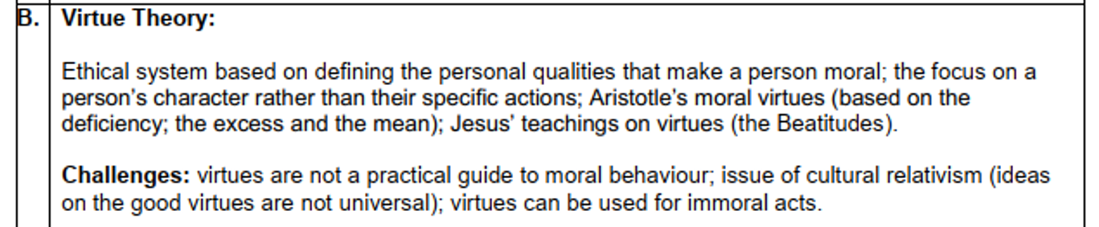

**An ethic based on character**

**What is Virtue Theory?**

* Most ethical theories try to work out morality (right and wrong) based on a person’s actions (as you have just seen in Divine Command Theory) or they judge the outcomes of our actions (as you see in Ethical Egoism).
* However, Virtue Theory is a very different type of ethic. This is because instead of concentrating on a person’s actions, Virtue Theory concentrates on a person’s character (‘ethos’ in Greek). More specifically it concentrates on developing a person’s virtues and reducing their vices.
* Virtues (arete in Greek) = our good characteristics (ethos): such as kindness, patience, friendliness etc.
* Vices = our bad characteristics: such as greed, selfishness, jealousy etc.
* Therefore, Virtue Theory is interested in what virtues make a good person, rather than the actions the person does.
* This is not to say that Virtue Theory completely ignores actions - Virtue Theory works on the assumption that if a moral agent’s character (ethos) can be moulded with virtues, then this person would automatically do good actions (because of their good character).

**Example of Virtue Theory in practice**

* We will consider lying as our example:
* **Divine Command Theory**: would argue that the action of lying is always wrong, this is because it breaks one of the Ten Commandments (in Exodus 20).
* **Virtue Theory**: a virtuous person (a person of good character) could either lie, or not, however if they did lie it would be because they were upholding one of their virtuous (kindness, generosity etc) and not for a vice (greed, selfishness etc).

**Developing the virtues**

* Virtue Theory seeks to determine whether there are any key virtues that underpin a good character.
* For example, what virtues did Martin Luther King or Nelson Mandela have. Once we have discovered the virtues of, for example Martin Luther King (such as compassion), we could develop (through practice) those virtues in our own life.

**Different versions of Virtue Theory**

* Over the centuries there has been much discussion on the virtues that make up a good character (ethos). However, we only need to consider two contributors: Aristotle and Jesus

**Contributor 1 – Aristotle**

**Background**

* Aristotle (384–322 BCE) was an ancient Greek philosopher. Aristotle reasoned out a set of virtues that helped a moral agent to be a successful member of their community, which Aristotle believed would bring them happiness (eudaimonia in Greek). Aristotle argued eudaimonia was the main aim of every member of a community.

**Moral Virtues**

* Aristotle empirically studied the people around him – particularly studying those members of society he thought had achieved eudaimonia (happiness from being a successful member of a community). From these studies, Aristotle developed what he believed were the essential virtues that would enable a person to achieve eudaimonia.
* There were 12 of them and they are commonly referred to as the ‘12 moral virtues’ (or qualities of character)
* Aristotle believed that these 12 moral virtues could be developed only through habit/practice.
* Two of the 12 moral virtues are below (check out the others but you don’t need to memories them all)

|  |  |  |
| --- | --- | --- |
| **Excess of the moral virtue (vice)** | **Moral Virtue** | **Deficiency of the moral virtue (vice)** |
| Rashness  Buffoonery | **Courage**  **Wittiness** | Cowardice  Boorishness |

* The moral virtues are in the middle column: courage and wittiness.

**Doctrine of the Mean:**

* However, you will notice that the moral virtues (in the middle column) are surrounded by the excess of the virtue (on the left) and the deficiency of the virtue (on the right). These are the vices (or the wrong way to try and achieve the virtue). Aristotle does this so that not only does he tell us what the good moral virtues are but also explains how to achieve them.
* Aristotle does this with what is known as the ‘**Doctrine of the Mean’ (a.k.a. the Golden Mean)**
* According to the Aristotle we all have the potential to develop the 12 moral virtues. The way we do this is to ensure that we keep away from either the excess or deficiency of the virtue (the two vices); so that we achieve the ‘mean’ or midway point. He argued that achieving the moral virtues was a matter of balancing between the two extremes.
* Aristotle argued this takes practice, until it becomes habit. However, if though practice we can take the mean (middle ground) with all 12 moral virtues, we would achieve our aim of happiness (eudaimonia).
* **I will illustrate the above with the example of ‘Wittiness’:**
* The way to achieve this moral virtue is to avoid the two extremes (Buffoonery and Boorishness). This is because no one really likes ‘hanging around with’ someone who is boorish (boring) and therefore they will not be a successful member of their community.
* On the other extreme no likes to ‘hanging around with’ a buffoon because they quickly become irritating (and thus they too will not be a successful member of their community).
* Therefore, the way to develop the virtue of wittiness is to take the **mean (middle way)** between the two extremes of boorishness and buffoonery. If you can do this (with practice) you will become happy because you will be a successful (popular) member of your community (because people like to ‘hang around with’ witty people).

**Phronesis:**

* Aristotle also believed that underpinning all the moral virtues is phronesis (practical wisdom).
* Phronesis helps people to decide what the ‘midway point/mean’ course of action in any practical moral situation e.g. how do I follow the 12 moral virtues when a fight is about to break out etc.
* This is because Aristotle believed the mid-point (mean) between the excess and deficiency is not necessarily fixed. This is because it can vary depending on the situation. This is where you need phronesis (practical wisdom) is needed i.e. to decide where the mean is in a particular situation.
* Aristotle believed that phronesis is acquired as we age and become more autonomous (our own individual selves). As Aristotle stated: **“the virtuous person has practical wisdom, the ability to know when and how best to apply the virtues.”**

**Intellectual Virtues:**

* Aristotle also argued that we need to develop a second set of virtues called the intellectual virtues.
* The intellectual virtues are associated with our minds and are intended to improve the quality of our minds. They need to be cultivated (developed) through instruction and guidance (taught rather than just practised).
* There are 9 intellectual virtues comprising five primary intellectual virtues and four secondary intellectual virtues. Again, they do not all have to be learnt, so below I’ve put one example of a primary intellectual virtue and one secondary intellectual virtue:
* **Scientific Knowledge (**Primary Intellectual Virtue)**:** learning `facts' so that you have knowledge – not unlike the knowledge you need, in your exam, to answer Part A questions.
* **Understanding** (Secondary Intellectual Virtue): this goes beyond the ability to learn facts. Understanding is to be able to analyse and evaluate those facts e.g. to evaluate whether Virtue Theory is any good. Not unlike the knowledge you need, in your exam, to answer Part B questions.

**Contributor 2 – Jesus**

**Background:**

* There is a long history of virtues being encouraged in Christianity; particularly in the Old Testament. For example, in the book of Ecclesiastes, Solomon writes of not finding many virtuous people.
* However, traditionally many Christians associate Christian virtues with Jesus.

**Jesus’ teachings on Virtues:**

* Jesus’ teachings on virtues generally occurred in his influential ‘Sermon on the Mount’ which can be found in Matthew (chp 5-7).
* The Sermon of the Mount was Jesus’ longest preach, recorded in the Bible, and it is dominated by moral teachings. However, it is not all about virtues; the virtuous part is called the ‘Beatitudes’ found in Matthew 5.
* Generally, the Beatitudes encourage positive transformation of the inner character (virtues) with particular emphasis on humility (modesty), charity, and brotherly/sisterly love.
* Specifically, Jesus highlighted eight virtues in the beatitudes. They are:

1. **‘Blessed are the poor in spirit’:** those who recognise their insignificance and helplessness before God. This Beatitude is therefore encouraging the virtue of humbleness
2. **‘Blessed are those in mourning’**: recognising concern or regret at being separated from God – the virtue of humility.
3. **‘Blessed are the meek’:** those who support others without making a scene about it e.g. an individual feeds a homeless person without boasting about it. Again encouraging the virute of humbleness.
4. **‘Blessed are they who hunger for righteousness’**: standing up for what is right e.g. a student stands up for a fellow student who is being bullied. The virtue of righteousness
5. **‘Blessed are those with mercy’**: to illustrate mercy towards others, because it is the right thing to do - the virtue of compassion.
6. **‘Blessed are the pure of heart’**: a person who has no bias or prejudice towards others - the virtue of selfless love.
7. **‘Blessed are the peacemakers’**: those who work towards peace in a world full of conflict - the virtue of justice.
8. **‘Blessed are the persecuted for the sake of right’:** willingness to suffer for religious and moral principles – the virtue of perseverance.

* It is interesting that Jesus’ virtues contrast with the virtues of Aristotle. Aristotle’s virtues encourage a person to think about themselves and their own personal goals (eudaimonia). Whereas Jesus’ virtues seem to concentrate on helping us to think of others before ourselves.

**Plan for the essay: Explain Virtue theory (20)**

Below is a table that will help you to plan the essay. The information that you have just read fits neatly into the 7 boxes below. Complete the table and then type or handwrite the essay up. I am looking for 2 pages handwritten. You will need to include quotes and examples created by the scholars, as well as your own examples. Have a look at the mark scheme to help you understand what makes a good A-level RS essay.

|  |
| --- |
| Part A question: Explain virtue theory (20) |
| **Introduction:**  Most ethics …  Virtues are…  Vices are…  (Looks at good people like MLK and Mandela and tries to harness what makes them great)  Character can be developed: |
| **Paragraph 1:**  What did Aristotle say? |
| **Paragraph 2:**  Doctrine of mean is … |
| **Paragraph 3:**  Phronesis is… |
| **Paragraph 4:**  Intellectual virtues are… |
| **Paragraph 5:**  Jesus also had virtues… |
| Paragraph 6:  What were Jesus’ virtues? |

**Mark scheme:**

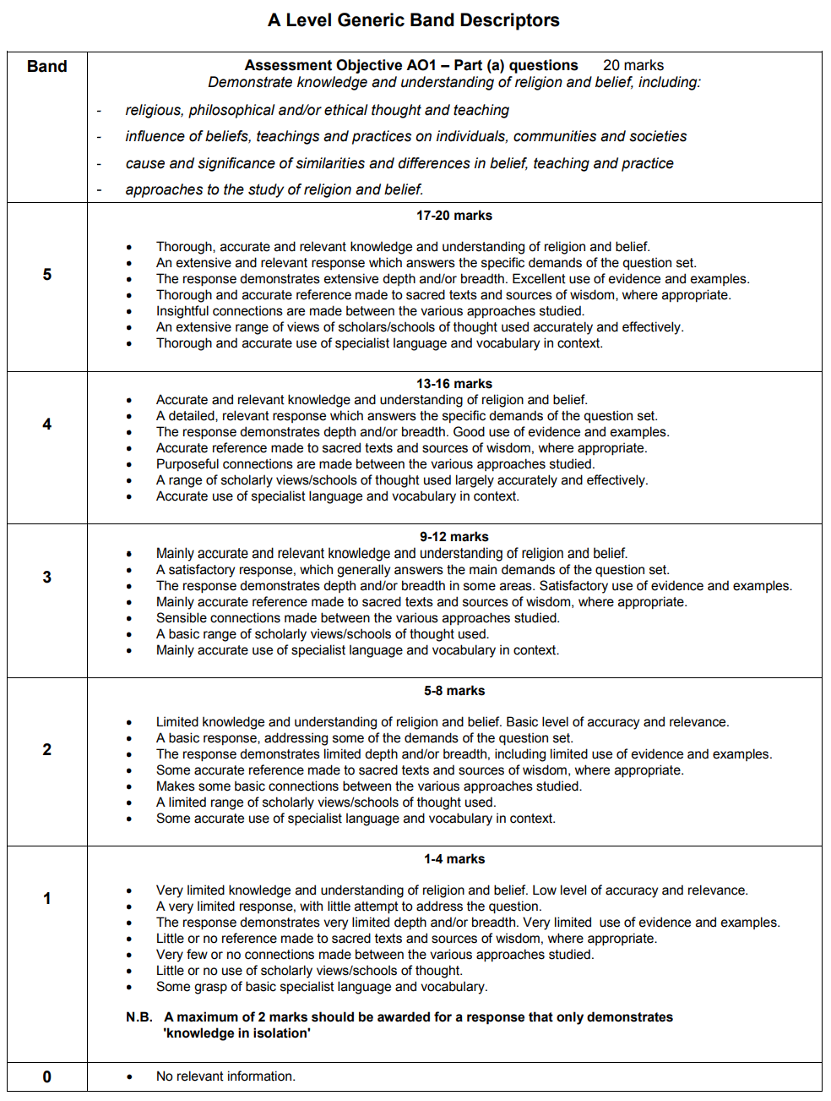This is a generic mark scheme that is used along side the content that you have already read through. If you can demonstrate that you understand the content and conform to the bullet points below, you will achieve a high grade.

**What stationery do I need?**

A ring binder, Lined paper, Dividers, Black pens, Coloured pen, Highlighters, glue stick

(If you struggle to purchase any of these items then the Religious Studies Department can help you)