Sport and Physical Activity
Cambridge Technical Extended Certificate
at
The Blue Coat Sixth Form

Part 1
This is Part 1 of the bridging course aimed to get you ready for your Key Stage 5 PE course.
The idea behind the bridging course is to give you a head start and so that you are already familiar with some of the key concepts and terms you will be using throughout the course. It doesn’t matter whether you have studied PE at GCSE as we are going to prepare you for the Key Stage 5 course.

Section A – Body systems and the effects of physical activity
The skeletal system
Task 1:
- Label the following outline of the skeleton with the list of bones provided;
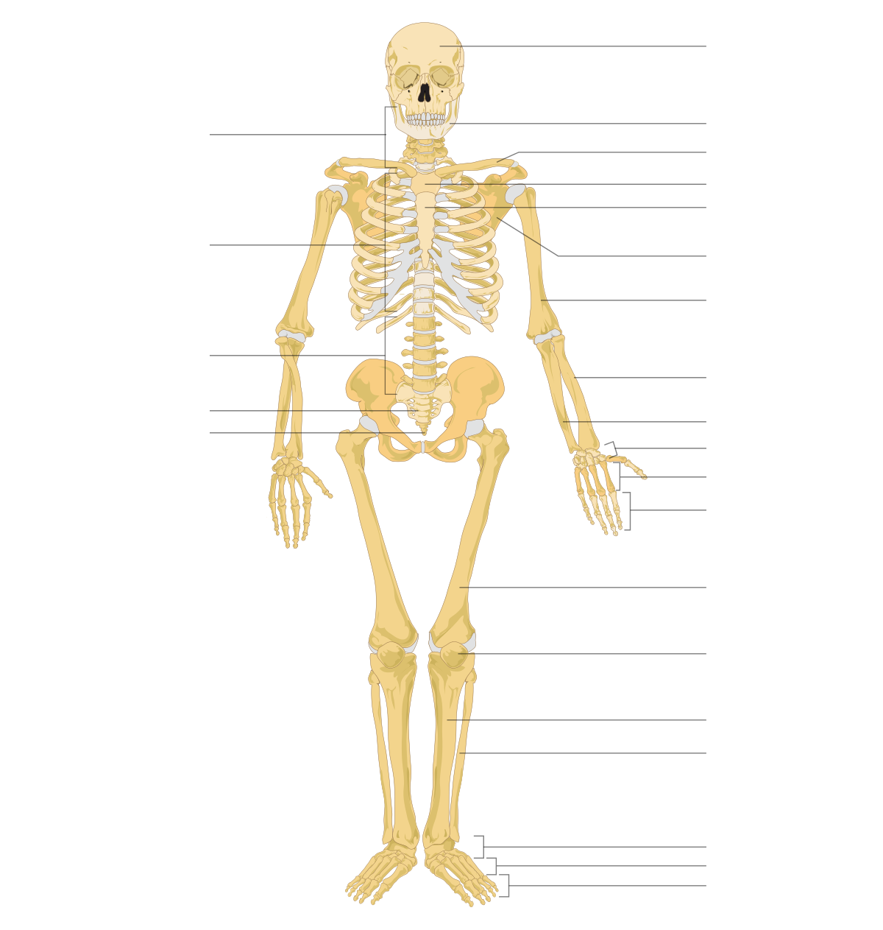
Bones to include;
cranium
sternum
ribs
cervical vertebrae
thoracic vertebrae
lumbar vertebrae
sacrum
coccyx
scapula
clavicle
humerus
radius
ulna
carpals
metacarpals
phalanges
femur
patella
tibia
fibula
tarsals
metatarsals

You will need to add a line for the following;

ilium
ischium
pubis
talus

Spend time learning their location, try to do this by getting someone else to read them to you and you indicate their position on your own body and the person can check whether you are correct or not.

Task 2:
Label the following diagram with the list of muscles provided;
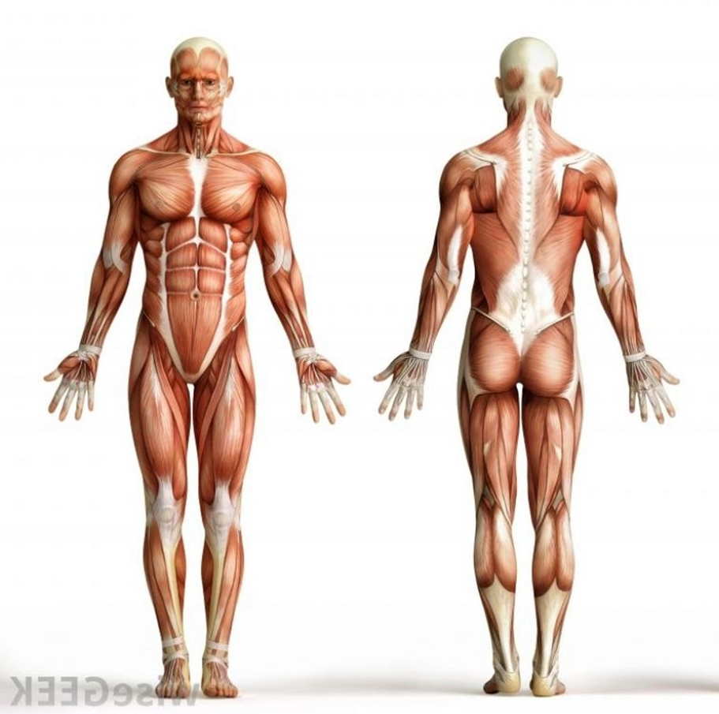

List of muscles (please add lines carefully and accurately)
Anterior Deltoid | Posterior Deltoid | Deltoid
Adductor longus,  Adductor brevis,  Adductor magnus | Gluteus maximus,  Gluteus medius,  Gluteus minimus | Rectus femoris,  vastus medialis,  vastus intermedius,  vastus lateralis
Latissimus Dorsi | Wrist flexors | Biceps femoris, semimembranosus, semitendinosus
Pectoralis Major | Wrist extensors | Tibialis anterior
Trapezius | Rectus abdominus | Gastrocnemius
Teres Major | Erector Spinae | Soleus
Biceps Brachii | Internal and external obliques | Pronator Teres
Triceps Brachii | Iliopsoas | Supinator muscle

Spend time learning their location, try to do this by getting someone else to read them to you and you indicate their position on your own body and the person can check whether you are correct or not.
Section B – Sport organisation and development
Task 1:
Research the following organisations
 | What do they do? | What are they responsible for? | Other information
UK Sport
Sport England

Task 2:
National Governing Bodies
Each NGB is responsible for managing a Sport and they have expert knowledge in that particular sport e.g. The FA are responsible for managing Football in England
Research a National Governing Body from a sport of your choice and choose 10 key bits of information to record below.
Sport:
Name of NGB:

Task 3:
Provision
Research your local area; What opportunities are available for people to get involved in sport and physical activity?

Name of Area:

Opportunities:

Section C – Sport and exercise psychology
Task 1:
Motivation
Make a list of everything that motivates you to participate in sport.

Split your list into the appropriate columns in the table.
Intrinsic motivation | Extrinsic (tangible) motivation | Extrinsic (intangible) motivation

Are you more motivated by intrinsic or extrinsic factors? Explain why.

Why might the types of motivation differ between an elite footballer and a novice cross country runner?

Task 2:
Goal setting
Consider the sporting goals suggested in the table below. State in the spaces provided whether you think the goals are long-term or short-term, and whether they are performance or outcome goals.
Goal set by sports performer | Type of goal – long or short | Type of goal – performance or outcome
To win the league

To do more weights to improve strength

To get picked for the county team

To improve the percentage of first serves that are successful in my tennis game
To improve my personal best time in 100m

To place in the top 3 in the National finals

Give a short, medium and long-term goal of yours related to your sport. It is easier to start with your long-term goal and then plan the steps required to help you to meet this.
Long term goal

Medium term goal

Short term goal

In order for goal setting to be effective, the well-known SMART principle is used. Record what the acronym stands for, with an explanation of each point.
S

M

A

R

T

Evaluate your three goals - are they SMART? If so, explain why, and if not, re-write them to ensure that they meet all of the criteria.

Useful YouTube videos for the physiology section;
https://www.youtube.com/watch?v=otHNMOaXSns&list=PLzh4kOin3WAqKL76NpiwuRoLrJDg65K16
Alternatively, type into YouTube – ‘A level PE Anatomy and Physiology Joints and Movement’, and the video you are looking for is by James Morris.
https://www.youtube.com/watch?v=2MOK3NrWTUE&list=PLzh4kOin3WAqKL76NpiwuRoLrJDg65K16&index=2
Alternatively, type into YouTube – ‘A level PE Anatomy and Physiology Joint action and muscles’, and the video you are looking for is by James Morris.
Not the same specification that you will be doing, but very good for understanding, nonetheless.

Useful information for the sport organisation and development section;
https://www.gov.uk/government/organisations/department-of-health
https://www.gov.uk/government/organisations/department-for-digital-culture-media-sport
https://assets.publishing.service.gov.uk/government/uploads/system/uploads/attachment_data/file/848082/School_sport_and_activity_action_plan.pdf

Useful information for the psychology section;
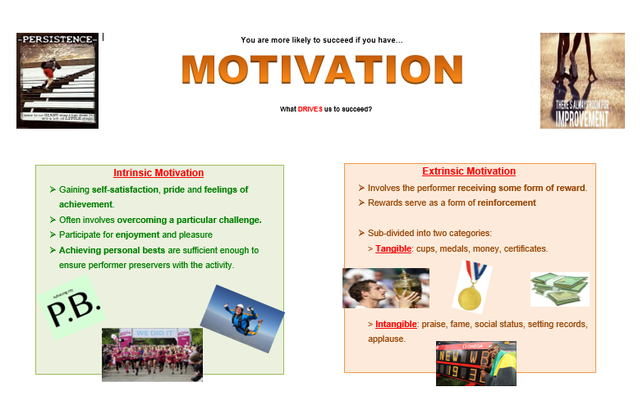
https://www.youtube.com/watch?v=f4npCA983sk
Alternatively, type into YouTube – GCSE PE Paper 2 – Goal Setting and SMART targets
Useful information to know

Which specification is it?
OCR Cambridge Technical Extended Certificate in Sport and Physical Activity
https://www.ocr.org.uk/qualifications/cambridge-technicals/sport-and-physical-activity/#level-3

Which textbook will I use?
Textbooks will be provided by the PE department, but if you want to purchase a copy, this is the amazon link.
https://www.amazon.co.uk/Cambridge-Technicals-Level-Physical-Activity/dp/1471874850
