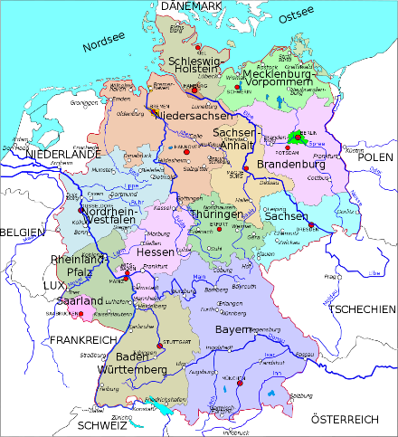
The Blue Coat School German A Level Year 11 Bridging Material – part 3:

Getting ready for September

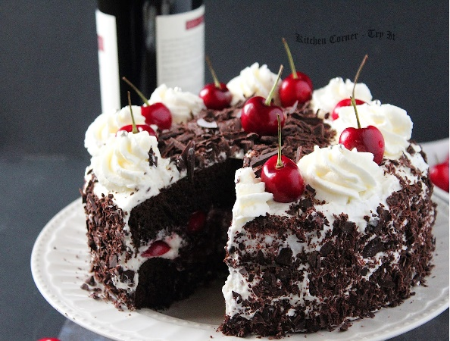
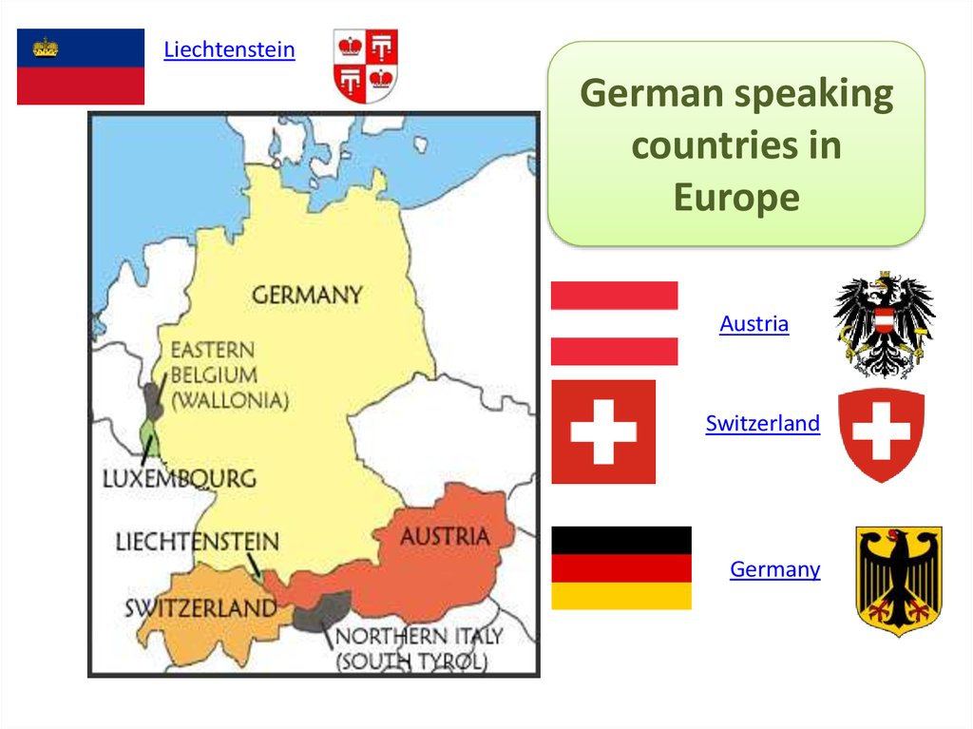

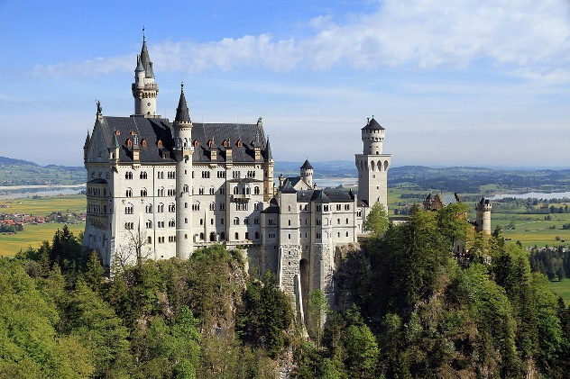

- Get to know your A level!
You will be following the Eduqas A level German specification. Here are the themes we will cover – the top two themes are what we cover in Year 12, so if you just do AS these are the themes you will do.
Content
Have a read through the themes:
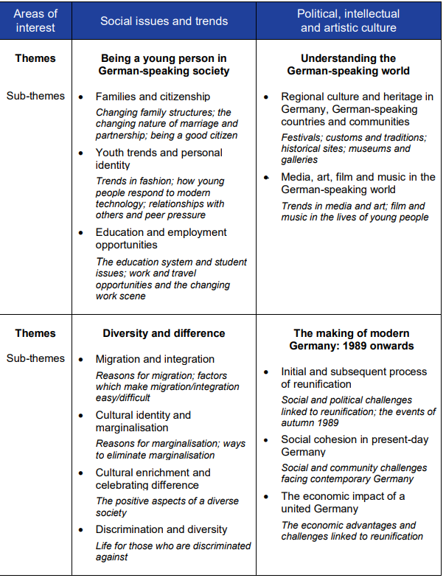
As well as these themes, we also study the film Good bye Lenin! in Y12 and the play Der Besuch der alten Dame in Y13.

Assessment
Assessment is in 3 parts whether you do AS or A level:
- Speaking
- Listening, Reading & Translation into English
- Writing – Translation into French, essay about film, essay about book (A level only)

Now have a look at the course online:
AS and A Level German | Eduqas Have a read of the specification and a look at the website.

- Now let’s look at the film you will study in Year 12 – you’ll love it!
Click on this link to view the trailer for Good bye Lenin!:
Goodbye Lenin - Trailer #1 - YouTube
Now work through all the activities below – remember to bring all your answers with you in September
A Sieh dir den Trailer an und hake (√) die 5 korrekten Aussagen ab. Korrigiere die falschen Aussagen.
1 | Der Erzähler und Hauptcharakter heißt Alex Kerner
2 | Alex wohnt in Westdeutschland
3 | Der Film spielt vor dem Fall der Mauer
4 | Alex’ Mutter ist im Krankenhaus
5 | Aufregung ist sehr gefährlich für die Mutter
6 | Als die Mutter in ihre Wohnung kommt, ist die Wohnung total neu und modern
7 | Die Mutter denkt, dass alles anders ist
8 | Alex hat Probleme, Spreewaldgurken zu bekommen
9 | Im neuen Deutschland kann man mit Ost-Mark bezahlen
10 | Alex’ Freundin möchte, dass Alex seiner Mutter die Wahrheit sagt
11 | Alex’ Mutter sieht original DDR-Nachrichten im Fernsehen
12 | Coca Cola ist ein ostdeutsches Produkt

B Finde die deutschen und englischen Paare:
1 | Ich bin Bürger der Deutschen Demokratischen Republik
2 | Die Mauer ist weg
3 | Meine Mutter hat von all dem nichts mitgekriegt
4 | Einen zweiten Infarkt würde sie nicht überstehen
5 | Das ist jetzt nicht dein Ernst ?
6 | Die DDR lebt weiter
7 | Hat sich ja gar nichts verändert hier
8 | Ich habe so einen Heißhunger auf Spreewaldgurken
A | The GDR (East Germany) lives on
B | I’m dying for a Spreewald pickle
C | The Wall is gone
D | You aren’t serious, are you?
E | My mum has no idea all this happened
F | Nothing here has changed at all
G | I’m an East German citizen
H | She wouldn’t survive a second heart attack
C Lies den deutschen Text, dann korrigiere die Fehler (mistakes) in den englischen Übersetzungen.
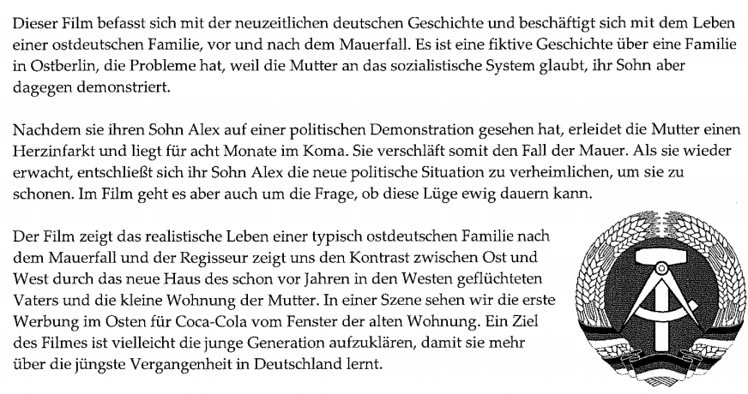
1 The film is about the life of a West German family before and after the fall of the Wall.
2 It is a real-life story about a family in East Berlin.
3 The mother suffers a heart attack and lies in a coma for 8 days.
4 When she wakes up, her son Alex decides to tell her about the new political situation.
5 The director shows us the similarities between the East and the West.
6 In one scene, we see the first advertisement for Coca Cola in the West.
7 One objective of the film might be to educate the older generation.

D Lies den Text nochmal. Dann beantworte die Fragen auf Englisch:
1 What political system does the mum believe in?
2 What does the son think of that political system?
3 When does the mum suffer the heart attack?
4 Why does Alex keep the fall of the wall a secret from his mum?
5 Where does the father live?
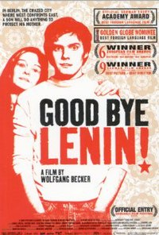

Click on the link below to watch the full movie:
Goodbye Lenin - YouTube

- Keep up with all the essential grammar you need to know
Now work through the grammar points below to ensure you really understand the basics of present, past and future tense as well as word order. Either print off this document and complete the tasks on the printout or complete the tasks on lined paper. Please make sure you bring your work to the first lessons in September.
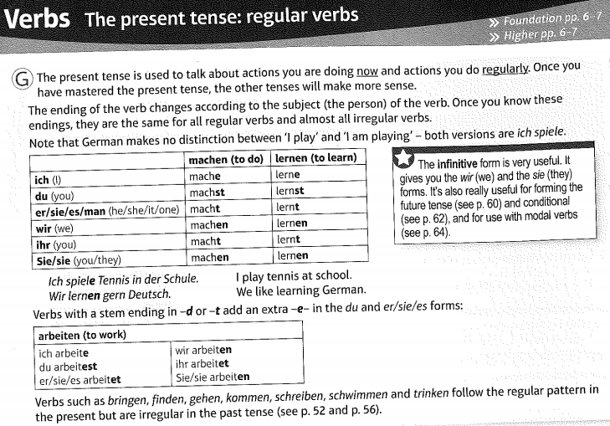
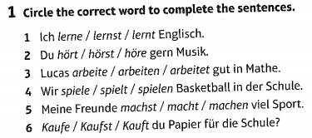
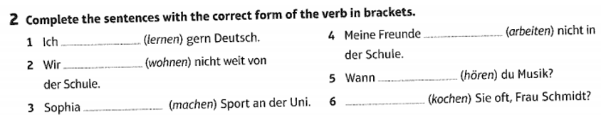
Irregular verbs change the vowel in their stem in the du-form and er/sie/es-form:
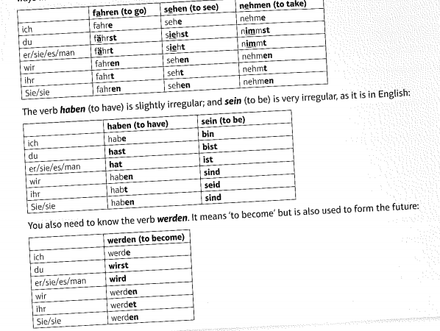
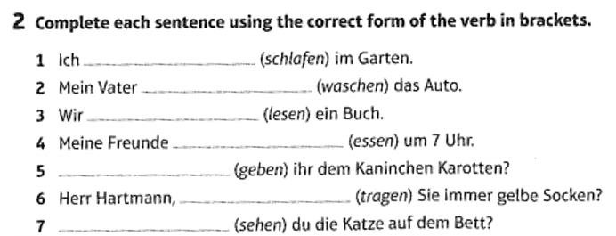
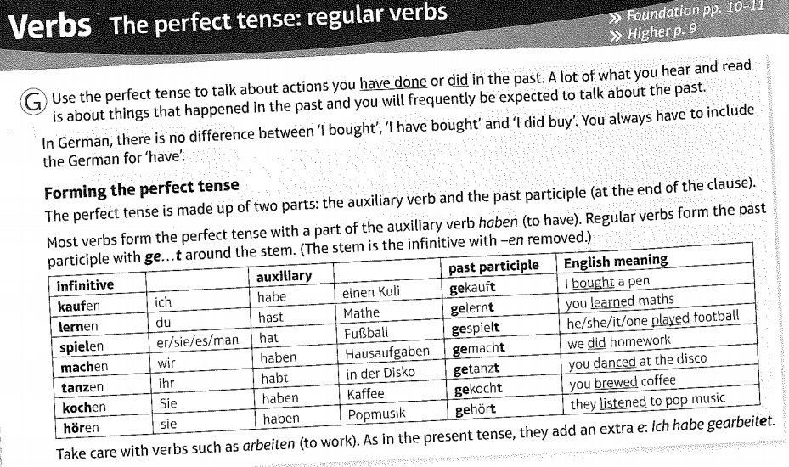
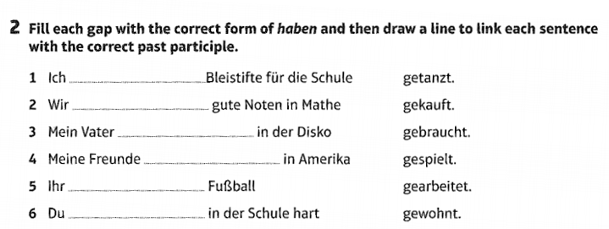

Irregular verbs in the perfect tense:



