Fine Art Y12 into Y13 Summers Tasks
AO3: Record ideas, observations and insights relevant to intentions, reflecting critically on work and progress.
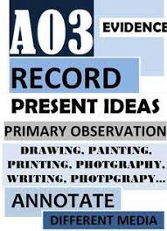
Your sketchbook now needs to demonstrate AO3 evidence. You have started by presenting your photo shoot. Please see ideas below. You should complete a range of observations from your photos in the style of the artist I preparation for your next big piece.
- Draw or paint from observation of your photos. They can be straight copies or they can be interpreted in the style of your chosen artist(s)
- Present in your book as the examples.
- Annotate your work to explain what you chose to do.
- Minimum of two double pages ( higher grade pupils tend to do more)
