Sport and Physical Activity
Cambridge Technical Extended Certificate
at
The Blue Coat Sixth Form

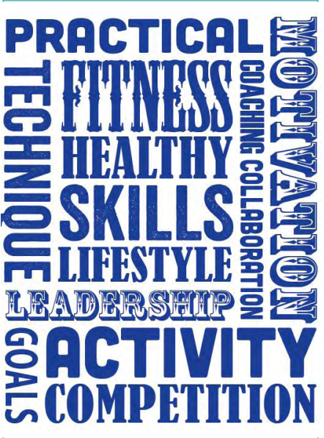

Part 3
This is Part 3 of the bridging course aimed to assess your knowledge and understanding of some of the key concepts and terms that you will use throughout the five units of the Key Stage 5 PE course.

This is the first assessed piece of work we will see from you so make sure it is completed to the best of your ability.

You will be expected to bring this completed work with you in September.

Section A – Body systems and the effects of physical activity
You are going to try a series of exam style questions, using the answers from part 1 and 2 of the bridging work so far. You need to make a separate point for the number of marks that the question is worth. Make sure you use the correct anatomical language for the names of the bones, muscles etc where appropriate. In September, these will be marked and recorded as an indication of how well you are starting this section of the course.

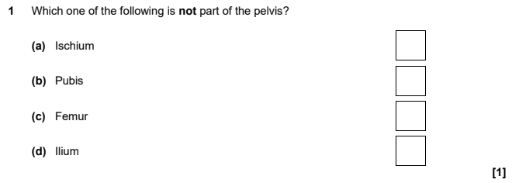
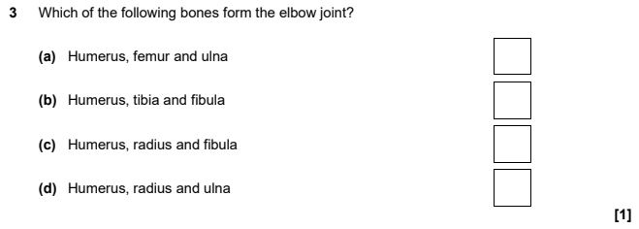
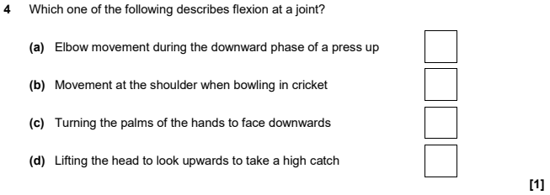
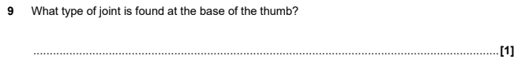

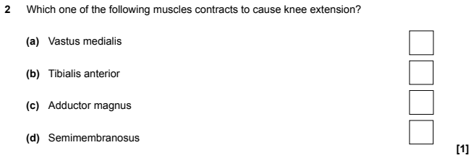
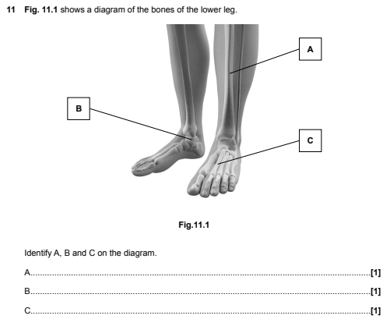
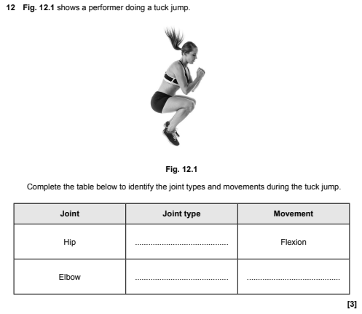

Section B – Sport organisation and development
You are going to complete a series of exam style questions, using knowledge acquired from the first two parts of the bridging work.

You need to make a separate point for the number of marks that the question is worth; There is no “banding” used for these questions.
In September, these will be marked and recorded as an indication of how well you are starting this section of the course.

- In the UK various organisations are involved with sport and physical activity; one such organisation is Sport England. Describe the work of Sport England. (6)

2) Explain the role of UK Sport (7)

Section C – Sport and exercise psychology
This section is coursework, not an exam, so you will need to answer in continuous prose:
- Describe the different types of motivation and explain how each can improve performance for a beginner and for an elite performer, using specific sporting examples.
- Describe the different types of goal setting and explain how setting the right goal can improve performance for a beginner and for an elite performer, using specific sporting examples.

Section D – Practical skills in sport and physical activity
For a sport of your choice, describe the roles and responsibilities of all the officials required for an elite / professional game. You may use images to help support your answer.

Section E – Sports coaching and activity leadership
Create a lesson plan for lesson one from your overview in part 2 of the bridging course.
Plan for 12 year 7, mixed ability participants in a space of your choice (e.g. Sports Hall, Gym, Field, Netball Courts).
The session should last for 30 minutes.

Here is a basic example of how you may set out your plan. You can use and adapt this, or you can create your own.
ACTIVITY:
NO OF PARTICIPANTS: |  |  | AGE RANGE: |  |  |  | ABILITY LEVEL
VENUE
OBJECTIVES FOR THE SESSION
TIME | ACTIVITY |  |  |  | MAIN TEACHING POINTS |  |  | ORGANISATION |  | RESOURCES/EQUIPMENT
Warm up

Drills (progressive)

Game situation

Cool down

Useful YouTube videos for the physiology section;
https://www.youtube.com/watch?v=otHNMOaXSns&list=PLzh4kOin3WAqKL76NpiwuRoLrJDg65K16
Alternatively, type into YouTube – ‘A level PE Anatomy and Physiology Joints and Movement’, and the video you are looking for is by James Morris.
https://www.youtube.com/watch?v=2MOK3NrWTUE&list=PLzh4kOin3WAqKL76NpiwuRoLrJDg65K16&index=2
Alternatively, type into YouTube – ‘A level PE Anatomy and Physiology Joint action and muscles’, and the video you are looking for is by James Morris.
Not the same specification that you will be doing, but very good for understanding, nonetheless.

Useful information for the sport organisation and development section;
https://www.youtube.com/watch?v=zr2q4_2gwDs

Useful information for the psychology section;
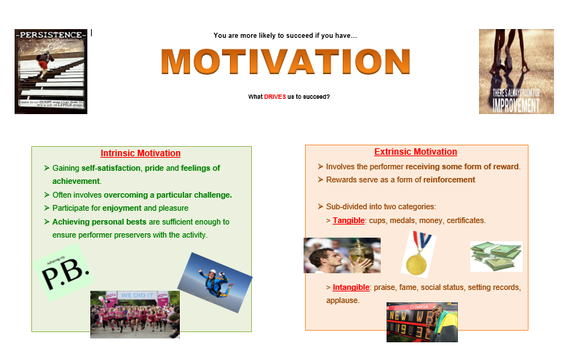
https://www.youtube.com/watch?v=f4npCA983sk
Alternatively, type into YouTube – GCSE PE Paper 2 – Goal Setting and SMART targets
https://www.youtube.com/watch?v=_25cZYWc5Rs
Alternatively, type into YouTube – ‘Achievement motivation PE’, and the video you are looking for is by James Morris.
Not the same specification that you will be doing, but very good for understanding, nonetheless.

Useful information for the practical section;
https://www.ocr.org.uk/administration/support-and-tools/siu/cambridge-technicals-sport-and-physical-activity-544072/

Overview of the course

OCR Cambridge Technical Extended Certificate in Sport and Physical Activity
https://www.ocr.org.uk/qualifications/cambridge-technicals/sport-and-physical-activity/#level-3
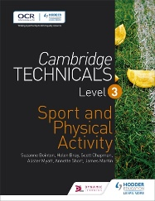
Textbooks will be provided by the PE department, but if you want to purchase a copy, this is the amazon link.
https://www.amazon.co.uk/Cambridge-Technicals-Level-Physical-Activity/dp/1471874850
Unit % | Topic | Content | Assessment
25% | Body systems and the effects of physical activity (physiology) | - Skeletal system  - Muscular system  - Cardiovascular system  - Respiratory system  Energy systems | Exam  1 hour 30  70 marks
25% | Sports coaching and activity leadership | - Roles and responsibilities of a coach  - Principles which underpin coaching  - Plan sports activities and sessions  - Prepare sports and activity environments  Deliver and review sports and activity sessions | Coursework assignments
16.6% | Sports organisation and development | - Organisation of sport in the UK  - Sports development  - Measurement of the impact of sports development  - Sports development in practice | Exam  1 hour  60 marks
16.6% | Practical skills in sport and physical activities | - Individual sport  - Team sport  - Outdoor adventurous activity  Officiating | Coursework assignments
16.6% | Sport and exercise psychology | - Motivation  - Attribution theory  - Stress  - Anxiety  - Arousal  Group dynamics  - Mental health and wellbeing | Coursework assignments

