A-level English Language
at The Blue Coat Sixth Form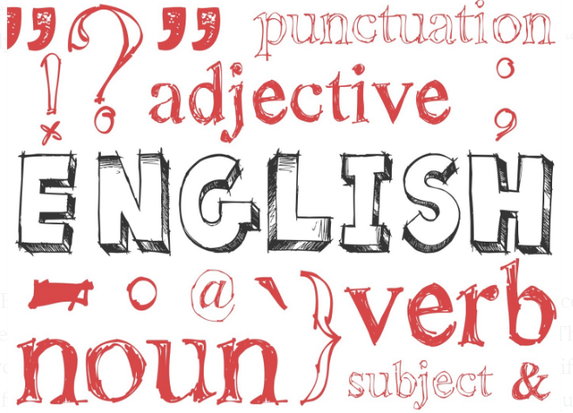Year 12 into Year 13
Welcome linguists! The purpose of this bridging course is to consolidate your knowledge and understanding of all the topics you have covered this year.
- C1 Sec A Spoken Language
- C1 Sec B Language Issues (Power, Standard and Non-Standard, Situation)
- C3 Writing and Commentaries (Travel, Crime, Monologues and Reviews)
Using this booklet, you are going to be able to: review and audit your subject knowledge by identifying areas of strength and weakness and putting measures in place to address any mis-understandings or gaps in your knowledge, measure your progress with a final assessment and finally for your Summer Task, begin work on your C4 Non-exam Assessment on Language and Identity which will take you into Year 13

Reviewing Learning
Click this link Course: A Level English Language (EDUQAS) (blue-coat.org) to be directed to Knowledge Organisers, covering all the topics you have studied this year. Take a few minutes to actively read through each of them using a highlighter to identify anything that is unfamiliar to you or that you feel you didn’t fully understand. Once you have done this. Record your findings on the table below:
Area of Study | Secure Knowledge | Revision Needed | Unconfident
C1 Sec A
Spoken Language
C1 Sec B
Language and Power
C1 Sec B
Standard and Non-standard
C1 Sec B
Language and Situation
C3 Travel Writing
C3 Crime Writing
C3 Dramatic Monologues
C3 Reviews
C3 Commentary Writing
Questions I would like to ask my teachers:

Having identified, your areas of weakness, plan a way forward as to how you can address them. Is this something you might be able to work out for yourself? Have you got notes in your folder that could help you? Can you ask friend for advice and guidance? Do you need to ask your teacher for additional support?

Summer Task 2020: Language and Identity
Non-exam assessment: 2500 - 3500 word folder (80 marks)
20% of qualification

This component gives you the opportunity to select an aspect of study that interests you on the theme of language and identity.
You are required to independently conduct a language investigation, to develop your methods of language analysis through research, data collection and interpretation and to select material that is culturally, personally and academically of interest.
To make best use of your time over the summer, it is an expectation that you complete all the following activities.

Title (Question)
The title must contain the word ‘identity’ and be approved by your class teacher.

Introduction
Explain why your topic is worthy of study – what you would like to investigate and why. Link it to one of the headings: Language and Culture, Language and Representation, Language and Diversity or Language and Gender and explain how it fits. State which theorists you intend to apply and why, explaining how are they relevant to the study?

Hypothesis
Explain what you are expecting to find linguistically in relation to your chosen language levels and why you expect to find them i.e. I expect the lexis to be…I expect to find a significant number of imperatives…I expect to see many adjacency pair interruptions from male speakers…etc.

Exemplar:

How do the presenters of Good Morning Britain use language to construct their on-screen identities?

Introduction:
I have chosen to investigate how language is used by TV presenters to create a sense of media identity. I have selected this topic for study because I find it very interesting to look at the different personas people create for themselves in the media.

This investigation fits under the topic of language and culture, in order to help to understand how language creates the sense of identity on screen.

Good Morning Britain (often abbreviated to GMB) is a breakfast programme on British television network ITV weekdays between 6:00 am and 9:00 am. Good Morning Britain is a daytime TV show made to be informative and often hosts guests to debate on controversial relevant topics that are occurring at present-day. The show is exposed to a large platform of 1.8 million views at its peak according to Entertainment Daily, so it is crucial that it runs as smoothly and as professionally as possible. To enable this to happen, the breakfast show is partially scripted. The current main anchors of the programme are Piers Morgan, Susanna Reid, Ben Shephard and Kate Garraway.

Within this study I will analyse the linguistic behaviours of the different presenters looking at how this enables them to construct a professional and, in most instances, affable on-screen identity. All four presenters construct their own distinctive personas to entertain the audience.

Within this investigation I am going to study in depth four very different hosts, Piers Morgan and Susanna Reid and contrastingly Ben Sheppard and Kate Garraway both of ‘Good Morning Britain’ and analyse how Piers Morgan portrays himself to be rude and brutal within his media identity and in contrast, how Susanna Reid maintains a more conciliatory approach in order to create balance. This contrasting style of interview technique has become their signature ‘style’. In contrast to this, Ben Sheppard and Kate Garraway have a more collaborative and harmonious approach.

Hypothesis:
I expect to find that all of the presenters will have a strong awareness of conversational maxims and may choose to flout them where appropriate. In addition to this, I think they will be highly skilled in accommodating their language to meet the needs of their guests and viewers – being able to hold the floor, maintain cooperative discourse structures and save and threaten face where relevant. I also anticipate that there will be evidence of a discourse community established between the GMB presenters and their audiences within their language use.
Data Collection

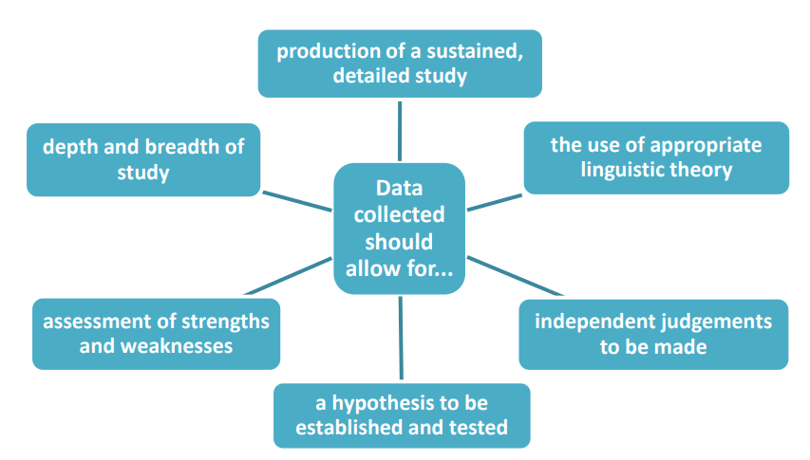

You need to collect spoken, written or multi-modal data which is appropriate to the topic area you have chosen and the hypothesis you wish to investigate. Analysis of the data will form the heart of your investigation, so it should be appropriately challenging and of personal interest. This data could be in the form of transcriptions, texts from any printed media, examples of their own language repertoires, speeches from the past and present etc. It is possible to combine spoken and written data, or you can focus on one mode. Think carefully about how to make your data manageable; too little or too much can make it increasingly difficult to draw any conclusions from it. You should also consider the context of the data and how that may influence it.

All data must be collected by September.
Have a wonderful summer!

