AQA Applied Science Level 3

Bridging work/Summer task

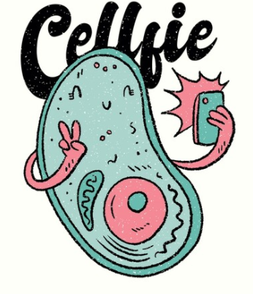

Applied Science - Biology
Unit 4: The Human Body - Summer Task

Use your notes in your booklet to answer the following questions:

Q1 Describe how fats are digested.
(5 marks)

……………………………………………………………………………………………………………………………………………………………………………………………………………………………………………………………………………………………………………………………………………………
…………………………………………………………………………………………………………………………………………………………………………
…………………………………………………………………………………………………………………………………………………………………………
…………………………………………………………………………………………………………………………………………………………………………
…………………………………………………………………………………………………………………………………………………………………………
…………………………………………………………………………………………………………………………………………………………………………
…………………………………………………………………………………………………………………………………………………………………………
…………………………………………………………………………………………………………………………………………………………………………
…………………………………………………………………………………………………………………………………………………………………………

Q2 Describe the difference between mechanical and chemical digestion, giving examples of them within the human digestive system.
(5 marks)

……………………………………………………………………………………………………………………………………………………………………………………………………………………………………………………………………………………………………………………………………………………
…………………………………………………………………………………………………………………………………………………………………………
…………………………………………………………………………………………………………………………………………………………………………
…………………………………………………………………………………………………………………………………………………………………………
…………………………………………………………………………………………………………………………………………………………………………
…………………………………………………………………………………………………………………………………………………………………………
…………………………………………………………………………………………………………………………………………………………………………
…………………………………………………………………………………………………………………………………………………………………………
…………………………………………………………………………………………………………………………………………………………………………

Q3 A man has diarrhoea and goes to see the doctor. The doctor diagnoses irritable bowel syndrome (IBS). IBS can reduce absorption of some nutrients into the blood. Figure 1 shows the digestive system.
Figure 1

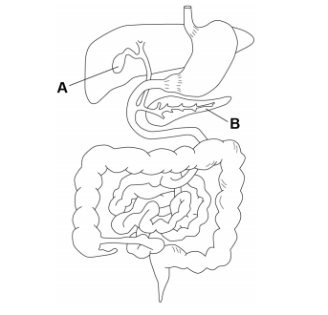
- Name the part of the digestive system which is affected by IBS.

…………………………………………………………………………………………………………………………………………… (1 mark)

- Label this part as X on Figure 1. (1 mark)

- The man’s symptoms are worse after eating fatty foods. Parts A and B in Figure 1 are involved in the digestion of fats.

Name part A: ……………………………………………………………………………………………………………………………………

Name part B: ……………………………………………………………………………………………………………………………………

(2 marks)

- Explain how part A helps speed up the digestion of fats.
(3 marks)

………………………………………………………………………………………………………………………………………………………………………………………………………………………………………………………………………………………………………………………………
………………………………………………………………………………………………………………………………………………………………
………………………………………………………………………………………………………………………………………………………………
………………………………………………………………………………………………………………………………………………………………

- Lipase is a type of enzyme that digests fats. Complete Table 1 for carbohydrase and protease.
(3 marks)

 | Carbohydrase | Lipase | Protease
Enzyme substrate |  | fats
ONE place in the body where the enzyme is made |  | small intestine
ONE place in the body where the enzyme acts |  | small intestine

- When water reacts with a protein molecule during digestion a hydrolysis reaction takes place. Describe the effect of hydrolysis on a protein molecule.
(2 marks)
………………………………………………………………………………………………………………………………………………………………………………………………………………………………………………………………………………………………………………………………
………………………………………………………………………………………………………………………………………………………………

Q4 A girl attended a clinic because she had diarrhoea. Diarrhoea is a condition in which the faeces become very watery. Figure 2 shows the human digestive system.

Figure 2
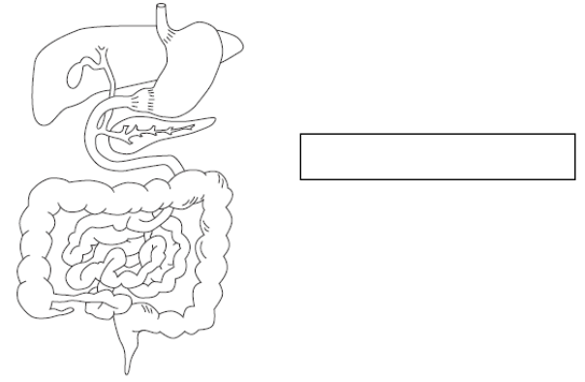
- In the box in Figure 2, write the name of the structure where water is reabsorbed from faeces, and draw a line to the structure you have named.
(2 marks)
- In normal conditions, the muscles help to move food through the gut. Describe how the muscles work to move food along the gut.
(2 marks)
………………………………………………………………………………………………………………………………………………………………………………………………………………………………………………………………………………………………………………………………
………………………………………………………………………………………………………………………………………………………………
………………………………………………………………………………………………………………………………………………………………
(TOTAL = 26 marks)

Applied Science - Chemistry
Unit 5: Investigating Science - Summer Task

This part of the summer task is very straightforward. All you need to do is make sure that what we covered in class for unit 5 is completed done. As a guideline, task 1 is expected to be at least 4 pages in size 12 font, excluding images. You will be submitting this in the 1st lesson back. If we covered task 2, then this is also expected to be fully completed. My suggestion would be to save this to the cloud using Microsoft OneDrive. You will be shown how to do this in class before the summer holidays.

