AQA Applied Science Level 3

Bridging work Part 3

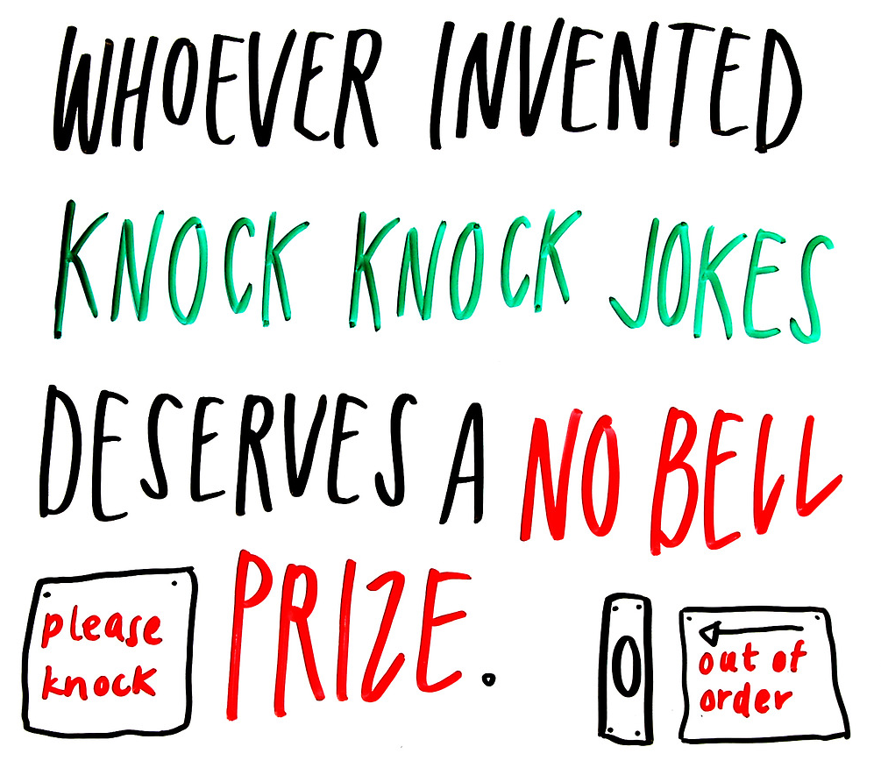

Introduction

Welcome back! This is part 3 of the bridging work for Applied Science!

Part 3 of the bridging work has been designed to allow you to develop your research skills, which is vital in Applied Science. Completing this task will enable you to jump start your learning for Unit 3.

An important reminder – once completed, store all your work from part 1-3 in a safe location. You will be expected to bring evidence of this work in to class when we start in September! Bring this in to your first lesson.

If you have any questions, email me (Mr Bhula) at abhula@blue-coat.org.

So, what is Unit 3?

Year 12 is made up of 3 modular units. In Unit 3, AQA will provide you with pre-release materials at the start of November. This will contain a range of sources on a current topical scientific issue, from newspaper articles to papers from scientific journals. This will allow you to develop your ability in interpreting information, to process and present data and to evaluate their usefulness and appropriateness. You will study these to prepare for the examination (which is largely a comprehension assessment.)

This will be externally assessed in the January 2022 examination period with a 90 min exam.

So, what do I need to do?

A part of unit 3, requires you to explore how scientists work and the many varied roles that are associated with them. Using the internet, you need to research the varied roles that scientists can perform in an organisation, including:

• biologist (including marine and zoologist)
• biomedical scientist, including microbiologist
• chemist, including biochemistry and analysts
• environmental scientist (ecologist)
• geneticist
• material scientist
• pharmacologist
• physicist
• product/process developer or technologist, eg polymers or food (biotechnologist)
• radiographer/radiologist
• research scientist
• scientific laboratory technician
• sport and exercise scientist
• toxicologist

You need to create a set of flashcards for this. On one side it ought to have the type of scientist from the list above e.g. “toxicologist” and on its reverse the roles and responsibilities of the scientist. You are expected to have a minimum of 4 bullet points for the roles and responsibilities. You must also include your initials in the top right corner on the front of each flash card. When finished, you will have 14 flashcards. You should now dedicate some time in learning and memorising each one. The more rigorously you do this, the better prepared you will be for your actual unit 3 exam in January 2022.
You are expected to bring these flashcards into your 1st applied science lesson, along with part 1 and 2 of the bridging work. You’ll be given your timetable on the 1st day of sixth form, so use this to identify when your first lesson is and bring this in to show the first applied science you meet in class.
The applied science team are looking forward to seeing you in September!

Good luck,

Mr Bhula, Miss Elliott and Mrs McGinn

