A level Politics
at The Blue Coat Sixth Form
Social Sciences Department
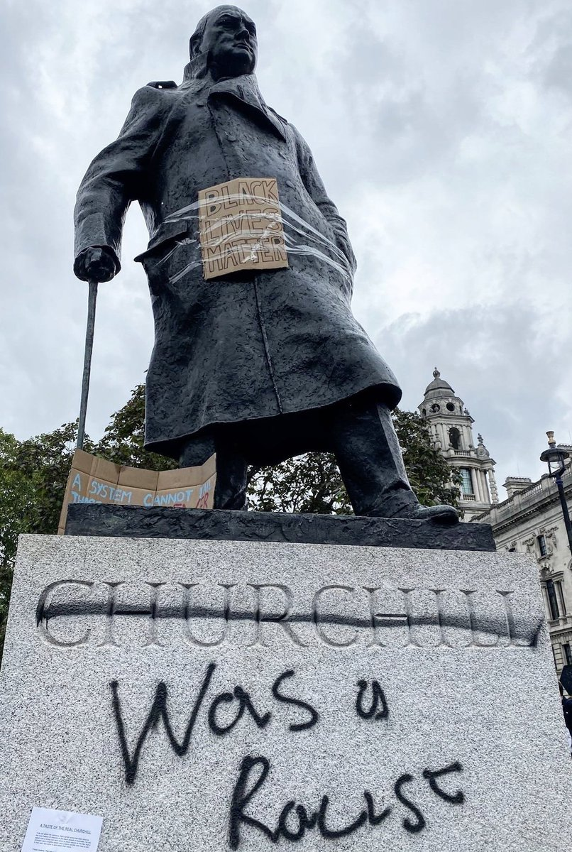

Issues of today

This task will focus on some of the pressing issues of today – current affairs.

Name__________________________
Issues of today

There are many global issues you may be aware of at this moment in time. International relations are currently negotiating a way out of this global pandemic but there are so many other pressing issues that we are dealing with in both global and UK political affairs.

It is important as a student you understand that these ‘issues’ are all dealt with in diplomatic ways by our government. However, as you may have learnt from the different manifesto pledges and party platforms of various political parties in the previous 2 bridging tasks, the party in power will often be the one who decides the direction taken in tackling particular issues.

The decisions may be ideological and based around the historical backgrounds of the party itself (such as Labour thinking along the lines of socialism and Conservatives being a little more traditional) but the decision can also be influence significantly by public opinion or even how the media portrays the issue in news, television, newspapers and so on.

This task will focus on you completing some independent research to educate yourself on current affairs and issues in the world of politics and then try to figure out what has been the influence on the outcome/ potential outcome.

Issue 1 – Free school meals

What is the issue?
Throughout the global pandemic there have been a number of issues over disadvantaged children accessing vouchers to enable them to continue to have access to what would be, free school lunches. The government decided to guarantee children have access to £15 a week during the pandemic but originally said they would not guarantee this through the summer holidays because under normal circumstances, free school meals does not cover the holidays.
Conduct some independent research on what has happened surrounding this issue and make sure to include information on the following in your response:

- The role of Marcus Rashford
- The power of campaigns driven by the people
- The role of the media in bringing the issue to our attention

________________________________________________________________________________________________________________________________________________________________________________________________________________________________________________________________________________________________________________________________________________________________________________________________________________________________________________________________________________________________________________________________________________________________________________________________________________________________________________________________________________________________________________________________________________________________________________________________________________________________________________________________________________________________________________________________________________________________________________________________________________________________________________________________________________________________________________________________
Issue 2 – Institutional racism

What is the issue?
We have become much more aware of the existence, impact and effect of institutional racism in our society over the last 20-30 years and this has recently reached fever pitch with the terrible circumstances surrounding the death of George Floyd in America. It is clear that not much has been done to combat this issue, especially in the USA but certainly in the UK as well.
Conduct some independent research on what has happened surrounding this issue and make sure to include information on the following in your response:

- A definition of institutional racism.
- The role of the #blacklivesmatter campaign/ organisation.
- Outline and show understanding of some of the potential solutions to institutional racism such as defunding the police, employing the Rooney Rule in the Premier League and removing statues that celebrate individuals who had historical roles in the slave trade.
- What have the Conservative Government done in response to the protests that have taken place surrounding this issue in the UK? What is likely to happen in the UK to combat institutional racism? What have Labour suggested?
________________________________________________________________________________________________________________________________________________________________________________________________________________________________________________________________________________________________________________________________________________________________________________________________________________________________________________________________________________________________________________________________________________________________________________________________________________________________________________________________________________________________________________________________________________________________________________________________________________________________________________________________________________________________________________________________________________________________________________________________________________________________________________________________________________________________________________________________________________________________________________________________________________________________________________________________________________________________________________________________________________________________________________________________________________________________________________________________________________________________________________________________________________________________________________________________________________________________________________________________________________________________________________________________________________________________________________________________________________________________________________________________________________________________________________________________________________________________________________________________________________________________________________________________________________________________________________________________________________________________________________________________________________________________________________________________________________________________________________________________________________________________________________________________________________________________________________________________________________________________________________________________________________________________________________________________________________________________________________________________________________________________________________________________________________________________________________________________________________________________________________________________________________________________________________________________________________________________________________________________________________________________________________________________________________________________________________________________________________________________________________________________________________________________________________________________________________________________________________________________
Some things to take away. Whilst conducting the research and completing the two tasks you have above, I would hope that you can recognise some of these pointed out below.

Firstly, there are many issues in the world that require attention by our government and swift action to ensure an outcome that is in the interest of the people. Sadly, some governments have certain agendas that prevent them from acting effectively to resolve disputes. For example, the free school meals issue was not going to be addressed at all had it not been for the campaign started by Marcus Rashford. However, take a moment to consider whether anything at all would have been done about free school meals if it was not for the celebrity endorsement of Rashford. We as the electorate must recognise that change starts with us as ordinary people who gather support for a particular issue and we fight for what we believe to be right – similar to the #blacklivesmatter organisation.

Secondly, you can see how the media have a huge role to play in bringing about change on major issues. We all read news on social media, listen to it on podcasts, watch news on television and discuss these issues daily amongst our friends and family who have also been informed by the media they consume. The media is extremely powerful in applying pressure on the government but it is also extremely powerful in shaping our understanding and opinions of particular issues. Media is bias and different media outlets will present certain issues in certain lights. You will probably have found in your research on institutional racism many outlets that present the #blacklivesmatter campaign as a group of bad people encouraging crime and looting and using institutional racism as an excuse to bring crime and deviance to society – in the same breath you probably found many media outlets celebrating the success of #blacklivesmatter in bringing the issue to our attention and helping build bridges to improve society as a whole.

Thirdly, and maybe most important; change in society on certain issues is the result of the power of the people. The definition of democracy is ‘people power’. The issues you have researched in this task involve the overwhelming support for change coming from ordinary citizens. This is why it is so important we are politically active and make sure our voices are heard through protests, demonstrations, petitions, voting in elections, joining political parties and other so on. There are many other significant issues out there that governments do not act on because there is not enough pressure on the government to bring change. This is why it has been noted that ‘elected officials are effectively elected followers’ – they must do what we, the public, want them to do. It is no coincidence that when something becomes popular, policy changes shortly after – think about the popularity of same sex rights leading to legalisation of same sex marriage, or demands for equal pay in the 1970s leading to the Equal Pay Act and in the modern day we see increased demands for environmental policy because the public are demanding change to combat global warming and recently Boris Johnson changed the governments deadline for banning the sale of petrol and diesel cars from 2040 to 2035 with the hope to make this even sooner. We, the people, are responsible for change on issues of the day. But if we do not send letters to MPs, encourage celebrities to support our campaigns, organise protests, get the media on board and so on then we will not experience change. A worrying trend in Western societies over the last 20 years has been a decline in people exercising their democratic rights, we must reverse this trend and the two issues you have looked at today are promising for recognising and understanding the power of the people.

Final task – assessment

Your task to hand in when we come back to school in September is as follows. Answer the following question.

Evaluate the impact and effect the media had on the general election outcome in 2019.

Advice for response:

Aim to write around 2 pages for your response. Start off by making it clear what you mean by the media (most likely the impact and effect of social media platforms, newspapers, television debates, radio and so on) and then go on to find evidence that would lead us to believe that the media influenced the outcome. For example, consider the image below from the Sun newspaper and how this type of media could influence the way people voted.
After writing at least one paragraph on the impact the media had on the general election write at least 2 more paragraphs on other factors that contributed to the election outcome. Consider some things we have covered so far such as the role of the leaders (some said Corbyn was too old and did not ‘look the part’) or pick out certain manifesto pledges such as ‘Get Brexit done!’ by the Conservatives.
A final short paragraph should be a written conclusion on what you believe to have been the most important factor that contributed to the election outcome of 2019. What do you believe was the factor that was most responsible for the majority win the Conservatives secured under Boris Johnson?
