The Blue Coat Sixth Form.
Bridging Course
Part 3

Welcome to the final part of the BCSF bridging course!
In this section we will be asking you some questions to best get to know you.
If you come in September we would like to know as much information about you as possible and this part is designed to give staff and form tutors some additional information about yourself, your hobbies, talents and family!

Task 1:
Subjects
Which subjects would you like to study? Give reasons for your choices. (Don’t say “because they sounded interesting!”)
Subject 1:
Reason:

Subject 2:
Reason:

Subject 3:
Reason:
______

___________

Task 2:
Give yourself 30 seconds to look at the grid below.
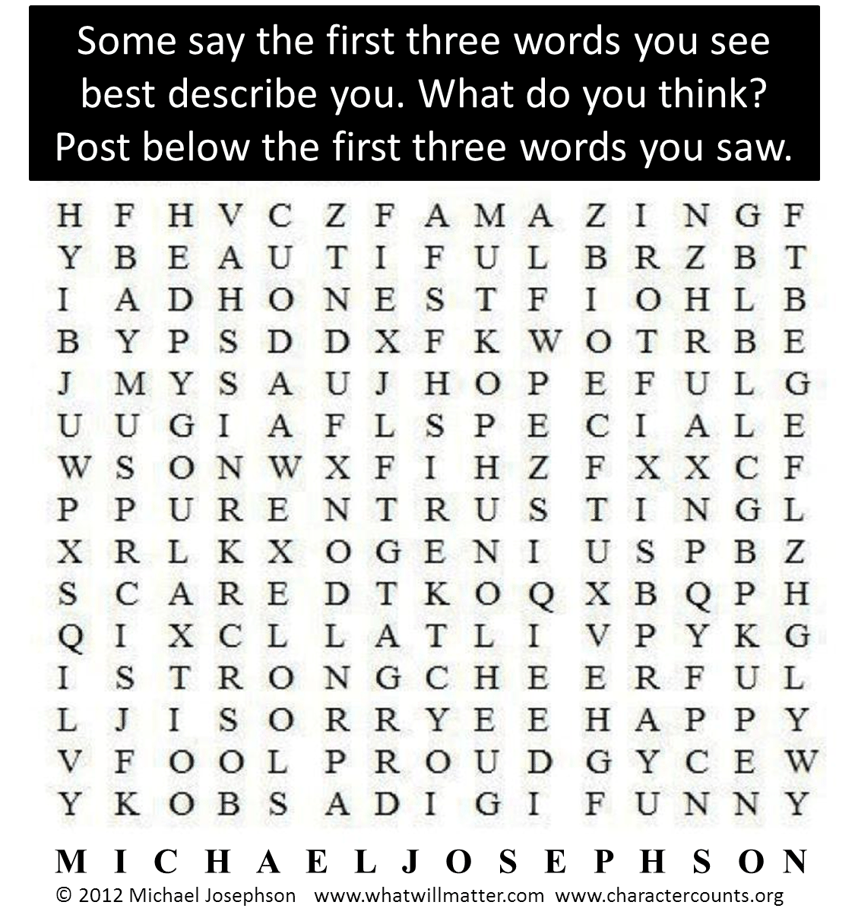
What are the first 3 words that you see?

1. _____________________
2. _____________________
3. _____________________

Explain how each of these words best describe you / your personality:
________________________________________________________________________________________________________________________________________________________________________________________________________________________________________________________________________________________________________________________________________________________________________________________________________

Task 3:
Answer the following:

Is there any product that you couldn't live without?
________________________________________________________________________________________________________________________________________________________________________________________________

Who has had the biggest impact on your career choice?
________________________________________________________________________________________________________________________________________________________________________________________________

What are you most proud of in the last year?
________________________________________________________________________________________________________________________________________________________________________________________________
Who do you admire most in the world? Why?
________________________________________________________________________________________________________________________________________________________________________________________________________________________________________________________________
If you could pick one celebrity to play you in a film, what genre of film would it be and who would you pick and why?
________________________________________________________________________________________________________________________________________________________________________________________________

Task 4:
Stepping up to A – Levels.
This is known as a transition period, (a time of change) especially in comparison to GCSE and what you are used to but, in particularly how you have experienced the end of 2019 – 2020 academic year with regards to Covid-19.
Watch the clip: Advice from a current Year 12 – 13 student.

https://youtu.be/LyDfhCLx8HI

Create a to do list for yourself on what things you will do to get yourself prepared for all of your subjects in September.
My to do list:
1.__________________________________________.
2.__________________________________________.
3.__________________________________________.
4.__________________________________________.
5. _________________________________________.
6. _________________________________________.
Other: _____________________________________________________________________________.
Finally, use the space below to draw an image that represents you and explain what the image is and why you chose this.
This can be anything from sunshine, a musical note etc.

This is an image of ________________________________________. I chose this to best represent me because ________________________________________________________________________________________________________________________________

We hope you found these questions fun to answer / share with us in September.
Good luck with completing all your Subject Bridging Courses. We look forward to seeing you in September.

Bye for now!

