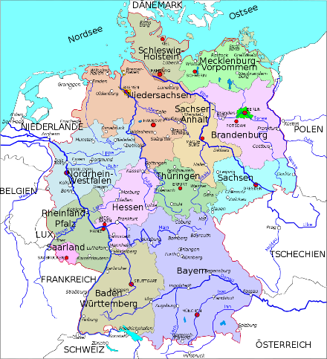
The Blue Coat School German A Level Year 11 Bridging Material – part 2:

An introduction to the A Level course

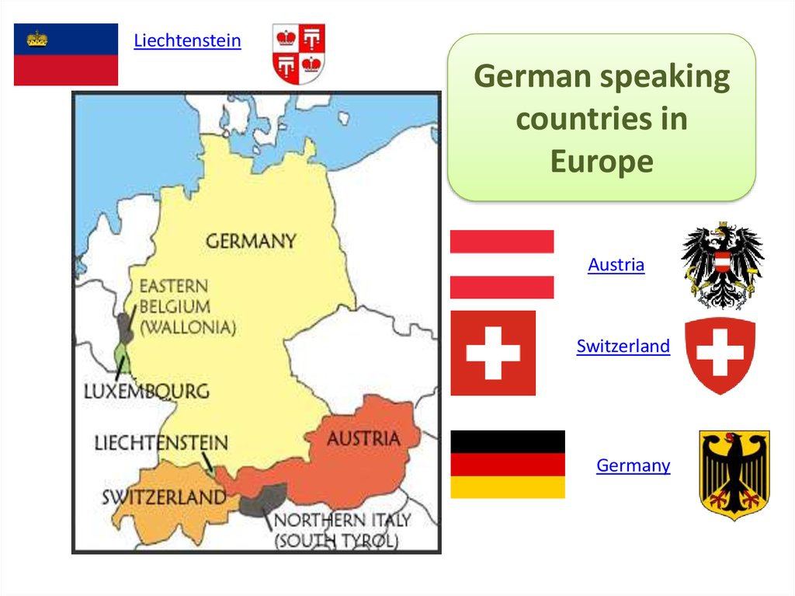

Guten Tag, Hallo und Grüß Gott! Welcome to your first taste of German A level! In the second section of material, we want to give you a taste of what you will be studying in the first few weeks of the A Level course in September. Make sure you bring this work with you in September!
Bridging Work Part 2 tasks:
- Die Familie - in the first weeks of the A Level course, you will be looking at German-speaking societies and how families and marriage have changed. Below there are 2 links to videos about types of family. Watch the videos (feel free to re-watch them, pause the recording and click on the 3 horizontal dots below the video to open the transcript), and write out definitions (in German) for the following terms ready to show us in September: Familie / Kernfamilie / Kleinfamilie / Großfamilie / alleinerziehend / Patchworkfamilie / Adoption / Pflegefamilie / Regenbogenfamilie.
FAMILIE - Ethik einfach erklärt - - YouTube
Familie - was für Familien gibt es und was macht sie aus? - YouTube
Find out more about “Co-Parenting”. Click on the link below and do exercise 1 (Übung 1) first, then watch the video and do the remaining exercises. You can read the transcript by clicking on “Manuskript”; this will enable you to look up any vocab you don’t know. Make a list of all the vocab in blue in the transcript both German and English, take a screenshot of the exercises you completed and save it all, ready to show us in September.
Die neuen Familien | Video-Thema – Lektionen | DW | 13.01.2016
- Die Familie research- Do some research on what German people think of marriage (“Wie denken die Deutschen über Ehe / Heiraten?”). Make notes in German or English. The following link might be a good starting point: • Infografik: Heiraten: Egal wann, hauptsache aus Liebe | Statista
- Die Bildung - Alongside looking at the change of family structures you will be looking at the German education system. Below there are 2 links to videos about “Das deutsche Schulsystem”. Watch the videos (feel free to re-watch them, pause the recording and click on the 3 horizontal dots below the video to open the transcript), and make notes in German ready to show us in September.
Das deutsche Schulsystem - YouTube
Fakten: Schule in Deutschland | DW Deutsch - YouTube
- Die Bildung research- Do some research on the problems young Germans face in school. Make notes in German or English and write out some key vocab ready to show us in September. The following link might be a good starting point: Die 10 schlimmsten Schulprobleme und was Sie Sie dagegen tun können! - Elternwissen.com
- Die Grammatik- Brush up on your knowledge of German word order. Go on to German Grammar with Rules and Interactive Exercises (lingolia.com). Go to the Sentence structure section and focus on Main clauses and Dependent clauses (only do the activities on “Conjunctions”). Each section has an explanation of the rules first and then some free self-marking mixed exercises to practise the grammar. There is no need to do the extra exercises. Take screenshots of the work ready to show us in September.
- Der Film- Find a German film to watch (Choose from “Balloon” on iplayer or “Isi and Ossi”, “Charité” and “Skyline” on Netflix) and write a short review (no more than 200 words in German) about what you thought of it and why. Be prepared to discuss it when we meet for lessons.
3. Les questions

En France, tout le monde est contre le mariage pour tous
Vrai | Faux

La loi autorise tous les hétérosexuels à se marier
Vrai | Faux

Certaines personnes n’apprécient pas l’idée que deux personnes homosexuelles puissent être ensemble
Vrai | Faux

Des personnes ne souhaitent pas que les couples homosexuels adoptent des enfants
Vrai | Faux

Le changement, en France, provoque souvent des craintes
Vrai | Faux

Le mariage est la concrétisation de l’union de deux personnes
Vrai | Faux

Les députés ont tranché et ont aboli la loi sur le mariage pour tous
Vrai | Faux

Plus de 7000 couples homosexuels se sont mariés depuis cette loi. (vidéo publiée en 2014)
Vrai | Faux

