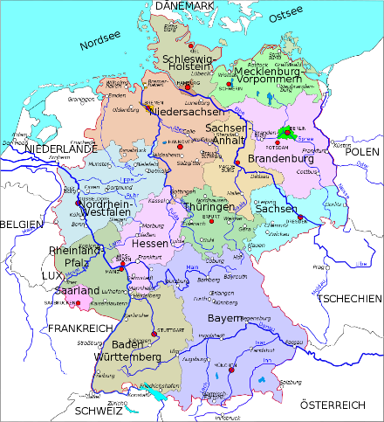
The Blue Coat School German A Level Year 11 Bridging Material – part 1: GCSE review

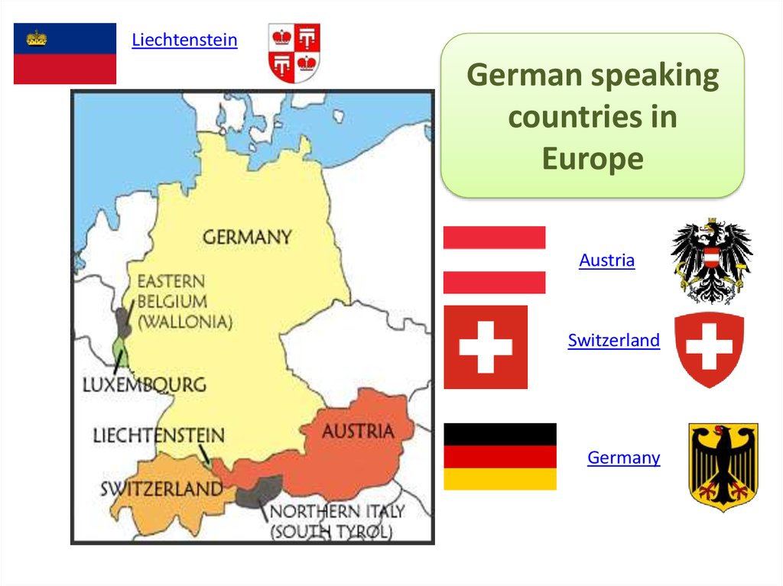

Guten Tag, Hallo und Grüß Gott! Welcome to your first taste of German A level! The A-level specification builds on the knowledge, understanding and skills gained at GCSE. There is of course a continued focus on language, but increasingly you will learn about culture and society of German-speaking countries.
Bridging Work Part 1 tasks (work to record and bring in September is underlined):
- Grammar
You will need to be confident with German word order and with both regular and irregular verbs in the present, perfect, imperfect and future tenses. A fantastic way to go over the rules for word order and tenses and practise them is on the Lingolia Learn German website.
Go on to:
German Grammar with Rules and Interactive Exercises (lingolia.com)
On the Verbs section, activities on modal verbs, infinitive with and without zu, separable verbs and subjunctive are most important at this stage. On the Tenses section, you should focus on activities on present, present perfect, simple past and future tenses. Each section has an explanation of the rules first and then some free self-marking mixed exercises to practise the grammar. There is no need to do the extra exercises. Take screenshots of the work ready to show us in September.
- Culture and society
- Vocabulary | Sonst noch etwas? | DW Learn German
Revise the GCSE vocab on fruit and veg first. Click on the link above and write down the vocab, ready to show us in September. Then click on the following link:
Nicos Weg – A1 – Folge 51: Sonst noch etwas? - YouTube and watch the video. Then click on the following link Inge and Nico at the farmer's market | Sonst noch etwas? | DW Learn German and do the exercises. This is one of many episodes from the series “Nicos Weg”, which is all about Nico, who has just arrived in Germany and is learning how to take part in German life.
- Deutschlandlabor - Folge 1: Schule - Goethe-Institut
Revise the GCSE school vocab first (subjects, facilities etc.). Then follow the link – click on “Manuskript zum Mitlesen und Wortschatzhilfen” to read the transcript of the video. Play the video and make notes in German and English on the information of the German school system and the school shown in the video. Include the following: School system, PE lessons, lesson activities (e.g. discussions, student presentations), canteen, students. Make up your own vocab list based on the video. Useful revision (and extension) of school vocab but also really good insight into school in Germany. This is the first of 20 videos on different aspects of Germany, its culture and people.
- Deutschlandlabor - Folge 8: Musik - Goethe-Institut
Revise the GCSE vocab for music and musical instruments first. Then follow the link – click on “Manuskript zum Mitlesen und Wortschatzhilfen” to read the transcript of the video. Click on “Arbeitsblätter für den Präsenzunterricht” and read through the questions on the second sheet; make sure you understand what they mean. Play the video and try to answer the questions (in German or English), ready to show us in September.

- Quarantäne Apfelkuchen - YouTube
Revise GCSE food vocab first, then click on the link above and watch the video to learn how to bake a typical German apple cake! Make a list of all the vocab in both German and English and write out the recipe in full (both German and English). We would love to sample your German home-baking in September, so why not bake this delicious cake just before your first German lesson and bring it in?

