Economics Bridging Unit - Part 1 – GCSE Review
Very few schools offer GCSE Economics, so it is unlikely that you have studied the subject before. The aim of this bridging unit is to introduce economics as a social science and highlight some of the mathematical skills required at A-level.
The first section’s questions are in blue boxes. Please hand write your responses. The extension questions / activities are voluntary.
Section 1 - Economics as a social science – read the following overview
The word “science” is derived from the Latin word ‘scientia’ meaning ‘knowledge’. Science refers to a systematic and organized body of knowledge in any area of inquiry that is acquired using “the scientific method”.
It follows that social science is concerned with creating an organised body of knowledge about society and the relationships between individuals within those societies.
The scientific method refers to a standardized set of techniques for building scientific knowledge, such as how to make valid observations, how to interpret results, and how to generalize those results. The scientific method allows researchers to independently and impartially test pre-existing theories and prior findings, and subject them to open debate, modifications, or enhancements.
The scientific method must satisfy four key characteristics:
• Logical: Scientific inferences must be based on logical principles of reasoning.
• Confirmable: Inferences derived must match with observed evidence.
• Repeatable: Other scientists should be able to independently replicate or repeat a scientific study and obtain similar, if not identical, results.
• Scrutinizable: The procedures used, and the inferences derived must withstand critical scrutiny (peer review) by other scientists.
In light of these four characteristics it’s clear that the social sciences are very different from the natural sciences. Some in the natural science community argue that social sciences aren’t sciences at all. Interestingly, a growing number of economists agree!
The natural sciences are precise, accurate, deterministic, and independent of the person making the scientific observations. Two scientists measuring the speed of sound through a certain media (concrete, plastic, glass) should get the same result; a different result implies one (or both) have made an error.
The social sciences tend to be less accurate and more ambiguous. If two social scientists seek to measure how happy society is, there’s a high degree of probability they will get different results: there’s no machine to measure happiness and no agreed scale of happiness. It’s conceivable that the same person interviewed by two social scientists could be described as happy by one and sad by the other.
Question 1: using evidence from text, explain why some natural scientists argue that social sciences aren’t sciences at all.

In summary, you’ll not find many disagreements among natural scientists on the speed of light or the speed of the earth around the sun, but you will find numerous disagreements among social scientists on how to solve social problems such as excessive alcohol consumption and poverty.
As a student of economics, you must recognise and accept the high level of ambiguity, uncertainty, and error present in all social sciences.
In economics the distinction is made between ‘positive’ economic statements and ‘normative’ economic statements.
Question 2: Define normative and positive economic statements. Give at least two examples of each.
Extension question: why is the distinction between normative and positive important?

Economics is one of many social sciences. Follow the link below for an overview of the many and varied disciplines classed as social sciences:
https://esrc.ukri.org/about-us/what-is-social-science/social-science-disciplines/
There is one noteworthy difference between economics and the other social sciences: economics is the only social science for which a Nobel Prize is awarded. Follow this link to get a feel for the types of research Nobel Laureates have been rewarded for undertaking:
https://www.nobelprize.org/prizes/lists/all-prizes-in-economic-sciences/
Extension:
The 2019 prize was awarded to 3 economists whose main area of interest is global poverty. This Channel 4 interview with one of the winners, French Economist Esther Duflo, is fascinating.
https://www.youtube.com/watch?v=i1pZfFY132Q

Research methods
Social scientists tend to conduct two types of research: qualitative and quantitative. Follow the links to discover what each involves:
Quantitative: https://esrc.ukri.org/about-us/what-is-social-science/quantitative-research/
Qualitative: https://esrc.ukri.org/about-us/what-is-social-science/qualitative-research/
Question 3: What is the difference between ‘a theory’ and ‘a law’? (careful, it’s not law in the legal sense of the word)
Extension question: scientific inquiry can take two forms: inductive research and deductive research. Define each and apply to economics.

Section 2
Maths in Economics
Answer all questions.
- Milano’s Pizza is a large-scale frozen pizza manufacturer based in Newcastle. They have 4 pizza machines. 1 machine can make 500 margarita pizzas an hour OR 400 ham and pineapple pizzas per hour. The manager currently has 2 machines making margarita pizzas and 2 machines making ham and pineapple pizzas. Assuming there are no defects or production problems, what is the maximum number of pizzas the firm makes in 12 hours.
- The regional demand for Milano’s ham and pineapple pizzas increases after two prominent Newcastle footballers post a photo of themselves on Instagram eating them. To satisfy the extra demand, the manager at Milano’s decides that she will use 3 machines to make ham and pineapple pizzas and 1 machine to make margarita pizzas. Calculate the new maximum number of pizzas made in 12 hours.
- After a few weeks, the manager decides that the only way she can cope with the surging demand is to buy 2 more machines (6 in total). She uses 1 to make margarita pizzas (2 in total) and 1 to make ham and pineapple pizzas (4 in total). Calculate the percentage change in production in both types of pizza.
- Geoff sells a house for £650,000 in Harrogate. The estate agent is paid 1.5% of the selling price for her services. Calculate how much she is paid.

- Geoff buys a new 1-bedroom apartment in London with the proceeds from his house sale in Harrogate. The apartment costs him £500,000 to buy. This time he has to pay Stamp Duty tax on his purchase. Stamp Duty tax at this price is 3%. How much tax does he pay?

- Over the next five years, London house prices go up by 45%. House prices in Harrogate decrease by 1.25%.

  - Calculate how much Geoff’s London apartment is worth five years later.
  - Calculate how much his house in Harrogate would have been worth if he hadn’t sold it.
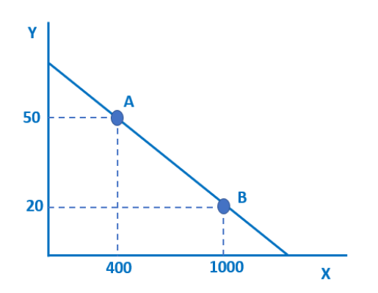
- A and B are two points on a straight line. If we move from A to B, how many X units do we gain and how many Y units do we lose?

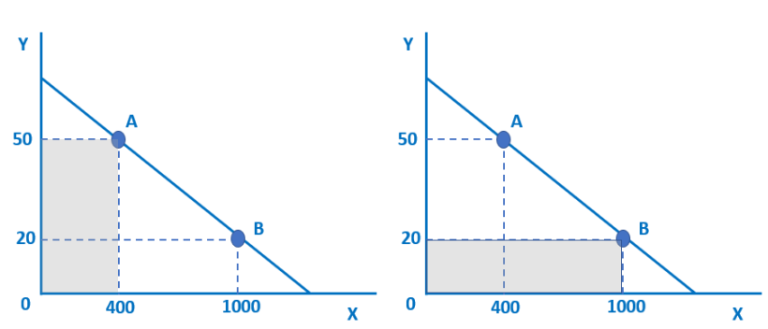
- Calculate the area of each of the shaded rectangles.

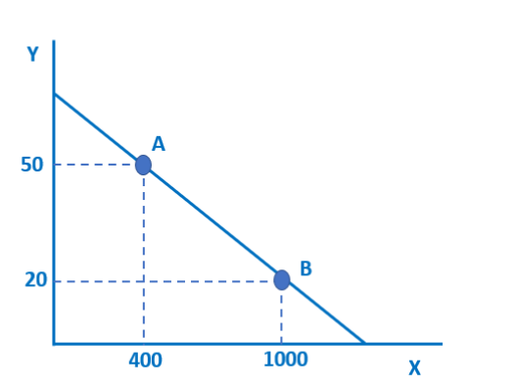
- The gradient does not change but the relationship between Y and X changes. At each amount of Y there are now 400 more units of X. Adapt the diagram above to illustrate the change.

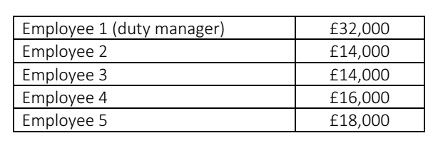
- The owner of a small carpet cleaning business looks at the annual salaries of his five employees.

The boss hires a sixth employee to the business. The employee is highly experienced and very skilled. As a result, she commands a relatively high salary of £26,000.

  - Calculate the extra cost of the additional employee.
  - Calculate the change in the mean average salary in the business.
  - Calculate the new median average salary for the employees of the carpet cleaning business.

- A British-made car costs £20,000. The current exchange rate is £1 (UK pound) to $1.30 (US dollars). 6 months ago, the exchange rate was £1 to $1.50.
Calculate how much the £20,000 car costs in US dollars
  - Now
  - 6 months ago.

