A level Politics
at The Blue Coat Sixth Form
Social Sciences Department
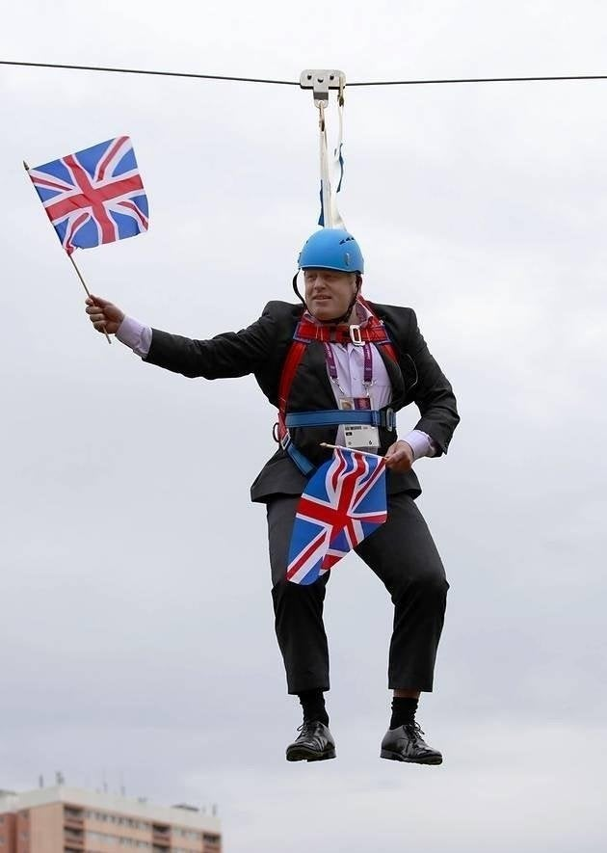

The social sciences department would love for you to use this time over the coming weeks and months to get interested in Politics. Start to develop your interest in the subject and build your general political knowledge. This will serve you well and enable you to hit the ground running in September when you commence your journey studying A Level Politics.

Name__________________________
What will you be studying?

It is important to have an understanding of what course you will be studying so please follow the link below and have a look at the specification. Throughout the course we will study British government and politics, American government and politics (with a comparison of the UK and USA) and the last section is on Political ideas (easier understood as ideologies).

Specification:

https://filestore.aqa.org.uk/resources/politics/specifications/AQA-7152-SP-2017.PDF

Textbooks:
You don’t have to purchase the text books listed below, but for your information, these are the textbooks we will use throughout the course.
- UK and US politics - AQA A-level Politics: Government and Politics of the UK, Government and Politics of the USA and Comparative Politics: Hodder Education
- Political ideas - https://www.hoddereducation.co.uk/subjects/government-politics/products/16-18/political-ideas-for-a-level-liberalism,-conser-(5)

Politics – what do we need to know?

There is no ideal ‘starting point’ for government and politics but so much of the course requires a deep understanding of key political ideas that are broadcast to us through different political parties so a reasonable activity for you to get into politics is to do some research on the major political parties of the UK. At this stage we would expect that you have an interest in politics, probably as a result of the Brexit referendum of 2016, recent general elections in 2017 and 2019 and the interesting election of Donald trump as President of the USA in 2016. Voting is an intrinsic aspect of any thriving democracy and when we cast our ballots in elections, we are largely voting based around the policy ideas each respective party wishes to introduce should they be fortunate enough to win a general election. The 2 major political parties we hear so much of in the UK are Labour and the Conservatives and this task will be based around gathering a better understanding of these two different political parties.

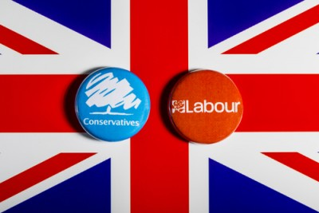

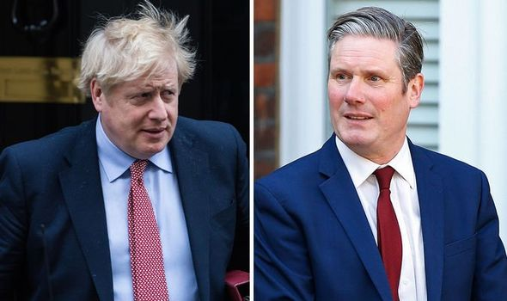
The two current leaders of the Conservative Party and Labour Party can be seen above. Find out what their names are and when they became leader of each respective party. The images continuing below are of previous leaders. What are their names?

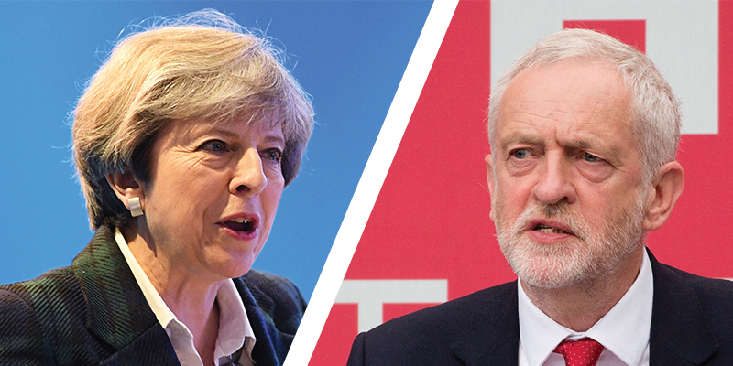
Conservative leader: ____________ Labour leader: ___________________

Conservative leader: ____________ Labour leader: ___________________
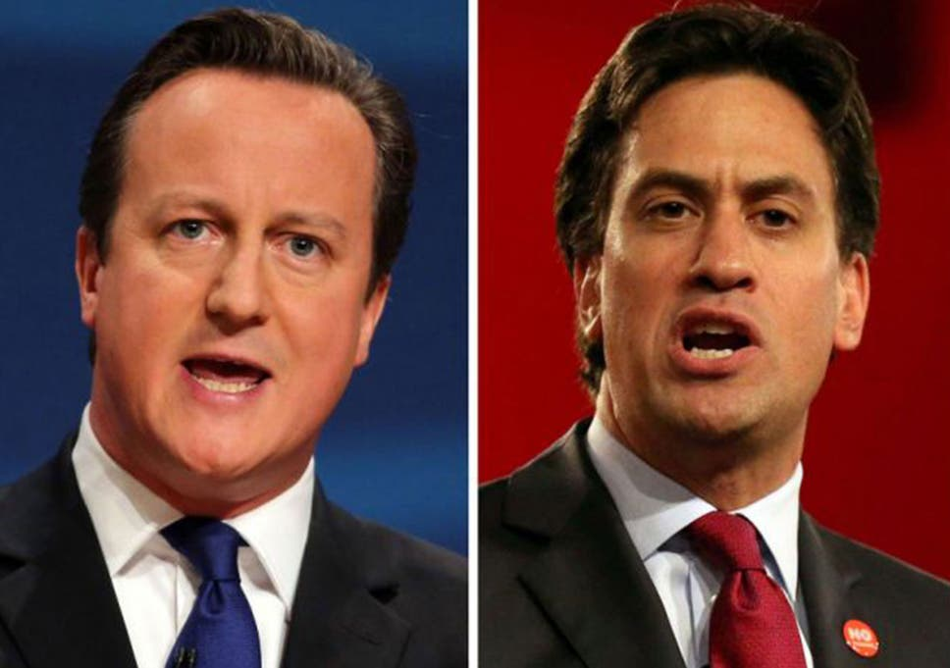
Conservative leader: ____________ Labour leader: ___________________
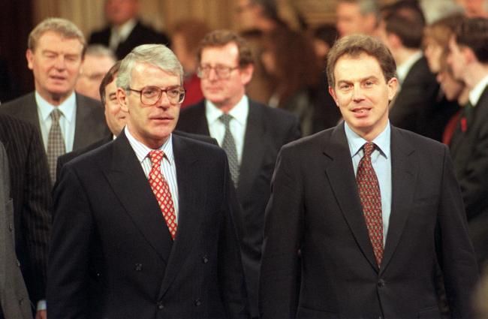

Conservative leader: ____________ Labour leader: ___________________
Having a good understanding of the leaders is extremely important because it is often these individuals whom we look towards to give us an idea of ‘what we are voting for’. The leaders have a tremendous influence over the direction of the party and they will have a lot of decision making power over the ‘offers’ each party promotes at General Election time.

Your task now is to research what each party has offered in the last 2 general elections of 2017 and 2019. The parties are release documents called ‘manifestos’ at times of elections and this is where we find out what each party aims to do in a range of policy areas. For a politics student it is really important to understand any similarities and/ or differences between the parties. This task will help you understand which party you prefer but it is also a great task to get you to grips with recognising what each party stands for.

For each of the elections, conduct some research and find out what each party manifesto wanted to do with regards to the specific policy areas highlighted in the columns below.

Labour 2017 manifesto | Conservative 2017 manifesto
Brexit plans:  NHS plans:  Income tax and corporation tax:  Education plan:  Renationalisation of railways:  Nationalisation of water utilities: | Brexit plans:  NHS plans:  Income tax and corporation tax:  Education plan:  Crime/ Police:  Immigration plans:

Use the following links to help if you need.
Labour manifesto summary 2017: https://www.bbc.co.uk/news/election-2017-39933116
Conservative manifesto summary 2017: https://www.bbc.co.uk/news/election-2017-39960311

Labour 2019 manifesto | Conservative 2019 manifesto
Brexit plans:  NHS plans:  Education plan:  Nationalisation of key businesses/ industries:  Plan for ‘Universal credit’:  Environment plans: | Brexit plans:  NHS plans:  Education plan:  Immigration plans:  Plans for ‘universal credit’:  Environment plans:

Use the following links to help if you need.
Labour manifesto summary 2019 – https://www.bbc.co.uk/news/election-2019-50501411
Conservatives manifesto summary 2019 –
https://www.bbc.co.uk/news/election-2019-50524262

After researching these different manifestos, hopefully you have a better understanding of what each party stands for. Hopefully this has also helped you better understand what you stand for politically as well. It will be very important to keep up to date with what Boris Johnson (Conservatives) and Keir Starmer (Labour) pursue as leaders of the respective parties.

Before your next activity is set, we strongly advise you start reading and watching more information related to politics. Some useful links can be found below. It is important you get into the habit of keeping abreast of current affairs. The list below is simply a basic expectation to utilise regularly but feel free to branch out further afield to other outlets that you can use for politics information.

Question time - https://www.bbc.co.uk/iplayer/episodes/b006t1q9/question-time
Andrew Marr show - https://www.bbc.co.uk/iplayer/episodes/b0080bbs/the-andrew-marr-show
BBC News - https://www.bbc.co.uk/news/politics
Week in Westminster - https://www.bbc.co.uk/programmes/b006qjfq
Jonathan Pie (satirical comedian based around politics) - Jonathan Pie - YouTube

