A level Politics
at The Blue Coat Sixth Form
Social Sciences Department

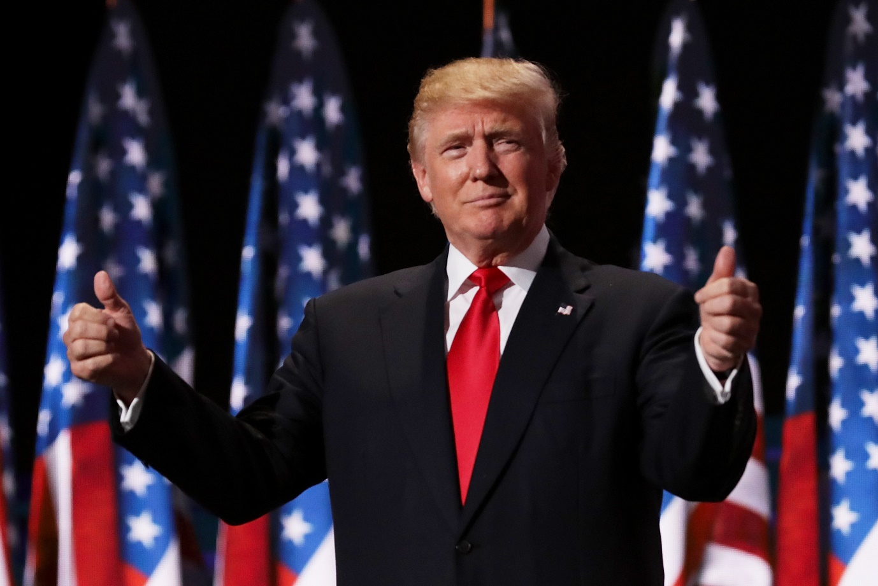

Introduction to American Politics

For your first bridging task you had an in-depth look at the similarities/ differences between the 2 main parties in the UK. As part of this you concentrated on recognising key ‘leaders’ throughout the last 30 years and then investigated the policies each party put forward in their manifestos. This time you will do a similar task but for American Politics.

Name__________________________
American Politics

We must first recognise that whilst American Politics on the surface appears similar to the UK; it is vastly different! Yes, both countries are democratic, both have their ‘leaders’ (Prime minister in the UK/ President in the USA), both have ‘legislatures’ (Parliament/ Congress) and both have their own ‘Supreme Courts’. But that is as far as the similarities get really. The intricacies of each country mean they are a great amount of key differences you must understand. Let us start with some important features of the USA you must understand:

- The USA has a codified constitution written in 1787 whereas the UK has an uncodified constitution that has naturally evolved since 1215 and the signing of the Magna Carta. Laws are very clearly laid out in the codified constitution of the USA such as what a President can or cannot do but there is no such similarity in the UK. There is no codified ‘list’ of the powers of the Prime Minister.
- The USA has a President who acts as head of state and head of the government. The Prime minister in the UK is only head of the government because the Queen is the head of state. This creates complex differences between each country because the President, like the Queen, is never allowed into Congress without permission from the legislature. However, in the UK, the Prime minister sits in the legislature and directs the government. There is no direct equivalent of a Prime minister in the USA which makes passing laws very complex – Congress could be controlled by one party and the Presidency by another party. Confusing, right? This is known as a separation of powers that is not evident in the UK but well established in the USA.
- Parties in the USA do not have ‘leaders’. As you found out in your last task, Boris Johnson is the current leader of the Conservatives and Keir Starmer is the current leader of Labour. Even though many see Trump as a ‘leader’ of the Republican Party, he is not. Instead of ‘leaders’ each party have key roles or positions certain high-ranking officials hold in Congress as we will learn today.

- Elections are very different in the USA. We have general elections once every 5 years to select our MPs who go to Parliament and represent us. The USA have major elections every two years. Every 2 years the whole of the House of Representatives is up for election (435 seats) and one third of the Senate is up for election (33/100 seats) alongside many state Governors (basically a President of the state you live in). There are also a whole range of elections that take place at the very same time in your home state such as your state representatives/ state senators/ city mayors/ local officials/ police Sheriffs and so on. It is effectively democracy overload once every two years in the USA. The President is elected once every 4 years and can only sit for a maximum of 2 terms – yet a PM in the UK can sit for as many times as they are elected.

For now, these differences will do. But please simply recognise that the USA and UK, whilst appearing similar, have lots of complex political differences. The whole ‘war of independence’ (1775-1783) was to make sure that the USA was not like the UK. For a start they did not want a monarchy and that is why the USA is a republic.

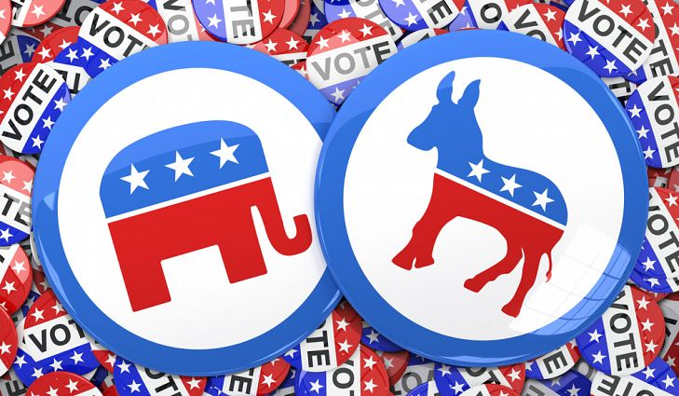

‘Leaders’ in the USA

In this task you are to find out the names of key individuals based upon the ‘role’ they currently hold. As a bonus, identify the ‘Party’ they represent.
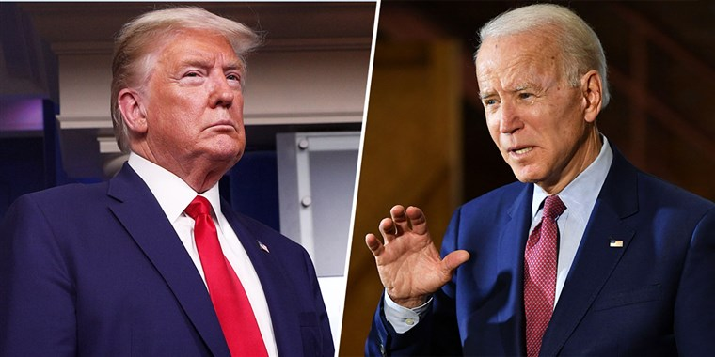
President of the USA post 2020 election: ___________________
2020 Republican nominee for President: _____________________
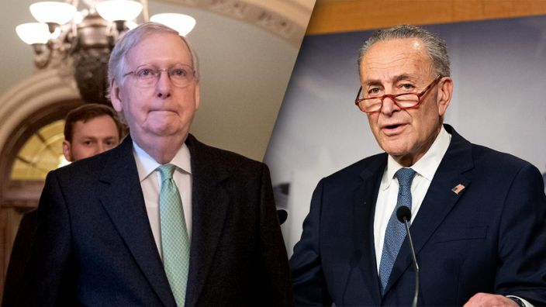
Senate majority leader (on the left): ________________________
Senate minority leader (on the right): _________________________
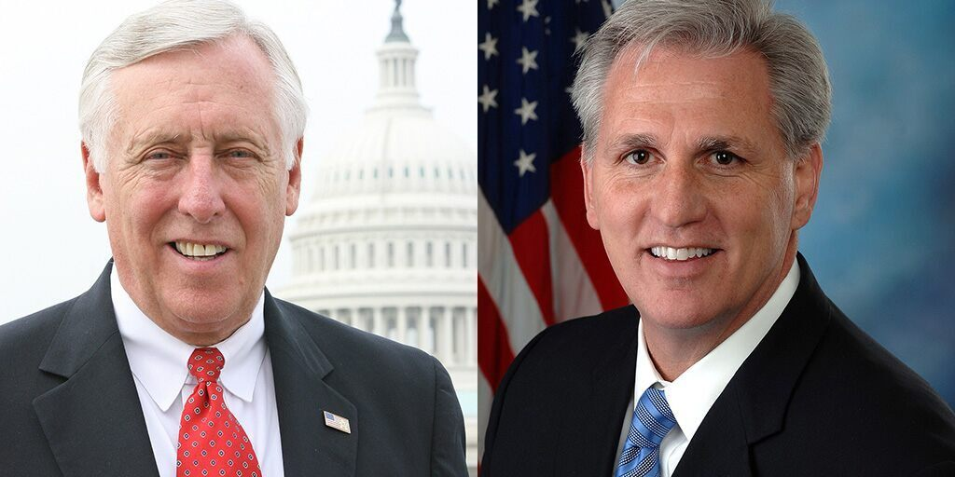
House majority leaders (on the left): _________________
House minority leader (on the right): ____________________
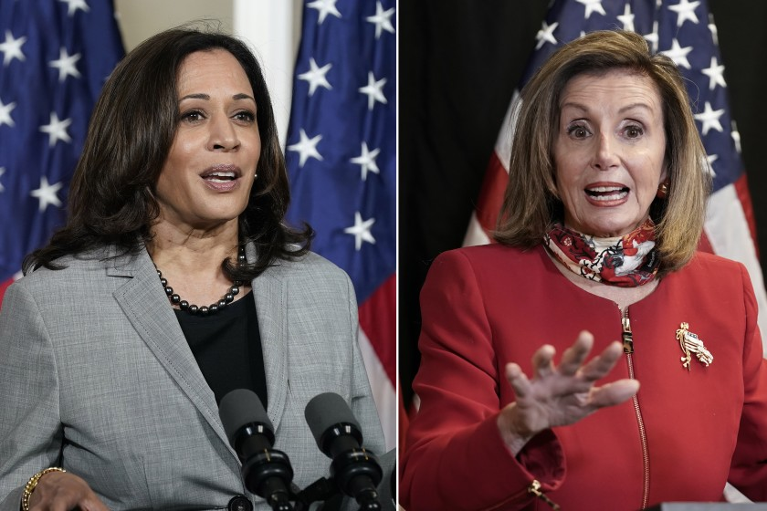
Vice President of the USA (on the left): _________________
Speaker of the House (on the right): ____________________

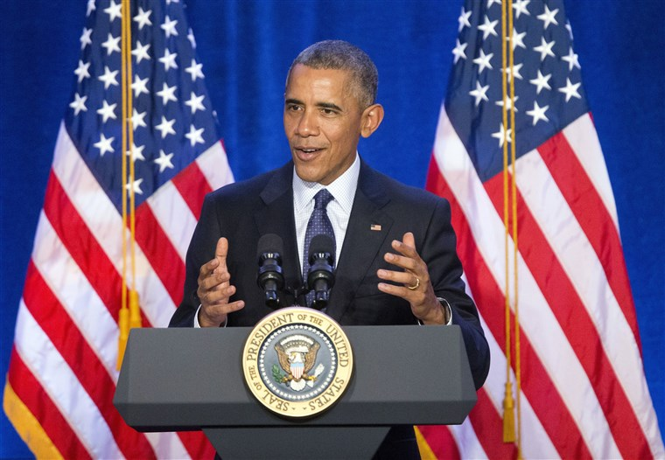
President of the USA from 2009 – 2017: _____________________

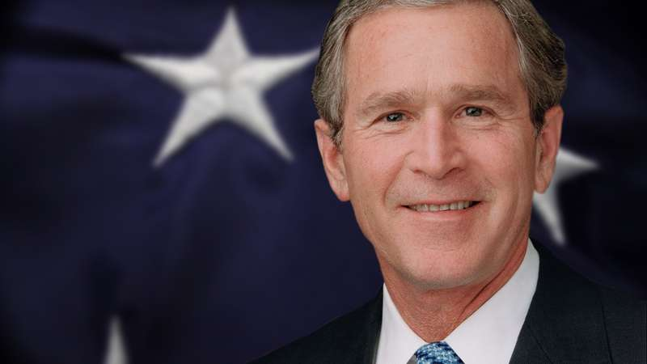
President of the USA from 2001 – 2009: ________________________
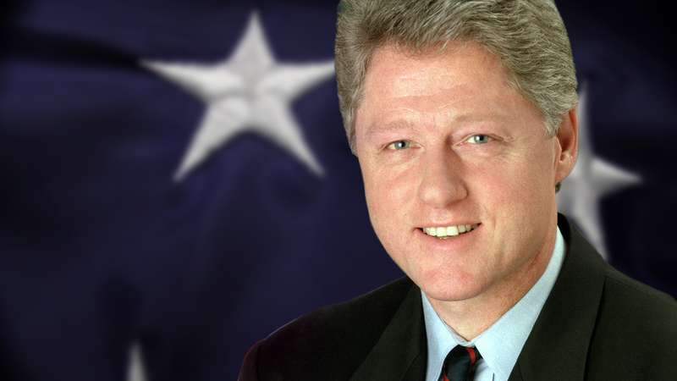
President of the USA from 1993 – 2001: _________________________

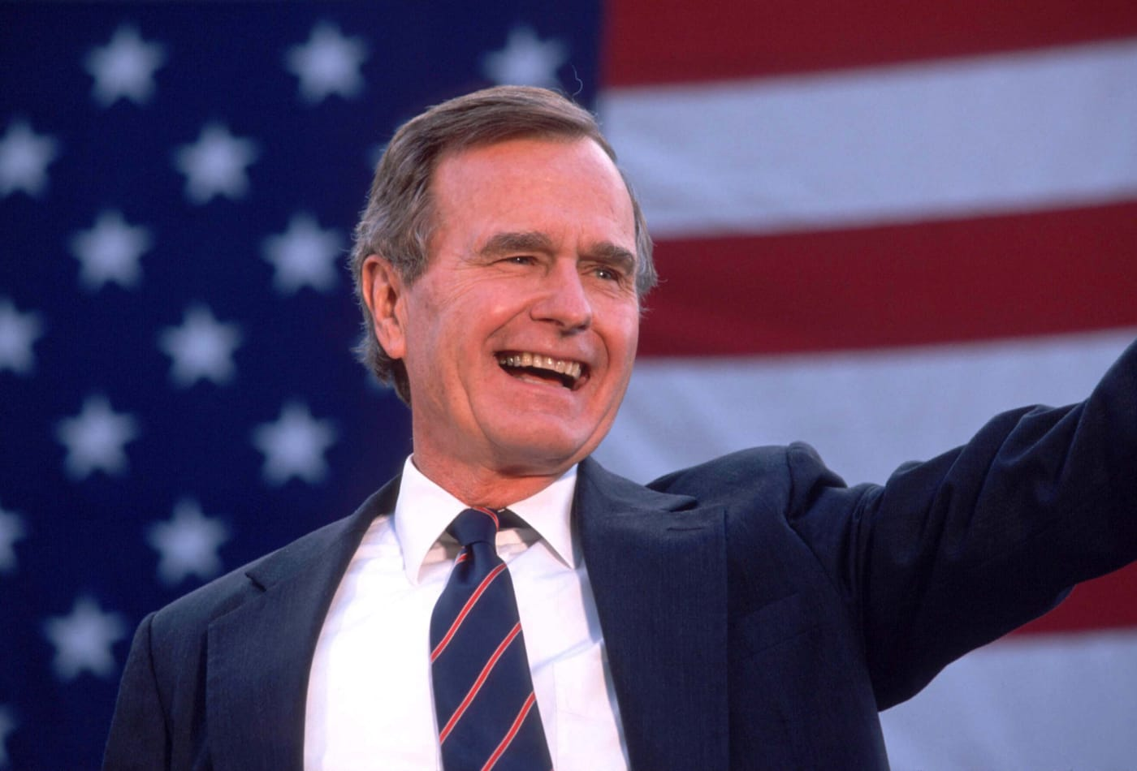
President of the USA from 1989 – 1993: ____________________________

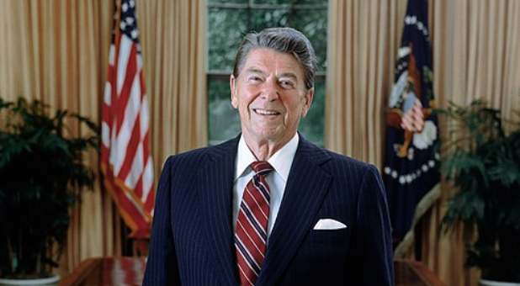
President of the USA from 1981 – 1989: __________________________

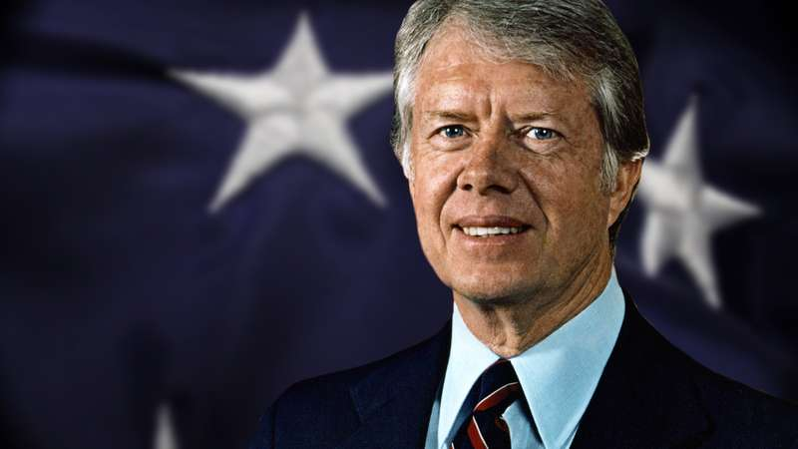
President of the USA from 1977 – 1981: _______________________

Voting in Presidential elections

As you have already learnt, Presidential elections take place once every 4 years with the next on scheduled for November 2020. Unlike in the UK, where Parties release ‘manifestos’, the USA does not release manifestos to the public. This is because the separation of powers in the USA means you could have Congress dominated by one party, or even divided (Republicans having a majority in the Senate and Democrats having a majority in the House of Representatives) and a President from an opposing Party. Seen as the President cannot sit in the legislature, the President cannot enforce Congress to legislate the plans he/ she made in the elections.

As such, the 2 parties release ‘platforms’ during the Presidential election which, instead of being ‘promises’ they will legislate if they win the office of Presidency, the platforms are merely a set of agendas or ideas they will attempt to pursue in office by persuading Congress to do as they wish. There are no guarantees that a President will achieve this

As an example, Trump and the Republicans planned to ‘build a wall’ in the 2016 platform before the Presidential election – and this was never fully built. This is because Congress did not agree with Trump over the plans for this to be built.

Similar to the task you did last time, I would like you to research the main ideas for each of the 2 main parties in the 2020 Presidential election. The Republicans and Donald Trump had their agenda kept from the 2016 election and the Democrats and Joe Biden had their agenda refreshed from 2016. Whilst completing this task, see if you can see any similarities/ differences between the Parties in the USA and the UK.
2020-Democratic-Party-Platform.pdf (democrats.org)
https://prod-cdn-static.gop.com/media/documents/DRAFT_12_FINAL[1]-ben_1468872234.pdf?_ga=2.199931822.1871695372.1591005534-794096952.1591005534

Republican Party Platform 2020 | Democratic Party Platform 2020
Tax plans:  Environmental plans:  Second Amendment plans:  Healthcare plans particularly abortion:  Immigration plans:  Criminal justice plans: | Minimum wage plans:  Environmental plans:  Gun violence plans:  Healthcare plans particularly abortion:  LGBT rights plans:  Immigration reform plans:
As a light-hearted introduction to American Politics, I encourage you to watch some of the ‘Daily Show with Trevor Noah’ on YouTube. Follow the link below to see some of their videos.

https://www.youtube.com/channel/UCwWhs_6x42TyRM4Wstoq8HA

