A-level Sociology
at The Blue Coat Sixth Form
Part of the Social Sciences Department

Part 2
Welcome Sociologists! This is Part 2 of the Bridging course aimed to teach you some of the skills you’ll need for your A level Sociology course.
Last time, we looked at what the study of sociology entails and introduced the key sociological perspectives. In part 2, we are going to focus on some of the key topic areas in your first year of study: family and education.

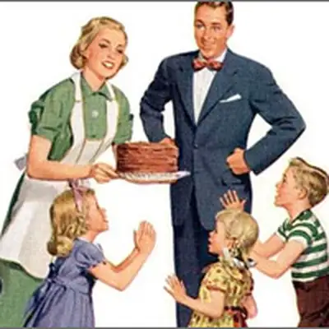
Section A- The sociology of families and households
One of the first areas you will study is the sociology of the family. Our concept of what a family is has changed throughout history and is a fascinating area of study for sociologists. It is the first place we develop our values and has a huge and lastly impact on the rest of our lives.

Task 1: Find the definitions for the following key family terms:
● Monogamy

● Bigamy

● Polygamy

● Maternal

● Nuclear family

● Empty nest

● Empty shell marriage

● Extended family

● Kinship

● Cohabitation

Task 2: How has the family changed over time?
Research the changing family in the UK and answer the following questions:
● How has the family structure changed over the past 100 years?

● How have the following policies affected the family?
- The Divorce Act 1969 and 1984

- The Paternity Act 2010

- The Civil partnerships Act 2004 and the Marriage (Same-Sex Couples) Act 2013

Task 3: How do families differ around the world?
Research different experiences of childhood across the world.
This link will be a good place to start: https://www.open.edu/openlearn/history-the-arts/history/different-cultures-different-childhoods

Section B- The sociology of education
Sociologists have differing opinions about the role our education system plays; some think it is crucial for the smooth running of society, whereas other think it is a toll used to exploit certain groups. The statistics show that some groups do far better in our education system- do you think that’s because they are more talented?

Task 4: Research the History of Education in the UK and answer the following questions:
- When did education become compulsory in the UK?

- Prior to compulsory education, what were the differences in who used to receive schooling?

- What are the oldest and newest subjects?

- How have the methods of dealing with behaviour changed over time?

- What are some of the major changes that have taken place in UK education in the 20th and 21st centuries?

  - Consider the impact of the following policies:
    - Education Act 1944 (Tripartite System)

    - Comprehensives 1966

    - Education Reform Act 1988

Task 5:

Find the definition of meritocracy.

Read the following news article https://www.tes.com/news/few-one-20-born-poorest-areas-go-university and answer the following questions:

- Does this article suggest we live in a meritocracy?

- Why is it important that ‘poor’ students go to university?

Task 6: Cornell noting taking
At A-Level, it is important to be able to summarise and digest large amounts of information effectively. One of the best ways to do this is through Cornell notes. (Watch a tutorial https://www.youtube.com/watch?v=ErSjc1PEGKE)
Try to use the technique to summarise the key study below:
Give each part a title that summarises the section | Talcott Parsons "The School Class as a Social System" 1961 | Bullet point the key facts or transform the information into a symbol/image
This functionalist study of the role of schools and education in socialisation, and also investigated the way in which the education system helped allocate people to their roles in society. Parsons argues that this is done in a meritocratic way.

Parsons argues that school acts as an agent of secondary socialisation. It is in school that children learn not the just the particularistic values of their own family, but also the universalistic values of the whole of society. At home, children are only judged by the standards of that household, but at school they begin to be judged by standards that apply to everyone and to learn the norms and values of society.

One of the important values of contemporary society, according to Parsons, is meritocracy. He argues that in our society, there is equality of opportunity, and people reach their position in life through hard work, rather than through privilege. School both teaches and is part of the process that makes it happen. In school, hard work and natural ability are rewarded, rather than titles or rich parents. And this continues in society as a whole, with children who achieve well at school going on to get the highest paid and most responsible jobs.

Many question whether this is really true. First of all, there is lots of evidence to show that coming from a wealthy background is a huge advantage in school. Second, lots of people get good qualifications and go on to carry out jobs that are not among the highest paid, and some of the most responsible jobs have low pay (e.g. childcare).
To finish: reduce the text into a few sentences. Draw out any connections or key concepts.

Keen to know more?
Read some of these articles relating sociology to COVID-19:

https://www.theguardian.com/education/2020/may/12/womens-research-plummets-during-lockdown-but-articles-from-men-increase

https://www.bbc.co.uk/news/business-52631222

https://www.bbc.co.uk/news/uk-52492662

https://www.youtube.com/watch?v=O-3Mlj3MQ_Q

https://www.tutor2u.net/sociology/blog/rise-in-corona-divorce-in-japan

https://nymag.com/intelligencer/2020/04/did-my-fundamentalist-upbringing-prepare-me-for-coronavirus.html

https://www.theatlantic.com/ideas/archive/2020/04/pandemic-shows-what-cities-have-surrendered-cars/610423/

https://www.bbc.co.uk/news/science-environment-51944780

Useful information to know
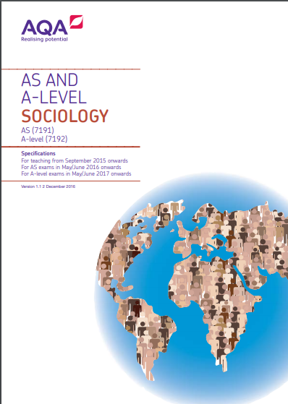
What specification is it?

AQA A level Sociology 7192
https://www.aqa.org.uk/subjects/sociology/as-and-a-level/sociology-7191-7192

What text book will I use?
Text books for Year 1 and Year 2 will be provided by the Sixth Form, but if you want to purchase a copy this is the amazon link.
https://www.amazon.co.uk/AQA-Level-Sociology-Book-Including/dp/0954007913
