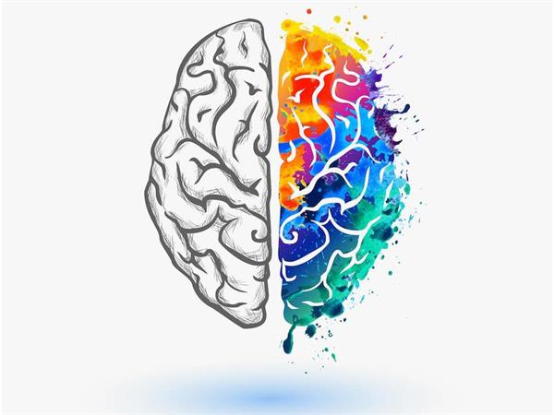
A level Psychology
at The Blue Coat Sixth Form
Part of the Social Sciences Department
Bridging Course - Part 2

Welcome back Psychologists! You are about to start Part 2 of the bridging course for your A level Psychology course.
In this session you will see that Psychology links with some of the subjects you have covered at GCSE, like Science, Maths and for some of you, Sociology.
Last time you were introduced to a key debate in psychology – “Nature versus Nurture”. In this session, you are going to see how this links to criminal behaviour – are criminals born that way or made that way.
Let’s get started!

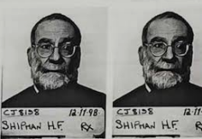
Task 1:
What makes a criminal?
List as many of the factors you think could influence someone to become a criminal. As you are doing this, think about whether this links to nature or nurture?

Factors that make you become a criminal
Before looking at the biological or innate explanations for why some people may become criminals – you need to have brain! You are going to attempt to make a brain.
You will need:
- Your brain (for thinking!)
- Modelling clay (or salt dough) Get the recipe for salt dough here https://www.bbcgoodfood.com/howto/guide/how-make-salt-dough-recipe
- Colours/paints – to highlight the different parts of the brain
Task 2: Building a brain – just for fun!

Front of head
Back of head

Brain stem

- Choose 6 pieces of play doh/modelling clay – try to have different colours for each section and where they will meet.
1. Form the brain stem. Pinch of a small amount of clay and roll it between your palms to create a thick rope. This section will have a slight “s” shape. The bottom should also have a pointed tip, while the top should have a flat edge and look a bit wider overall.
- The Cerebellum
Pinch off roughly half the amount you used with creating the brain stem. Roll and form this into a triangle with rounded edges. Position it so that one side of the triangle sits in the upper curve of the brain stem
3. Create the temporal lobe. Pinch off a roughly the same size lump of clay you used for the brain stem. Roll this clay into an oval shape. Place the centre of this oval onto the top of the brain stem, and press it gently to attach the two pieces of clay together. The bottom, left half of the oval should reach half way up the left side of the cerebellum if we consider the bottom of the triangle to be the part matched to the brain stem.
4.Make the occipital lobe. Take a piece of clay roughly the same size as your temporal lobe. Roll and flatten this piece into a quadrilateral which splays out at the top making a muffin shape. Position it so that the bottom centre of the lobe connects to the top, left 1/4 of the temporal lobe. The right side right side of the occipital lobe should cover the other left half of the cerebellum, with the muffin top spilling slightly over the top of the cerebellum.
5. Add the parietal lobe. Form another rectangle just larger than a square. One bottom shorter edge of the rectangle should cover the rest of the right half of the oval made by the temporal lobe. The rectangle should lean slightly to the right
6. Complete your brain by creating the frontal lobe. This should be largest amount of clay you use, and should sit at the front of your brains structure.

Well done!
You have made a brain!

Don’t worry – you won’t be tested on what these do for the A level!

Take a picture of your brain – bring this to your first Psychology lesson

Task: Briefly describe what the function of each of the parts of your brain do.
Use the link below to help you.
https://www.braininjuryhub.co.uk/information-library/an-introduction-to-the-brain?gclid=EAIaIQobChMI6unwsd2S6QIVYIBQBh1b8Q6NEAAYASAAEgJXb_D_BwE
Dr Raine is a psychologist who believes, that how the brain works in some individuals, influences them to become criminals.
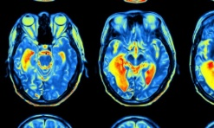
Watch the clip and list as many factors he says causes people to become criminals (violent criminals).
Brain section | Function
Brain stem
The Cerebellum
Temporal lobe
Occipital lobe
Parietal lobe
Frontal lobe
https://www.youtube.com/watch?v=wzqmbZ3gZ9E

Factors Dr Raine suggests cause someone to become a criminal

So, you can see that psychology links with the Sciences. But did you know that psychology also links with Maths?
Check your GCSE knowledge of some of the Maths skills you will need for psychology.
If you are unsure of what to do (it will have been a long time since you practiced some of these skills) check these links out!

Methods in Psychology: the maths you need to master!
I can………. | Yes I’m confident | No I need to review (check the links for help)
Work out percentages and fractions |  | https://www.bbc.co.uk/bitesize/guides/z2hsrwx/revision/1
Work out ratios |  | https://www.bbc.co.uk/bitesize/articles/zfkpnrd
Draw and create a pie chart |  | https://www.youtube.com/watch?v=p_nPxTRuLxo
Central tendencies (mean, mode, median) |  | https://www.bbc.co.uk/bitesize/guides/z2jb4j6/revision/2
So you can see – the Maths in psychology isn’t tricky – you might just be out of practice!
Next time!
In the final part of the bridging course we will be looking at a real-life crime and getting you to apply your psychological knowledge to a crime.

Want to know more?
Watch the TED talk – this discusses people who have been on death row and what might have influenced them to end up there!
https://www.youtube.com/watch?v=HYzrdn7YLCM

