The Blue Coat Sixth Form
Bridging Course
Part 2

Welcome back to the BCSF bridging course!
In this section we will be looking at how you can effectively improve your study skills.

We will be introducing you to our VESPA mentoring tools and using some tried and tested online learning resources to improve your skills.
This is particularly important this year as you will not have been through the challenge of your GCSE exams, so it’s a good way of getting into good habits.
Enjoy the course!
Introducing VESPA Mindset
VESPA
At BCSF we use VESPA to assist students in achieving success.
Read the brief introduction to learn more.
What is VESPA?
Over the last 15-20 years, much research into the psychology of success has been conducted and the findings are very interesting! Achieving the best grades possible in your A Levels is more than just learning the specification content. A particular set of skills and an advanced mindset is necessary. In other words, your attitude, self-beliefs about abilities and self-awareness of your own goals are essential to being an effective and successful A Level student.
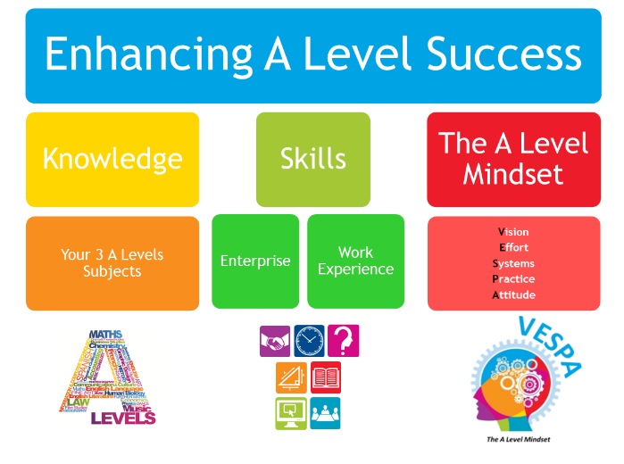

There has been very recent research conducted here in England into the mindset of A Level students. This research into the mindset concept has identified the following key (VESPA) elements:

Commitment to the Effort needed  Having a Vision | Having suitable Systems  in place | Practising  your learning & skills |  | Developing a positive mental Attitude

These 5 elements = success! But the key is that it is all 5 elements! You need to have all 5 elements to achieve your true success. All of us can enhance each of these elements to provide us with an effective mindset.
We use the VESPA model in BCSF, so this is something you will hear a lot about when you join us!
Task 1 – organising your time
You have probably been working your way through the Bridging Courses for your A level subjects (or not?!) If you are struggling with organising your studies, take a look at this tool to help you. At BCSF this is probably the most used study tool our students use to help them get organised.
You may feel overwhelmed by the work you have to do. You may have kept lists– scribbling down jobs and crossing them off when they’re done. And lists are good – they help you keep on top of what it is you’ve got to do. The drawback of a list is – it doesn’t tell you what to do first. A better tool to use for prioritising tasks is this one:
The Energy Line
An energy line beats a to-do list any day of the week. It helps you put things in order according to how much effort you need to give them. Put things on the left-hand side – ‘high’ or ‘extreme’ – if you need to work like mad on them. Put them on the right if you can kick back and leave it a bit. Attach dates for submission and you’re really getting there. Put the jobs on post-it notes and move them around, taking them off altogether when they’re done.
How to use the energy line:

- Write down all the tasks you need to do (the key is to make these tasks as specific as possible) – e.g. complete page 2 of the Biology Bridging course. (This is the overwhelming bit and can be a little scary!)
It is useful to do this on post it notes so you can move them around the energy line.
- Sort them into what is going to take the most amount of your time/be the most challenging.
- You are now organised!
- When you have completed a task – the best bit is binning the post it note with that task on it.

Task 2: Sign up for the free study skills course
This free course is aimed specifically for students and helps you to understand what’s the best way to study.
Log on to the link below, then search “improving your study techniques”.
https://www.futurelearn.com/subjects/study-skills-courses

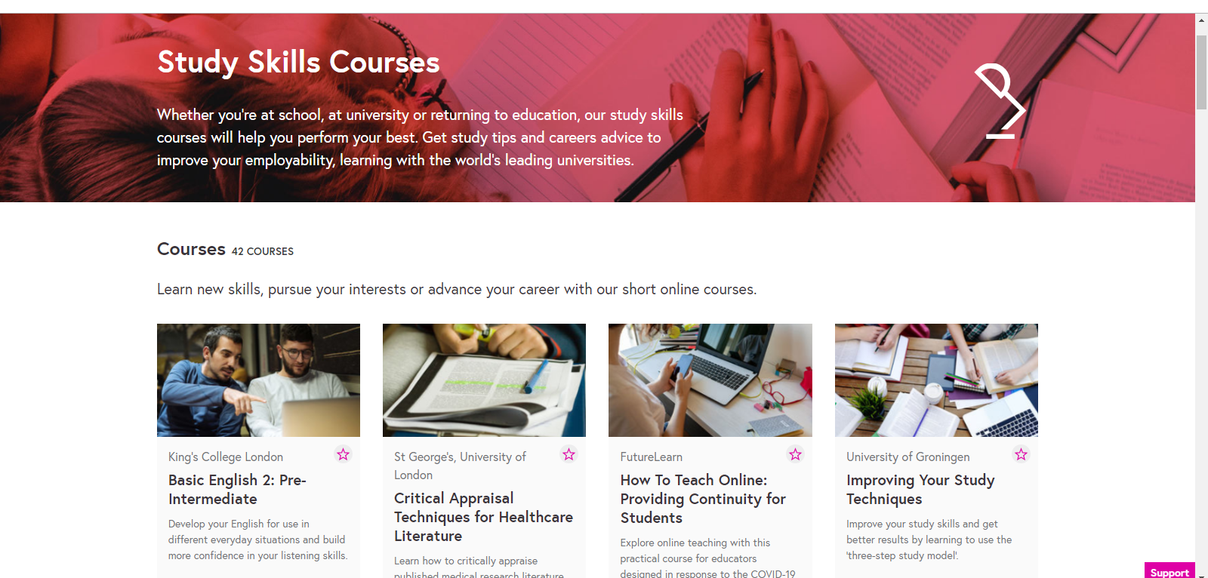
Don’t forget to evidence that you have completed the study skills course – bring this to 6th Form in September.
(A screenshot of the completed course is fine).
If you are keen to learn more – there are lots of free courses on this website – so have a look!

We hope you found these study tools useful.
Good luck with completing all your Subject Bridging Courses.
We look forward to welcoming you back for our third and final 6th Form Bridging course.

Bye for now!

