A level Psychology
at The Blue Coat Sixth Form
Part of the Social Sciences Department
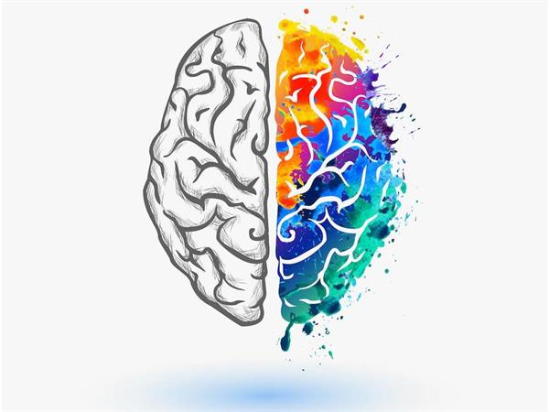
Bridging Course - Part 1
Welcome Psychologists! This is Part 1 of the Bridging course aimed to get you ready for your A level Psychology course.

The idea behind the bridging course is to give you a head start and so that you are already familiar with some of the key concepts and terms you will be using throughout the course.

Psychology is about studying human behaviour and being curious about why people behave the way they do. You probably already have your own theories to explain people’s behaviour. By studying psychology, you will have the chance to put those theories to the test – and to compare them to established theories.
The first idea you will investigate is the biggest question in Psychology – what is the biggest influence on our behaviour – is it Nature OR Nurture?
Part 1 – What influences behaviour?
This first section will look at a famous study The Milgram Obedience study and investigate whether our behaviour is influenced by innate (internal) or our nature, or in fact whether it is the situation (external) or nurture that affects individuals more.

Task 1:
As you watch the recreation of the video – consider what you would do in the same situation? What would your friends and family do? Are we all the same.
Watch the video
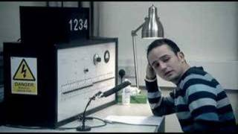
https://www.youtube.com/watch?v=y6GxIuljT3w

1. What do you think are the key things that influence people’s behaviour in the video?

2. Read the extract from Milgram’s conclusion – what does he suggest influences behaviour? .
Milgram (1974) explained the behavior of his participants by suggesting that people have two states of behavior when they are in a social situation:
- The autonomous state – people direct their own actions, and they take responsibility for the results of those actions.
The agentic state – people allow others to direct their actions and then pass off the responsibility for the consequences to the person giving the orders. In other words, they act as agents for another person’s will.

Watch the clip to get a further understanding of his conclusions.

https://www.youtube.com/watch?v=JXXbIF5Okjc
Write down 2 things he suggests influence participants (the people in the study).
1.

2.

Nature – this is the influence of our biology. So, elements like our DNA, hormones, brain (neurological anatomy), gender may influence our behaviour.
Nurture – this is the influence of our environment, friends, family or the situation a person is in.
Task 3
Which do you think is more influential? Explain your reason in the box below.

Task 4:
List all the behaviours that you think are influenced by nature or nurture – the behaviour can be anything, we’ve done the first ones to get you thinking. Try to come up with 5 for each. You’ll notice that personality is in both – which do you think it is?
Nature | Nurture
Intelligence  Personality? | Accent  Personality?

Consolidating task
Let’s see how much you have learned and can remember.
In your own words, explain what psychologists mean by Nature?
In your own words, explain what psychologists mean by Nurture?
Sketch a picture to describe the Milgram study on Obedience

Next time!
In the next part of the bridging course we will be looking at Crime and whether criminals are born bad or made bad. In other words -is it nature or nurture?

Excited to know more?
Watch the TED talk on Criminals

https://www.youtube.com/watch?v=u2V0vOFexY4

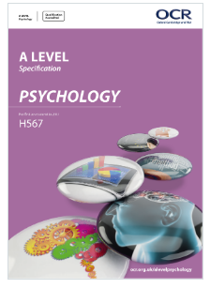
Useful information to know

What specification is it?

OCR A level Psychology H567
https://www.ocr.org.uk/qualifications/as-and-a-level/psychology-h167-h567-from-2015/

What text book will I use?
Text books for Year 1 and Year 2 will be provided by the Sixth Form, but if you want to purchase a copy this is the amazon link.
https://www.amazon.co.uk/OCR-Level-Psychology-AS-Year/dp/0198332750
