A-Level Geography
@ Blue Coat Sixth Form
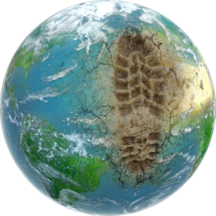

BRIDGING UNIT PART A

Where have we come from and where we are going in our study of Geography?

ADMIN
This bridging unit is designed to help you transition from GCSE to A-Level Geography. If you have any questions about the tasks, or wish to know anything more, then please contact Mr. Venables (Head of Geography) at nvenables@blue-coat.org

What topics will I study as part of A-Level Geography?

As part of OCR A-Level Geography you will complete three examinations and one piece of non-examined assessment (coursework). You will study a broad range of topics across both years:

Paper 1 | Earth’s life support systems – the carbon cycle, the water cycle and other essential fundamentals of physical geography.  Coastal landscapes – the physical processes that occur at coastlines and how they shape the landscape.
Paper 2 | Space and place – what are our perceptions of different places and what shapes these? Why do we have positive perceptions of some places but negative perceptions of others?  Global migration – the reasons why people move globally and the impacts of this on different countries.  Power and borders – who controls what land and who decided? What happens when the safety/security of a country is threatened?
Paper 3 | Climate change – the causes of climate change, the impacts of climate change and potential solutions to the climate crisis.  Hazardous earth – plate tectonics, earthquakes and volcanoes. Risk factors for humans and how to adapt to them.

How does this progress from what I studied at GCSE?

You will have already been introduced to a range of skills and concepts through your study of GCSE. These fundamentals of geography are ever-present in the A Level course. For example, the ability to:
- Interpret and analyse data presented on maps.
- Identify trends and anomalies in data presented on graphs.
- Evaluating strategies and balancing up their pros and cons.
- The idea of sustainability and environmental protection.
In addition, there are some areas in which content clearly overlaps with and extends from knowledge you have gained at GCSE. On the next page complete a brain-dump exercise of anything you can remember linked to the three topics highlighted:
Coastal landscapes

Climate change

Earthquakes and volcanoes

What will I get out of studying Geography?

Aside from the obvious things such as a grade with which you can apply and be accepted to university, a range of highly-transferrable and employable skills and the ability to take part in a coherent debate about the future of the planet, the main goal is to become young adults who take a deep interest in the world around you to allow you to hopefully play a role in solving some of the greatest challenges all around us.

Let’s start with some developing some understanding about the world around us and how we know what is going. It’s important that you get used to questioning source of information. Who made it? What expertise do they have? Could they be biased in any way? This is particularly important when we study the debate around climate change. Use the grid to research and summarise some information about this source:

Who is Danny Dorling? | What expertise does he have?
What is a TED talk? | Could there be any bias?

Watch the TED talk given by Danny Dorling by following the link below and answer the questions.

Link: https://www.ted.com/talks/danny_dorling_maps_that_show_us_who_we_are_not_just_where_we_are#t-406804

Video Questions

How has the first world map, by Benjamin Henning, been manipulated?
__________________________________________________________________________________________________________________________________________________________________________________________________________________________________________________________________________________________________________________________________________________________________________________

What do the lines on the map represent?
______________________________________________________________________________________________________________________________________________________________________________________________________________________________

What does the second world map, with the dates on, show?
______________________________________________________________________________________________________________________________________________________________________________________________________________________________

Describe global population growth using the graph Dorling shows.
T rend
E vidence
A nomalies
M anipulate

What can be learned from the two maps of water security and food security?
______________________________________________________________________________________________________________________________________________________________________________________________________________________________
______________________________________________________________________________________________________________________________________________________________________________________________________________________________

How does the story about Tokyo’s energy use after the 2011 tsunami show that physical and human events are interrelated?
______________________________________________________________________________________________________________________________________________________________________________________________________________________________
______________________________________________________________________________________________________________________________________________________________________________________________________________________________

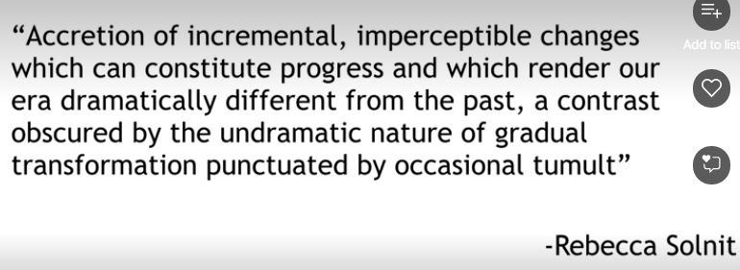
Rewrite this statement in plain English.
______________________________________________________________________________________________________________________________________________________________________________________________________________________________
______________________________________________________________________________________________________________________________________________________________________________________________________________________________

How might this link to the news coverage of the current global pandemic?
______________________________________________________________________________________________________________________________________________________________________________________________________________________________
______________________________________________________________________________________________________________________________________________________________________________________________________________________________

THANK YOUR FOR COMPLETING PART A OF THE BRIDGING UNIT.

PTO FOR A COPY OF THE SLIDE THAT WAS SENT TO YOU IN APRIL ABOUT THINGS YOU CAN BE DOING TO PREPARE FOR A-LEVEL.

