A-level English Language
at The Blue Coat Sixth Form

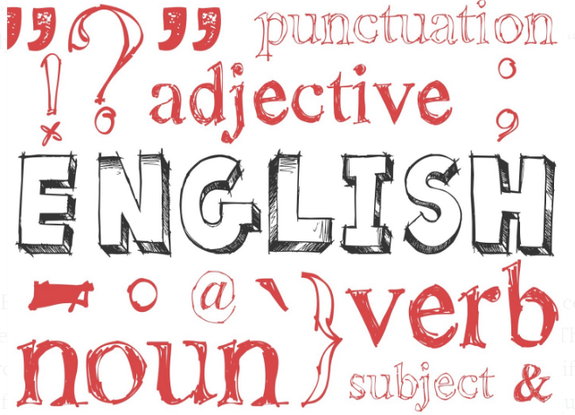
Part 1
Welcome linguists! This is Part 1 of the bridging course aimed to prepare you for your English Language A Level.
The purpose of the bridging course is to give you a head start in your studies and to introduce you to some of the key concepts and terms you will be using throughout your English Language A Level.
You have chosen a subject that will open your eyes to a world that has previously been hidden in plain sight. Such critical awareness will allow you to be a conscious, critical human being who is able to challenge assumptions and understand the role that language plays in shaping our identity and the society we live in.

So far, your study of the English Language at GCSE has been largely restricted to analysing texts and writing for different purposes and audiences. Whilst there is some overlap (which we will explore in this module), it is important to understand that there is so much more on offer at A Level. Take a look at the structure of the course below:
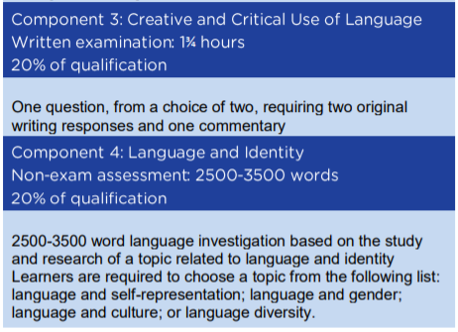
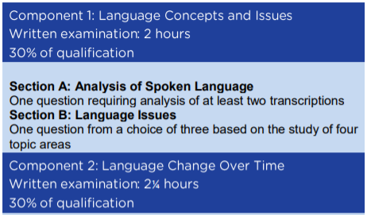

For this first section, we are going to be looking at Component 3: Creative and Critical Use of Language. In particular, how to construct a commentary.
What is a commentary?
A commentary is a text that enables you to explain the decisions you have made as a writer and demonstrate your awareness of audience, purpose and convention.
From your knowledge of GCSE, what do you understand by the term audience?

From your knowledge of GCSE, what are the main purposes of a piece of writing?

Often a piece of writing is not limited to a single audience or purpose. Whilst a writer (text producer) may have a particular audience in mind (text receiver) their writing may be exposed to and viewed by others. For example, a leaflet giving advice on how to revise may be intended for the student (intended audience), but also read by teachers and parents (secondary audience). This is the same when it comes to purpose. Again, it is likely that the writer will have a primary purpose. To continue with the earlier example, an advisory leaflet’s main function is obviously to advise! However, in order to do this successfully, it will need to be both informative and to a certain extent entertaining or it runs the risk of not being read at all.
With this in mind, can you identify the various audiences and purposes of the following texts? Try to use some of the key terms (in bold) in your answers where you can.

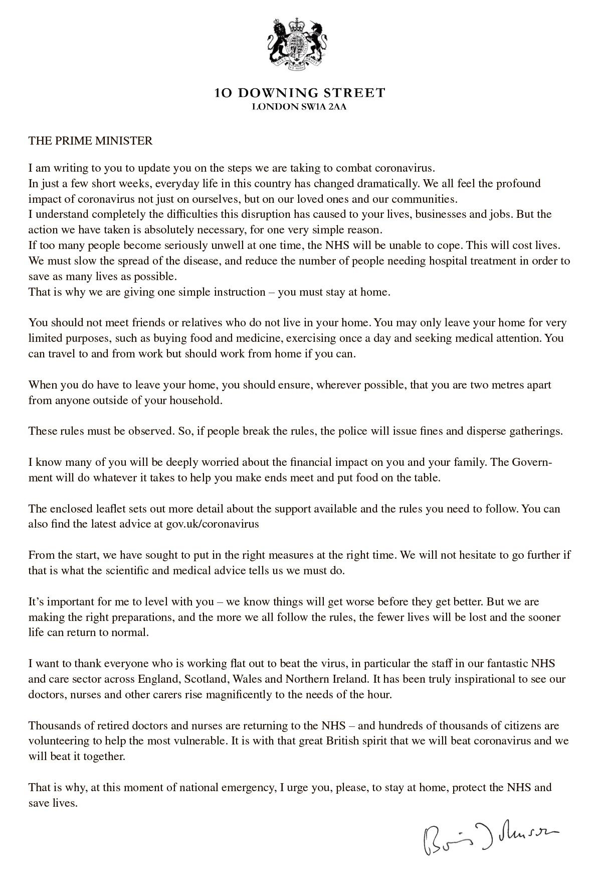
TEXT A

TEXT B

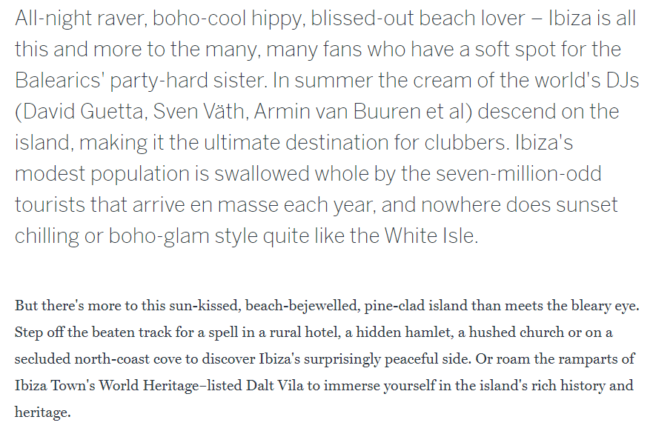
Welcome to Ibiza

TEXT C
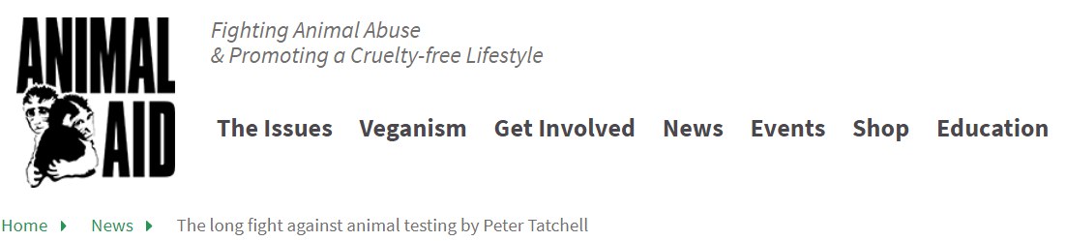

The long fight against animal testing by Peter Tatchell

The use of animals in medical research is increasing at its fastest rate since 1986. We must find a credible humane alternative.
By Peter Tatchell, human rights campaigner
The government has been assuring us for many years that animal experiments are only sanctioned for high priority medical research, as a last resort. We were told that the trend was for fewer laboratory procedures using animals. Indeed, the government boasted that it was committed to big cuts in animal-based research through the development of replacement methods. This seemed to be the case for several years, when the use of lab animals steadily declined.
It therefore comes as major surprise to learn that in 2008 the number of medical experiments involving animals has shown the largest rise since modern records began. Home Office figures state that nearly 3.7m experiments were performed on animals last year, a rise of 454,000 or 14% on the previous year. This is the steepest increase in animal use in medical research since 1986, when the government introduced new recording and monitoring procedures.
While most experiments in 2008 involved mice, macaque monkeys were used in 1,000 extra experiments, a hike of 33%. This trend is particularly disturbing and difficult to justify, given that macaques (and other monkeys used in UK labs) are intelligent, social animals. They share many human-like attributes, including language, tool-use, reasoning, emotions, improvisation, planning, empathy and the capacity to feel both physical and psychological pain. The mere fact of their imprisonment in laboratory cages – usually in solitary confinement – is a serious abuse of these thinking, feeling creatures.
The spike in animal experimentation coincides with the 50th anniversary of landmark proposals to find alternatives. Alas, for half a century, successive governments have failed to fund the promised development of replacement methods – even though every scientist knows that animal models are flawed and imperfect approximations of the human body and human disease.

 | Audience | Purpose
TEXT A
TEXT B
TEXT C

Having identified the multiple audiences and purposes of the writing, it is important to explore the ways in which the text fulfils the conventions of the genre. The term convention is used where there is a generally accepted usage or practice. In this case, it refers directly to genre. Genre means a type of art, literature, or music characterised by a specific form, content, and style. Put simply, you are identifying the ways in which a particular type of text is categorised.
If you were going to write a newspaper article, what conventions of the genre would you include?

Having analysed audience, purpose and genre convention, you are then expected to apply what is know as the language levels. The language levels are:
- phonetics, phonology, prosodics: how speech sounds and effects are articulated and analysed
- lexis and semantics: the vocabulary of English, including historical, geographical, social and individual varieties of English
- grammar including morphology: the structural patterns and shapes of English at sentence, clause, phrase and word level
- pragmatics: the contextual aspects of language use
- discourse: extended stretches of communication occurring in different genres, modes and contexts.

In November 2018, the AQA GCSE English Language Paper 2 question was:
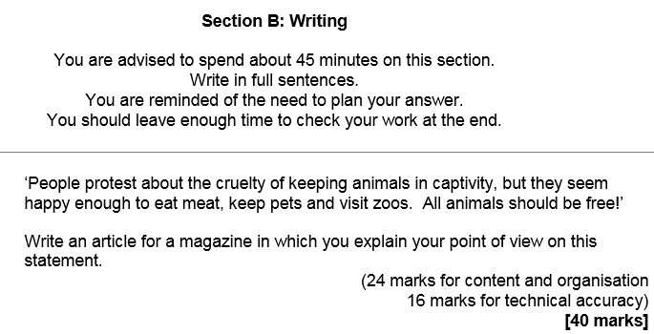

On the next two pages are two articles taken from The Guardian’s, Comment is Free section. Both of these texts are opinion articles and would be excellent illustrations of what the task would look like in real-life.
Read and annotate the following articles carefully:

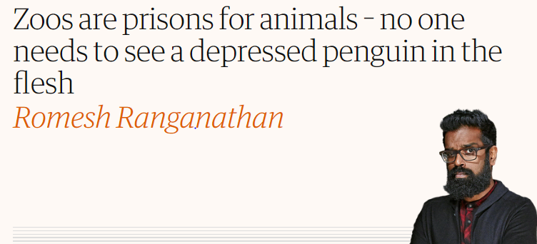

That a zoo in Cumbria is having its licence revoked as a result of nearly 500 animals
dying there over a two-year period comes as no shock – but it still slightly surprises
me that anybody thinks that we should have zoos at all. The animals always look
miserable in captivity. If you don’t believe me, visit a farm park. It’s as likely as not
that you will see a goat, pleading with its eyes to be euthanised, while a sign on the
enclosure says: “Gerry the goat is quite the character – he often plays a game in which he looks
like he has been crying for many, many hours!”

A lot of zoos play the conservation angle, which is a rationale that has been reverse
engineered. That’s not really why zoos exist. Zoos exist so that we can wander round with our
children and say: “No, don’t bang the glass, Timothy, he’s getting agitated,” before going home
to post on Facebook about the educational day that we have had.

The argument that zoos have educational merit might have once seemed convincing, but there
is less reason to see animals in captivity than ever before. David Attenborough’s Planet Earth
shows you all the animals you could ask for in their natural habitat, with added drama and
narrative arcs. We are surely only a few series away from filming inside the animals, with
Attenborough using his dulcet tones to give the origin story of an elephant turd. Why, then, do
we need to see them in prison?

On holiday recently, I was persuaded by my family to visit a marine theme park that bombards
you with messages of preserving marine life. We spent the afternoon seeing seals and penguins
that looked to be in varying stages of depression before taking in the dolphin show, which
meant watching a two-minute video about saving dolphins, and a 10-minute demonstration of
how the park has managed to enslave them and get them to perform tricks. I wondered about
the message behind getting the dolphins to pull some kids around in a boat almost as much as
I wondered why my own children hadn’t been offered that experience.

When Cecil the lion was killed, the general public were so incensed that the dentist who shot
him became an international hate figure; the perfect example of the public picking and
choosing when to give a shit about animals. It’s apparently really bad to shoot Cecil despite the
fact he has had a much better life than the huge number of lions that we continue to keep in
captivity. I am not suggesting that it is wrong to care about Cecil, but if we are in uproar about
that, why aren’t we as upset about the animals in tanks and cages, or the ones that we eat? I
wonder if we would have been so upset if the lion didn’t have a name. Or was called Piers.

There are counter-arguments, of course. After a visit to the Sea Life centre in Brighton, my
eldest son took a passionate interest in marine life that has stayed with him, and I wouldn’t be
surprised if animal conservation went on to be one of his primary concerns. This is almost
certainly as a direct result of our visit, but it’s also first-world privilege in micro form: “We
must have some animals in cages for little Stephen to look at, otherwise how will he learn?”
Similarly, the idea that kids only get excited about things they can see in the flesh is ridiculous.
My kids are obsessed with dinosaurs that no longer exist, and Skylanders, which have never
existed. One of our sons watches endless YouTube videos of Kinder Surprise eggs being
opened, so the bar is set pretty low in terms of what will get him interested. I would, however,
be delighted to hear that the YouTubers responsible for these videos had been put in a series of
cages for our enjoyment.

I have no doubts that the people working in zoos, safari parks and conservation centres all
really care about the animals. But there is a pretty strong argument that there is a negative
effect on conservation awareness, given that children take away the message that “endangered
species” are probably OK because they have seen them in the zoo. Plus, zoos and conservation
spaces are impossible to effectively regulate. Have a look online and see the number of cases of
animals being killed because of lack of space, horses being painted to look like zebras, animals
in aquariums showing clear signs of distress.

Still, I was struck by my own hypocrisy when I was looking to get a family pet. When I found
myself Googling: “How long will a puppy cry for its mother and siblings,” it occurred to me
that I probably no longer wanted to do it. The idea that I don’t want animals to be imprisoned,
but that I quite fancy having a prisoner of my own doesn’t sit comfortably. This might sound
extreme and no doubt cat owners will tell me that their cats are free to go wherever they want
but always return. I live in Crawley, however, and often when I’m out I immediately want to
return straight home I could never be sure if the cat coming back was a thumbs-up for the
return straight home. I could never be sure if the cat coming back was a thumbs up for the
family, or a silent protest against the lack of amenities in town. I’m also starting to consider
setting my children free.

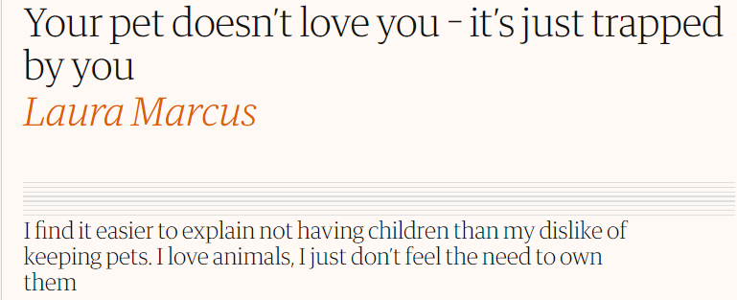

Reading about how the Queen treats her Corgis like royalty gave me the same vague sense of confusion that I always get when I hear about the overwhelming love some people have for an animal companion. I don’t get it. I never have. It simply doesn’t compute with me. How can you possibly love a animal with the same fervour as you love a fellow human?
“But they’re part of our family,” pet lovers frequently insist. How? You didn’t give birth to them. You can talk to them but they can’t talk back, and if you imagine for one second that your cat really gives a damn about your feelings then you’re sorely misguided. If cats do consider you at all, it’s probably to think: “What strange creatures these human animals are; many take better care of us than they do their own young.”
Perhaps it’s because I never grew up with pets. My parents believed we humans had no right to own other animals. I agreed with them then, and I still do. When at junior school it was my turn to bring home the class guinea pig for the weekend my father immediately released it into the wild of our garden. Don’t worry – he kept a firm eye on it and guinea was safely returned to school on Monday in its sad little wooden cage. Should it ever have been kept like that? Ditto rabbits and other beasts that should be in the wild. We haven’t tamed them; we’ve entrapped them. Even your pet moggy is a wild animal, as any owner who’s come downstairs in the morning to the entrails of a mouse, vole or bird will attest.
I’ve found it far easier to explain not having children than my dislike of pets. You don’t want children, fine. Quite understand. But pets? How could you not love a small furry animal? But I do love creatures, the great and the small. My problem is always with their owners, and with the word own. For many it’s seems to be about control. You can’t possibly control another human being the way you can an animal, though of course many try. Call a dog and it comes to you. Lovely. The slobbery greeting you get from a dog when you get back home gives a huge buzz. Someone loves you! No they don’t. A pet is relieved not to be alone, and probably wants its dinner.
I do wonder if I have something missing. It’s obvious pet lovers have a special bond with each other, noticeable even on social media. Some on Facebook are currently urging people to change their profile pics to that of animals to show they’re against animal cruelty. And only the other day JK Rowling was exchanging tweets with Stephen King about how they’d have finished their books months ago if their dogs could make up their mind which side of the door they wanted to be on. Such shared experiences cut across barriers and it’s hard not to feel a bit envious.
I do care about animals. I loathe zoos and think they should be closed down, save for necessary preservation work. I won’t eat veal or battery-reared chicken, I am against the badger cull and living in a rural area, I believe farm animals should be treated as humanely as possible. I also love cooking for vegetarian friends. I just think a real animal lover wouldn’t dream of thinking they had the right to own one and treat it like a personal possession.

LINK: https://resources.eduqas.co.uk/Pages/ResourceSingle.aspx?rIid=984

Follow the link above to take you to the Eduqas Website where you will be able to explore opinion writing in more detail.
Having read the texts and had a go at some of the online activities, you are now ready to have a go at writing a commentary for either one of the two texts.
Write as though you yourself were the text producer (the writer) and critique the writing.
Remember to begin by addressing the text’s audiences, purposes and genre conventions. Try to use as many of the key terms you have been exposed to in this bridging unit.
Once you have done this, then have a go at applying some of the language levels. There are some prompts to help you.
***
How to Write a Commentary.
In your first paragraph, always begin by identifying the style, purpose and audience of the piece. E.g. What have you written? Why? Who for?
The why and who may be more complicated than simply stating a single reason. Here you might want to explore who the intended audience is (primary) but also discuss any secondary audiences. This is the same for purpose.
Common purposes are: argue, persuade, advise, inform, describe, explain, advise, analyse, review, comment, entertain.
The next thing you should focus on is genre. What are the conventions of the type of writing you have tried to construct? Be as specific as you can here. For instance, with articles we know that there is a whole host of sub-categories. How is an opinion article distinctive to others?
Once you have covered this you should then take a language level-based approach to your analysis.
Lexis and Semantics
Ask yourself…
Is there a predominant semantic/lexical field operating throughout the text? Why?
Have you used lots of pre and post modification? Why?
What type of adjectives have you used? Attributive, evaluative, base? Why?
What types of verbs have you used? Imperative? Modal?
Have you used lots of proper nouns? Why?
Have you used any colloquialism or slang words? Why?
Have you included any specialist lexis or jargon? Why?
Are there any puns on words?
Have you used any clichés? Avoided any clichés?

Grammar
Think about the types of sentences you have used and why. The four main sentence types are: declarative, interrogative, exclamative, imperative. What impact will they have on your writing?
What tense have you chosen to write in and why? Is there a shift in tense anywhere in the text for any particular reason?

Discourse Structure
What narrative have you chosen to write in and why? First Person?
Have you used direct address? Why?
Synthetic personalisation?
Have you tried to establish a discourse community?
Have you used any rhetorical devices?

Word Classes
Nouns | Proper | Refers to names of people and places | James, London
 | Abstract | Refers to states feeling and concepts that do not have a physical existence | Love, anger
 | Concrete | Refers to objects that have physical existence. | Countable (Can be pluralised e.g. cup)
 |  |  | Non-countable (Do not take the plural form e.g. furniture)
Verbs | Material | Show actions or events | Hit, jump, wash, build
 | Relational | Identify properties or show states of being | Be, appear, seem, become
 | Mental | Show internal processes | Think, believe, wish
 | Verbal | Show external processes of communicating through speech | Say, shout, scream, whisper
Adjective and adverbs | Base | The basic form or an adjective or adverb, modifying another word. | Bid, interesting, carefully
 | Comparative | A form used to compare two instances either adding ‘er’ or using ‘more’ | The parcel was bigger  He read more carefully
 | Superlative | A form used to compare more than two instances identifying a best example | That was the biggest parcel  That was the most interesting game
 | Attributive | Adjectives that come before the noun | Dark evening  Mysterious event
 | Predicative | Adjectives that come after the noun | The evening was dark  The event was mysterious
 | Evaluative | Evaluative adjectives tell about something that can be measured and compared. | Nice, boring
Pronouns | Personal | Refers to people and are differentiated in terms of person, number and gender | I – First person singular  You – Second person singular  She – Third person singular feminine  They – Third person plural
 | Demonstrative | Orientate the reader or listener towards a person, object or idea either nearby or further away | This, that, these, those
 | In-definite | Refer to a person object or idea that is non-specific | Someone, anybody, everything
Determiners | Articles | Show that something is definite or indefinite | The (definite)  A/an (indefinite)
 | Possessives | Show ownership | My, your, her, our
 | Quantifiers | Show either specific or non-specific quantities of a noun | One, two (specific)  Some, any, a few (non specific)
Conjunctions | Co-ordinating | Link words or larger structures such as phrases and clauses together where they are equal | And, but or yet
 | Subordinating | Link clauses together to show that one is dependent on the other | Because, although, while, therefore
Here is a copy of the mark scheme for this particular task:
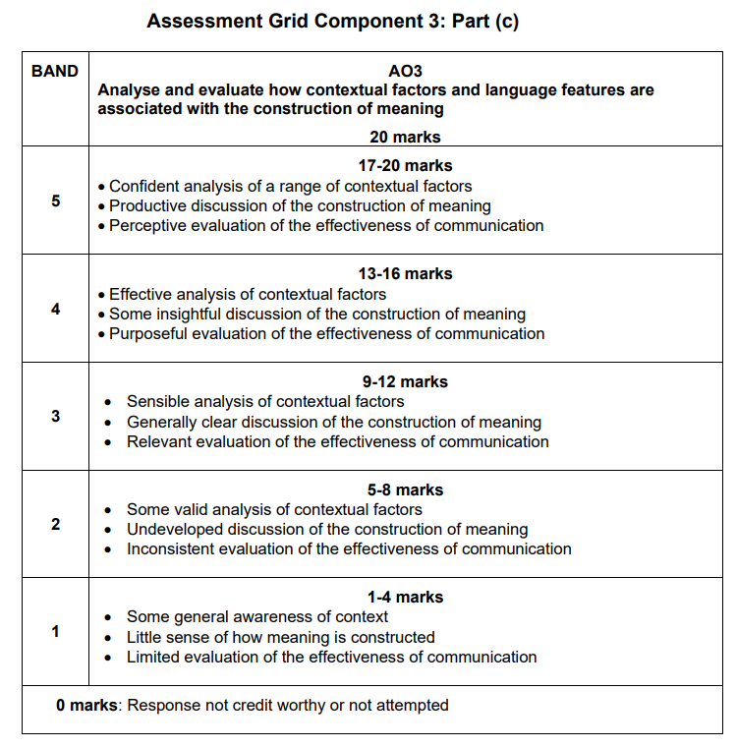

Exemplar Response from the Board WAGOLL (What A Good One Looks Like)
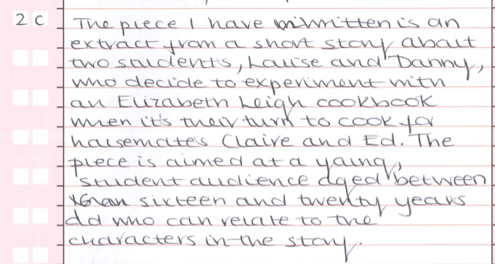
This student only offers one very specific purpose. Be open to exploring multiple purposes and audiences where appropriate. The scope for this will vary dependent upon the task. This commentary was written for an extract from a short story.
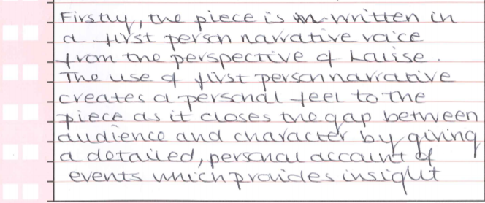
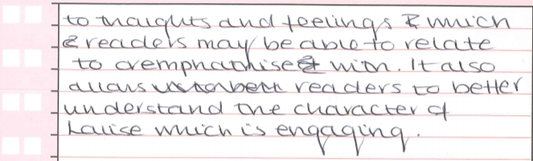
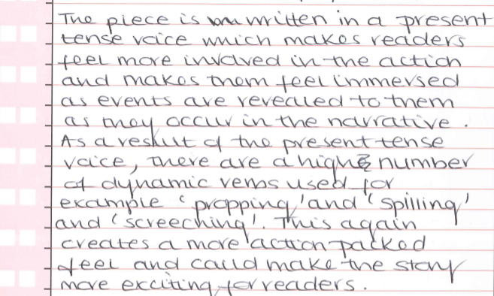
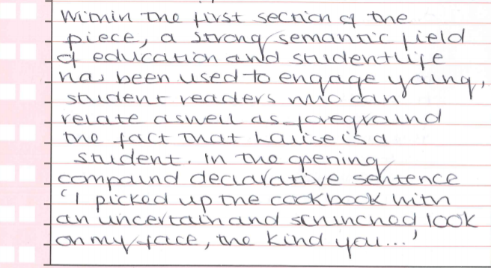
You get the idea!

KNOWLEDGE ORGANISER  Component 3: Creative and Critical Use of Language  Written examination 1 ¾ hours  20% of qualification  One question, from a choice of two, requiring two original writing responses and one commentary | Creative Writing: This component presents you with stimulus texts which may be literary or non-literary. It is designed to engage you in the creative process and give you the opportunity to demonstrate your expertise. You will be required to produce original writing in any genre. In preparation for this question, you will study a range of literary and non-literary texts and practise producing texts in a variety of genres.  I can:  - apply creative skills in the production of engaging writing  - recognise the importance of audience, form and purpose  - show expertise in their use of English to communicate in different ways.  Commentary: You are also required to write a commentary on one of the two texts you have produced. This task is designed to encourage you to analyse and evaluate the language choices you have made. In preparation for this task, you will practise analysing and evaluating your own writing.  I can:  - apply critical skills to my chosen text  - analyse and evaluate contextual features  - articulate reasons for the language choices I have made  - support points with apt quotation
Original Writing Key Points:  You should have a sound knowledge of:  • register e.g. mode, tenor, field  • the distinctive linguistic features of different literary and non-literary text types  • the influence of contextual factors on linguistic choices  • punctuation and the ways in which it can be used to create different effects  • the language levels.  This knowledge will help you to produce:  • a range of different literary and non-literary text types.  Your experience as writer will help you:  • to be creative in engaging with a task  • to demonstrate expertise, writing in different ways for different audiences and purposes  • to manipulate language to create specific effects  • to develop a personal voice |  |  | Critical Commentary Key Points:  You should have a sound understanding of:  • register e.g. mode, tenor, field  • the distinctive linguistic features of different literary and non-literary text types  • the influence of contextual factors on linguistic choices  • punctuation and the ways in which it can be used to create different effects  • the language levels  This knowledge will help you to produce:  • a commentary which assesses the effectiveness of your original writing.  Your experience as a critic will help you:  • to analyse and evaluate your own writing using the language levels and key terminology  • to explain what you have tried to achieve  • to explore the influence of the contextual factors  • to consider the ways in which you have shaped meaning.
Key Vocabulary: I can use and/or identify…  Rhetorical device  Audience  Purpose  Primary audience  Intended audience  Secondary audience  Text producer  Text receiver  Genre conventions |  | Synthetic personalisation  Field  Mode  Tenor  Formality  Tone  Register  Style  Stage Directions |  | Narrative hook  Cyclical structure  Direct address  Narrative voice  Narrative arc: exposition, problem, conflict, resolution  Characterisation  Setting  Pun

Commentary:
______________________________________________________________________________________________________________________________________________________________________________________________________________________________________________________________________________________________________________________________________________________________________________________________________________________________________________________________________________________________________________________________________________________________________________________________________________________________________________________________________________________________________________________________________________________________________________________________________________________________________________________________________________________________________________________________________________________________________________________________________________________________________________________________________________________________________________________________________________________________________________________________________________________________________________________________________________________________________________________________________________________________________________________________________________________________________________________________________________________________________________________________________________________________________________________________________________________________________________________________________________________________________________________________________________________________________________________________________________________________________________________________________________________________________________________________________________________________________________________________________________________________________________________________________________________________________________________________________________________________________________________________________________________________________________________________________________________________________________________________________________________________________________________________________________________________________________________________________________________________________________________________________________________________________________________________________________________________________________________________________________________________________________________________________________________________________________________________________________________________________________________________________________________________________________________________________________________________________________________________________________________________________________________________________________________________________________________________________________________________________________________________________________________________________________________________________________________________________________________________________________________________________________________________________________________________________________________________________________________________________________________________________________________________________________________________________________________________________________________________________________________________________________________________________________________________________________________________________________________________________________________________________________________________________________________________________________________________________________________________________________________________________________________________________________________________________________________________________________________________________________________________________________________________________________________________________________________________________________________________________________________________________________________________________________________________________________________________________________________________________________________________________________________________________________________________________________________________________________________________________________________________________________________________________________________________________________________________________________________________________________________________________________________________________________________________________________________________________________________________________________________________________________________________________________________________________________________________________________________________________________________________________________________________________________________________________________________________________________________________________________________________________________________________________________________________________________________________________________________________________________________________________________________________________________________________________________________________________________________________________________________________________________________

