The Blue Coat Sixth Form
Bridging Course
Part 1

Welcome to the BCSF! We look forward to you joining us and starting the next part of your academic career.
You have 3 bridging courses to do for the A level subjects you have chosen and a bridging course for 6th Form.
This bridging course is designed to do two things – to give you some tips and guidance on how to best prepare for the challenge of A levels, but also to get some information about you – so that your form tutors, form and the 6th Form team can get to know you.
Part 1: Getting to know you
BCSF Profile
What would your profile say about you?
Add a friend:
facebook

Name:

Likes and interests

Activities/Hobbies

Music

Quick fire random questions
just for fun!

What is your favourite food:

Best film you have ever watched?

Describe yourself in 3 words

Chocolate or crisps?

Part 2: Study skills/working at home
We all struggle with working at home. Not having friends around you and a change in your school routine can lead to struggling to study and being motivated.
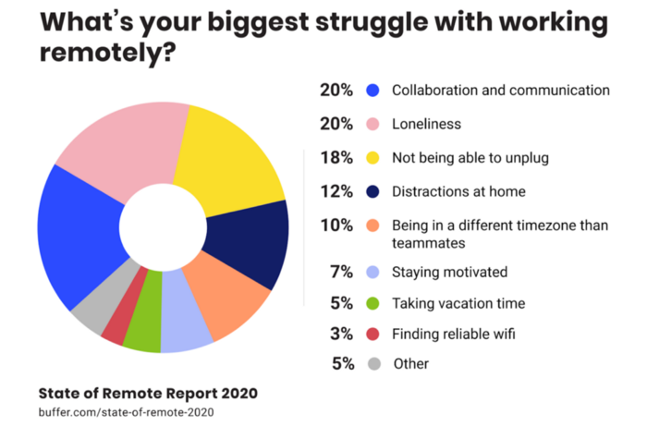
What is your biggest struggle when you’re asked to work independently?

Well there are lots of benefits too! Take a look……
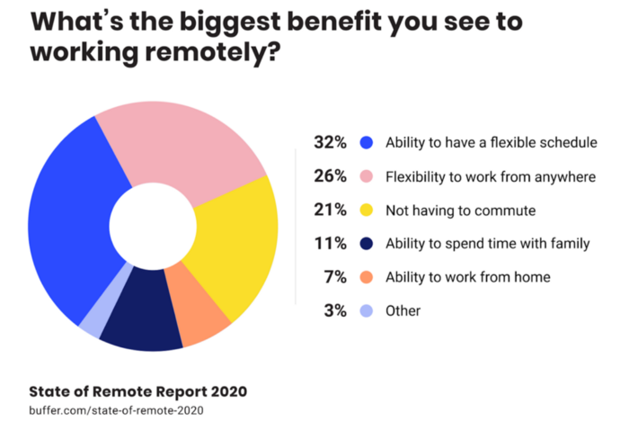

Working from home means you can decide when and where you work, whilst having time for things you want to do! For the first time, you get to choose how to plan your time – so use it wisely!
Daily routine is really important to continue, this will be different to your usual routine but, will still help you manage your workload and mental health.
- Be disciplined – don’t work all day / night. Give yourself time to exercise, enjoy your favourite programme or time on social media. Make sure this is structured and stick to a timetable.
- Set targets for your day. Work off to do lists each day. Spread your workload out. Not all work has to be completed in one day.

Part 3: Get motivated – hot to get started with your bridging courses!
Watch the TED Talk clip https://www.youtube.com/watch?v=arj7oStGLkU

A really interesting (and short) talk about why it might be difficult to make a start on your bridging courses!

What now? Decide which Bridging course you are going to do first. Set yourself a deadline to try and organise your work.

In Part 2 – we will give you more hints and tips on how to manage your time effectively. In the meantime, make a start on your bridging courses.
Welcome to BCSF.

